**Goodbye to Gambling**

OFFICIAL INTERNATIONAL PUBLICATION! ntTUT

OF THE ASSOCIATED LOCKSMITHS OF AMERICA, INC.

Also** *ADA andOoorHardware* . o*vetyiev, o, Higher Se,*

*curity Exit Devices* * *The Complete Door*

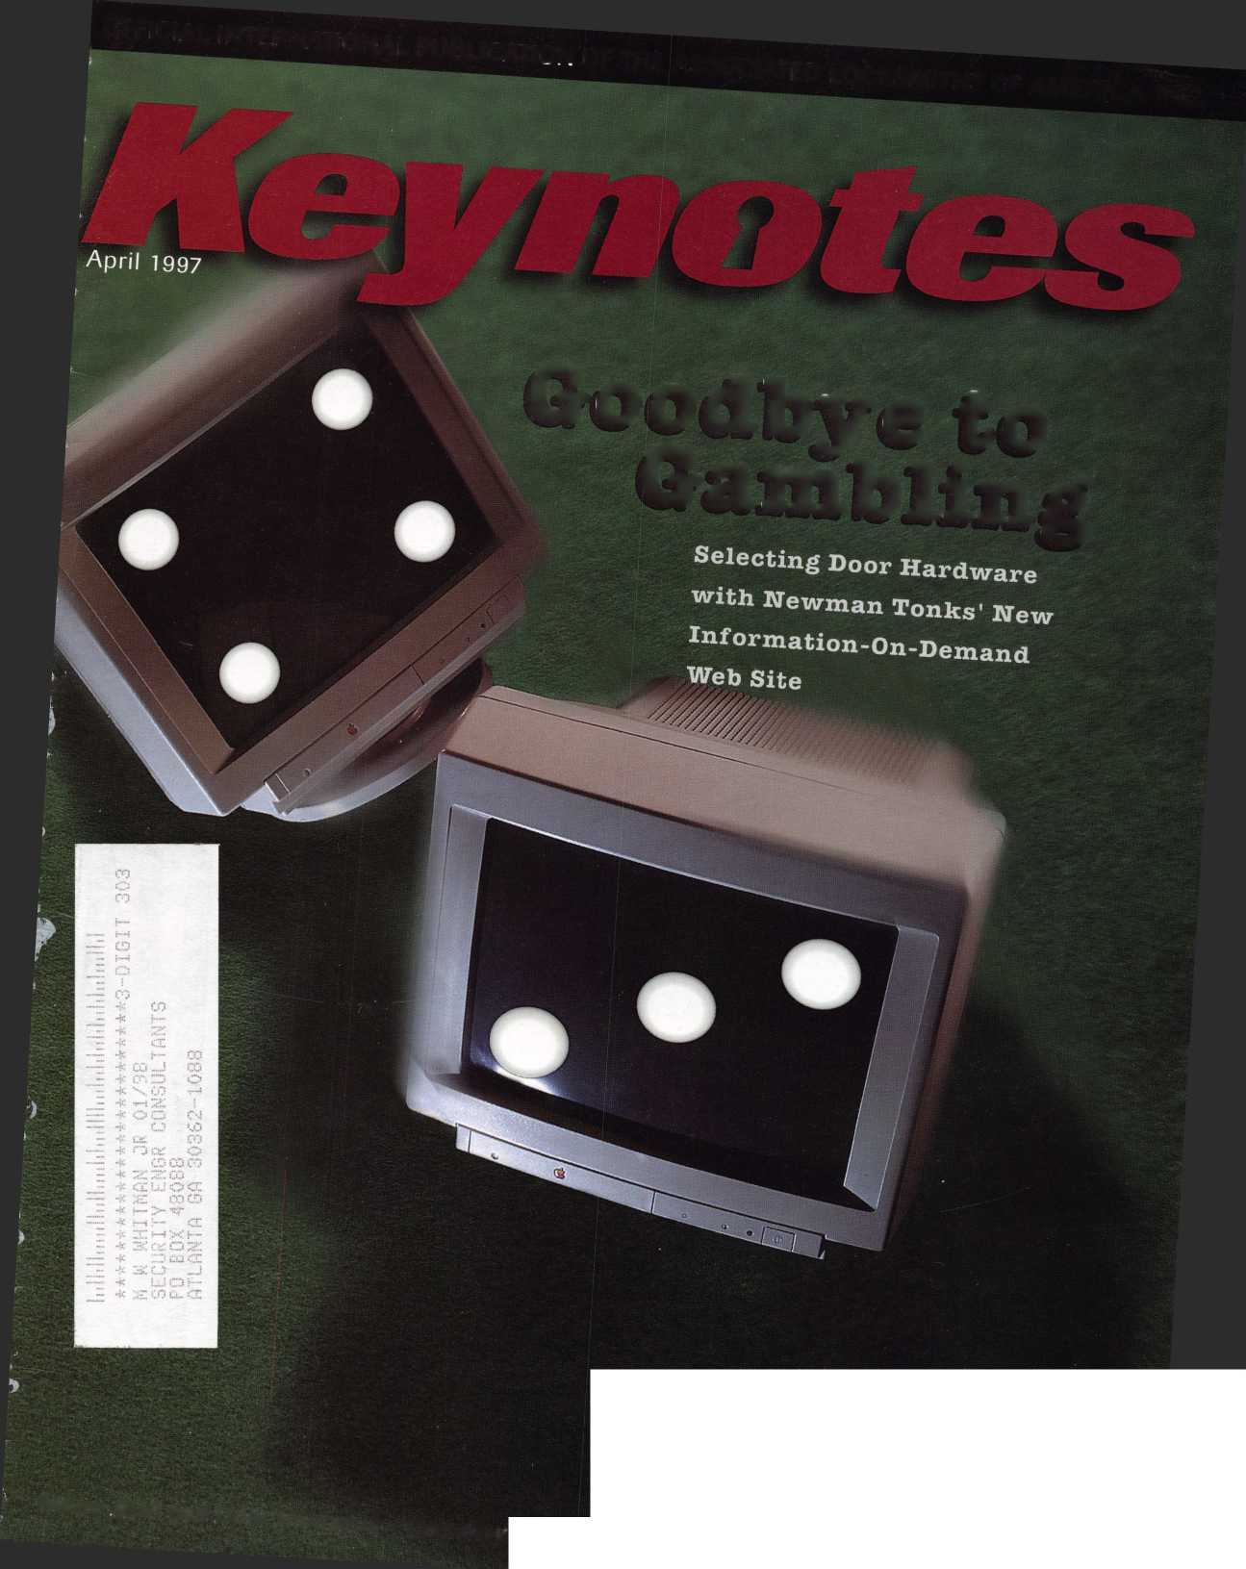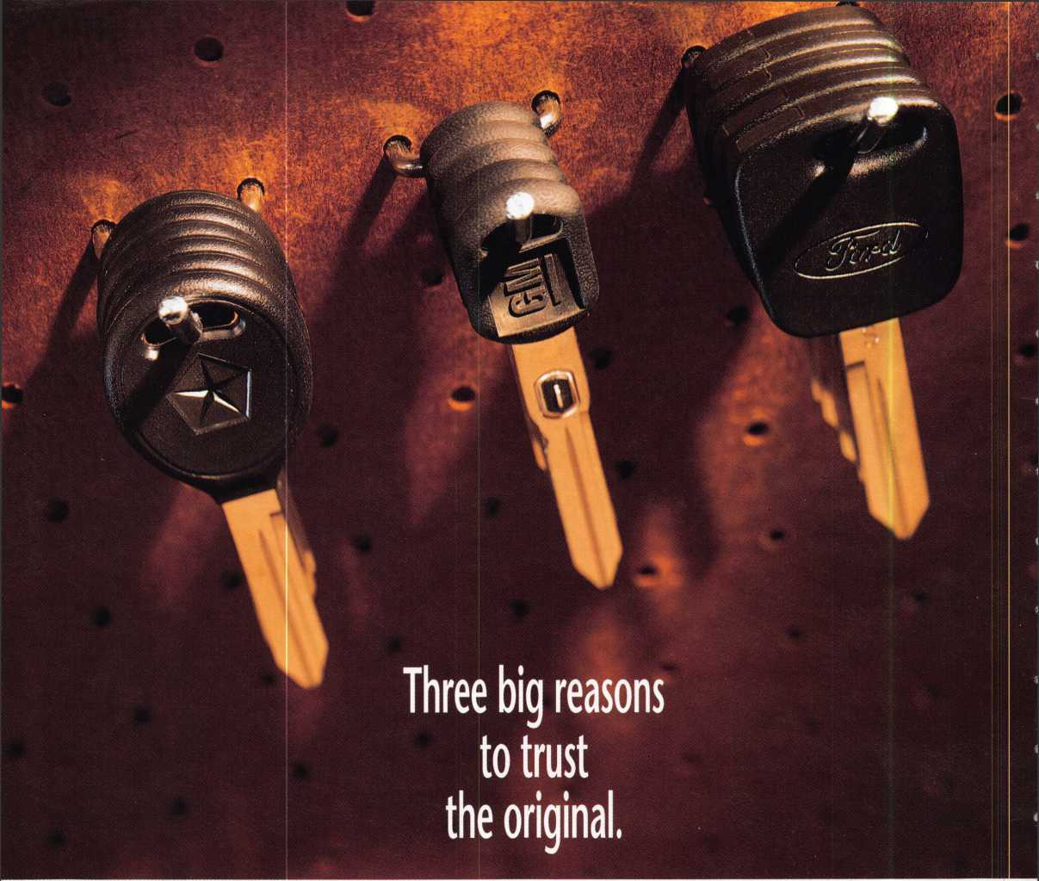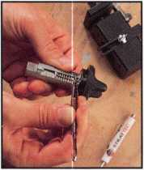

Quality. Availability. Serviceability. That's the big three STRATTEC offers to every customer,  
from Detroit's largest automaker... to locksmiths like you.

STRATTEC is the lock and key supplier for over 80 models—going back more than 15 years.  
So you can offer your customers the security and peace-of-mind they can only get with genuine  
original equipment parts. And whether automotive work is the lion's share of your business or a  
profitable sideline, you get added security, too. The security of knowing you've given your customer  
all the best—doing your best work—installing the very best parts available.

We make fifty million locks every year, to the most exacting standards in the industry...  
and all our know-how goes into every STRATTEC'" part you install. We offer information and training  
to help you stay on top of a rapidly changing business. We want to make it easy to put your trust  
in STRATTEC. Just like your customers trust you.

Call your distributor for all your STRATTEC parts. And for your  
free copy of our Professional's Choice Catalog, with complete applications  
back to the '83 model year, call STRATTEC at 414-479-8038.

**STRATTEC**

It's your reputation. Trust the original.

©1997 STRATTEC SECURITY CORPORATION. All Rights Reserved.

**WITH QUESTIONS OR COMMENTS CONTACT:**

**ASSOCIATED LOCKSMITHS OF AMERICA, INC 3003 LIVE OAK ST.**

**DALLAS, TEXAS 75204**

**214-827-1701**

**800-532-2562**

UTION

**ALOA 97 ND SECURITY XPO**

**UGUST 2,1997 CONVENTION CENTER DTEL**

**RENO, NEVADA**

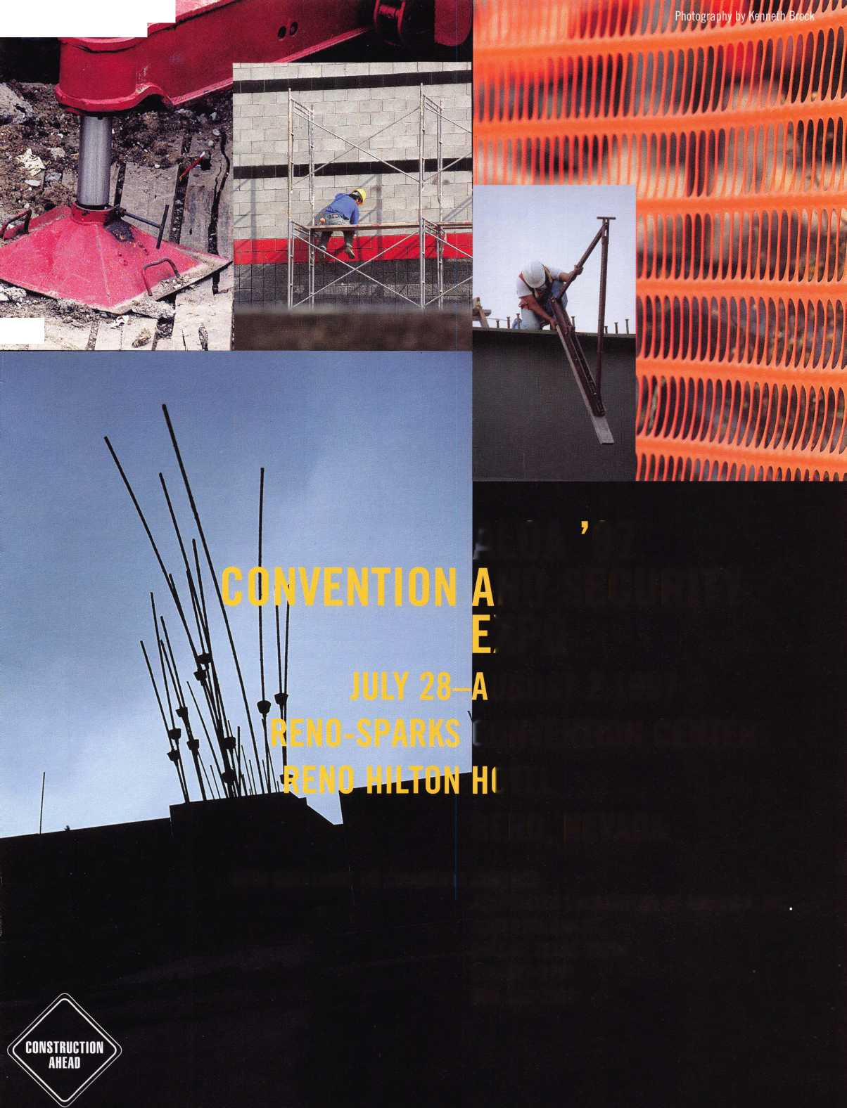

A Word With

)aviri I owell

Shared knowledge is one mark of a confident, growing, productive association

The ALOA spring board meeting just adjourned—be sure to check out the details in  
May’s issue. The ongoing projects we discussed include ALOA’s developing strategic plan;  
the ongoing membership recruitment drive; the legislative fundraising efforts slated to  
begin this spring; the membership-wide opinion survey that you will be receiving shortly;  
and, of course, the ALOA ’97 Security Expo and Convention. You’ve been mailed your con-  
vention brochure by now. Don’t waste a minute in selecting your classes (some fill up fast),  
and in making your plane and hotel reservations.

The April door and hardware issue seems like a good time to talk about the relationship  
between our vocation and that of the professionals who belong to DHI (the Door and  
Hardware Institute). As some of you are aware, ALOA has taken steps to ensure that DHI  
members are aware of locksmithing services, and of the benefits of joining professional forces  
to provide the best in physical security. While some ALOA members are also highly trained  
door specialists ... and while some DHI members are also proficient locksmiths ... those two  
scenarios are not necessarily the norm. A number of ALOA and DHI members are at skill  
levels where they could profit from the expertise of the other. And—thanks to a mutually  
beneficial advertising trade agreement with DHI—their members have now been invited to  
attend ALOA ’97 in Reno to further learn how our various skills and responsibilities some-  
times overlap. I would like to encourage those ALOA members attending convention (and I  
hope there are many) to interact with these fellow professionals as they learn more about  
locksmiths and locksmithing. Let’s leave them with a wonderful impression and give them  
lots of new ideas to take back to their businesses. Let’s make each attending DHI member  
feel positive about picking up the phone and calling a locksmith if the need arises in their  
jobs. Remember—shared knowledge is one mark of a confident, growing, productive associ-  
ation. Have you ever watched geese flying in their usual “V” formation? Scientists have  
learned that each bird, by flapping its wings, creates an uplift for the bird that follows.  
Together, the flock as a whole gains about 70 percent greater flying range that if they were  
journeying alone. I think this is a philosophy we should keep in mind as we support ALOA,  
support each other, and partner with related associations.

Until next month, keep flying high.

-David Lowell, CML, CMS

Keynotes

April 1997

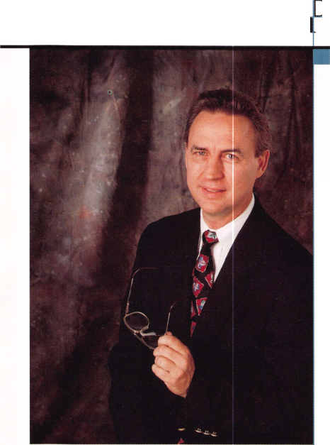

|  |  |
| --- | --- |
| /stefh — _ |7 ^_: | Board |
| Executive |  |
| Editor Anne McDonald Davis, ABC j  Associate Editor Laurie Kline  Art Director/Designer Derek Holiman | mm  m |

Advertising Sales Contributing Authors

Publications Committee

ALOA Professional Staff

Staff Administrator Office Manager Receptionist Comptroller Financial Assistant Associate Executive Director Meetings & Education Coordinator Administrative Assistant Membership Coordinator Mailroom Assistant

Mary Sadler

Anelia M. Banda

Jerome V. Andrews, CML

Charles Cameron,CML

Paul Chandler, CRL

Claire Cohen, CML

Don Coleman, CPL, CPP

Bob De Weese, CPL

Ray D’Adamo, CML

Sal Dulcamaro, CML

Joe Esposito, CML

James Glazier, CML

Jon Griswold, CML

AJ. Hoffman, CML

Ken Holmlund, CRL

Tom Hood, CML

Richard A. Lacy, CPL

Barry Leas, CRL

Ray Lusk, CML

Mark Ohno

David Parrott

Henry H. Printz,CML

Randy Simpson, CML

Robert Stafford, CPL

Dave Thielen

James Watt, CML, CPS

John D. Cannon, CML, Chairman

Jerome Andrews, CML

A J. Hoffman, CML

Tony Ramunno, CML, CPS

Donald E. Rule', CML

James Watt, CML, CPS

Evelyn Wersonick, CML, CPS (Trustee)

Charles W. Gibson, Jr.

Mary May

Margo E. Vela

Kathy J. Romo

Debra Bradshaw

Carmen D. Murphey, CMP

Jessica Vasquez

Janelle Vergara

Brandon Durrett

Jesse Morales Jr.

Complete address and phone number listings for the ALOA Board and Keynotes authors are available in your membership directory or by contacting the ALOA office at [214]827-1701



Mission Statement: The Associated Locksmiths of America, Inc. is dedicated to enhancing the professionalism, education and ethics among locksmiths and those in related sectors of the physical security industry. With approximately 10,000 members in the United States, Canada and the freeworld, ALOA is poised to help members obtain the knowledge, the strength, and the confidence to perform their role in the physical security field with pride and dignity. But it is only through active involvement and participation that ALOA can fully achieve its potential-and can help members to achieve theirs.

Policies: Keynotes® is the official publication of the Associated Locksmiths of America, Inc. (ALOA). Keynotes® acts as a moderator without approving, disap­proving, or guaranteeing the validity or accuracy of any data, claim, or opinion appearing under a byline or obtained or quoted from an acknowledged source. The opinions expressed by the authors do not necessarily reflect the official views of ALOA. Also, appearance of advertisements and new products or service information does not constitute an endorsement of products or services featured by the Association. The Association does not accept responsibility for the inac­curacy of any data, claim, or opinion appearing in this publication, due to typographical errors on the part of the authors, Association staff or its agents.

Editor’s Note: This publication is designed to provide accurate and authoritative information in regard to the subject matter covered. It is provided and dis­seminated with the understanding that the publisher is not engaged in rendering legal or other professional services. If legal advice and other expert assistance is required, the services of a competent professional should be sought.

Authors’ Payment: Effective Nov. 1, 1995, payment will be made for original articles submitted exclusively to Keynotes® magazine at a rate of: technical arti­cles—$75 per page, double-spaced with standard one-inch margins; and business/human interest articles-$50 per page, double-spaced with standard one- inch margins. (If only a portion of an eligible article is published, payment will be made for that portion only.) Authors will be paid $10 for each photograph, chart, exhibit or illustration that is utilized for their article. Maximum payment for both copy and photos is $350 for technical articles and $150 for business/human interest articles.

Payment will not be offered for articles submitted by ALOA employees or members of the ALOA Board of Directors (unless material is of a technical nature), nor for articles submitted by a company that promote that company’s products or services. ALOA reserves the right not to pay for articles submitted by an individ­uals) that promote a particular company’s products or services.

Disclaimer: The Associated Locksmiths of America, Inc., (ALOA), reserves the right to refuse any article for any reason. Additionally, ALOA reserves the right to edit, amend or modify any article submitted for publication in order to preserve technical accuracy, clarity, fairness or grammatical correctness. ALOA will make the best efforts to notify the author of any changes. The extent of ALOA’s liability for any article or information contained therein will be a notice of correc­tion or retraction in the next possible issue.

Keynotes® (ISSN 0277 0792) is published monthly except for the combined July/August issue by The Associated Locksmiths of America, Inc., 3003 Live Oak St., Dallas, TX 75204-6186. Telephone: (214) 827-1701; FAX (214) 827-1810; e-mail [aloa@anet-dfw.com](mailto:aloa@anet-dfw.com). Subscription rates for members-$15.00 per year. Second class postage paid at Dallas, Texas. POSTMASTER: Send address changes to: Keynotes, 3003 Live Oak St„ Dallas, TX 75204-6186. © Copyright 1997, All rights reserved. No part of the contents may be reproduced or reprinted in any form without prior written permission of the publisher.

President

David M. Lowell, CML, CMS (602) 263-7716

Regional Vice Presidents Southeast

Dallas C. Brooks

Chairman: Finance Committee

(334) 826-8990

North Central

David A. Paulsrud, Sr., CML

Chairman: ALOA Scholarship Foundation, Inc.

(612) 533-6164

South Central

Carl King. CML

Chairman: Bylaws Committee

Curator: ALOA Museum

(713) 465-2500

Southwest

John I. Shandy, CML

Chairman: Membership Committee

(303) 443-9740

Northeast

John D. Cannon, CML

Chairman: Publications Committee

(703) 960-6413

Northwest

James M. Watt, CML, CPS Chairman: PRP Committee (406) 549-7667

Secretary

Ricardo Ohmit, CML (217) 384-6006

Trustees:

Breck H. Camp, CML, Chairman

(770) 455-6244

Henry H. Printz, CML

(201) 538-2737

Evelyn V. Wersonick, CML, CPS

(505) 247-9413

Leonard J. Passarello, CPL

(416) 752-7210

Edwin Toepfer, RL

(416) 225-5589

Directors

Dana L. Barnum, CML Chairman: Chapters Committee (610) 565-9900 Mark E. Blum, CML, CPS (517) 482-5809 James H. Glazier, CML Chairman: Education Committee (301) 831-5454 John J. Greenan

Chairman: Legislative Committee (773) 486-2030 Barry K. Leas, CRL (610) 272-9292 Raymond C. Lusk, CML Chairman: Convention Committee (509) 624-3152 Jeffrey S. Nunberg, CML (305) 324-8800

Anthony J. Ramunno, CML, CPS Chairman: Library/Museum Committee (330) 782-6204 Randy L. Simpson, CML Chairman: Public Relations Committee

1. 780-7026 Robert H. Stafford, CPL Chairman: Grievance Committee (860) 768-7917

William T. Straub, CML

1. 779-0383 Bruce J. Tarbet, CML (601) 924-4184

Chairmen of International Affairs

Laurence P. Mills Australia (129) 958-0445 Hans Mejlshede, CML Europe

Members-at-Large

Jerome V. Andrews, CML

(860) 621-3601

Steven G. Engel, CML, CPP

Chairman: Strategic Planning Committee

(414) 731-5400

Thomas Freehling, CML

(320) 629-6538

AJ. Hoffman, CML

(714) 474-8877

J. Thomas Hood, CML

(610) 539-9555

Donald E. Rule', CML

(601) 324-2658

April 1997

***Keynotes * 3**

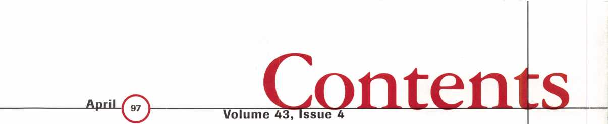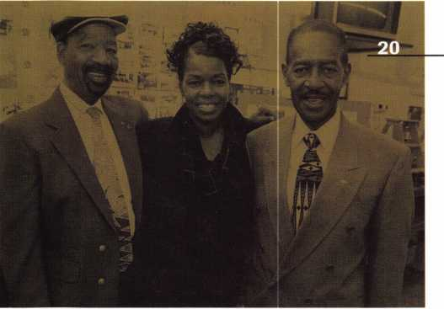

2

A Word with David Lowell

o

o

9

Legislative Comment

Be Active By John Greenan, CPL, CPS

Under Construction

ALOA ’97: Getting Closer By Carmen D. Murphey,

CMP

52

PRP Report

Making Informed Choices By James Watt, CML, CPS

57

Focus on Education

The spotlight’s on three biggies By James Glazier, CML

59

Chapter News

Solutions lead to results By Dana Barnum, CML

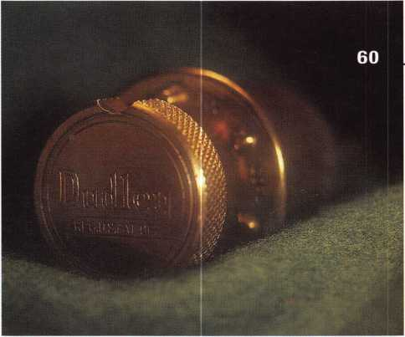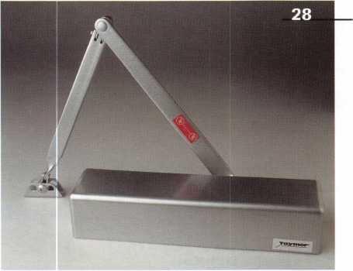

6Q

Mailbox CD

Some restrictions may applj □

,BD

a

Upcoming Events

12

Applicants for Membership

Scheduled for clearance by May 1

13

Industry News

llco/Silca have officially joined forces

14

Security Marketplace

Check out these innovations

**3**

**CD**

**3**

c/>

55

ALOA Extra

Time for the annual contest

60

Back Page

Good ideas that never caught on

44

Associate Members

49

Classifieds

54

Buyers Guide

55

Ad Index



Keynotes

April 1997

**Advertising**

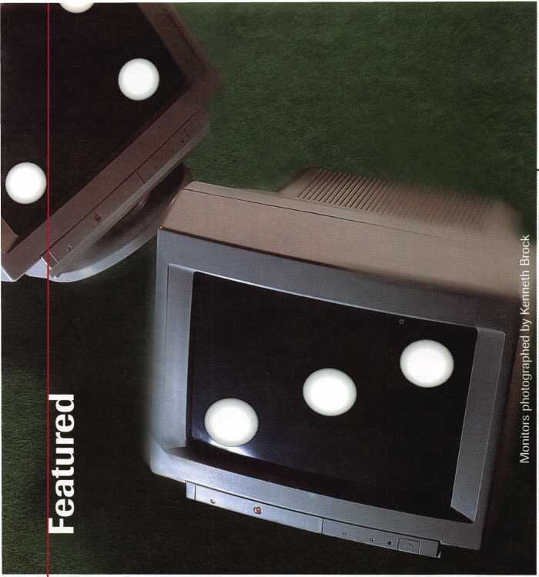

Featured:also

20

**Edwin’s Golden Opportunity**

Business sense and business savvy, and a great personality to

boot. Meet Edwin Scott and his secret to success.

By Laurie Kline

34

**The ALOA Mentor Program**

The ALOA mentor program gives newcomers what they  
need to succeed. Find out how you can be a part of this  
innovative program.

By Bob De Weese, CPL

36

**Impressioning, Part Three**

The final segment on the process of impressioning.

By Sal Dulcamara, CML

30

Cover

**<http://www.newmantonks.com>**

Searching for the right door hardware? There’s no gamble, thanks to the Newman Tonk’s Information-on-Demand web

page. Get the on-line scoop that saves you valuable time.

By Lisa Manning

17

**The Complete Door**

When it comes to taking the PRP, the best preparation is thorough. Learn tips on mastering the door hardware section and score high in your career too.

By Claire Cohen, CML

23

**Alarm Will Sound**

A look at several high security exit devices for commercial buildings. Learn about products that’ll help you boost securi­ty while staying within regulation guidelines.

By Paul F. Chandler, CRL

26

**All of the Above**

Interested in knowing how to covert an overhead stop/holder to suit your needs? You’ve got several choices because these units are versatile.

By Donnell Siebert

28

**Americans With Disabilities Act: It’s Your Business**

Find out how profitable a little information, and action, can really be. And the installation of door hardware plays a key role.

By Tom Winterhalter

April 1997

Keynotes

5

Keynotes

Mail Box



[Dept]

**If you have an opinion to offer on the letter(s) printed in Keynotes each month, let us know! Submissions to the “Keynotes Mail Box” department are printed on a space-available basis. Write to: Keynotes Mail Box;**

**Associated Locksmiths of America, Inc.; 3003 Live Oak Street; Dallas TX 75204; or FAX (214) 827-1810.**

Good Job

Dear Editor:

I’m writing in response to your article, “Higher Learning” in the February 1997 issue of Keynotes. If you don’t know it already, he [Bob Stafford] was right on the money. Everything he noted is true—for every institution, I’m sure.

I’m a security systems technician with the University of Alabama at Birmingham (UAB) Police/Physical Security Unit. We are the locksmiths, card access, CCTV, digi­tal alarms systems and key control depart­ment for this major state university. The campus virtually covers the entire south side of metropolitan Birmingham, with other properties scattered all over the state.

We are the largest employer in the city. The university has an average undergraduate enrollment of over 10,000, as well as an extremely large medical school and exten­sive research facilities. All of us here have read the article and applaud it. We have 10 technicians, four clerical personnel and two assistants who lock and unlock the campus. And our supervisor.

I know most of our technicians are ALOA members. Five of us, including myself, are NBFAA Level II, certified alarm technicians. Five of our technicians have attended the Advanced Physical Security Training Program at the Federal Law Enforcement Training Center in Glenco, GA. As you can see, we are an extremely diverse group of technicians.

Mike Cobb #024283

License Required

This letter refers to the January 1997 Keynotes article, “Saf-T-Lok: Security for Handguns. ”

Dear Editor:

Stop! Your article on installing a Saf-T- Lok is in violation of Title 27 C.F.R. Part 178 Federal Code, Sub D. 178.41 Requir­ing a Federal Firearms License before work­ing on any gun.

Before you can do any work on any firearm, you must have a valid FFL in your possession. This includes cleaning, repair or

any modification for any firearm, regardless of ownership.

Installing a lock on a firearm involving the modification of the trigger/sear/inter­rupter/and hammer chain is gunsmithing. As such, it will require the above license.

Doing gunsmithing work without the proper training will expose you to a very large liability problem. If you are modifying the manufacturer’s original specifications, you could make the firearm unsafe.

Doing this type of work without the required FFL will make you subject to BATF enforcement. They don’t care how you got into this problem.

You don’t have to have a license from the Feds to do this, but you will spend a bit of time at Club Fed if you do it.

Mark B. Fridl, RUCMCL Owner, Northwestern Lock Service

Information On the Way

(Response from Sal Dulcamaro, CML, author of the article, uSaf-T-Lok: Security for Handguns ”)

Dear Editor:

Mr. Fridl’s letter legitimately calls atten­tion to the potential risks of working on handguns. His letter got me to make a few phone calls to see if all his fears and warn­ings are valid in relation to the Saf-T-Lok.

First, let me emphasize that my field of expertise is locks and not guns. I will pre­sume Mr. Fridl to be much more knowl­edgeable about handguns since he is a gun­smith. I called my local office of the Bureau of Alcohol, Tobacco and Firearms (BATF), and the person I spoke with wasn’t aware of any particular regulations in regards to installing such a lock on a gun. She suggest­ed that I call Washington, D.C., and then proceeded to give me the phone number. I spoke to someone at the Washington BATF office, and I described (as best I could) the nature of the locking device and how it was attached to the gun. From my description, he seemed to think that it might be possi­ble to be able to install the locks without a Federal Firearms License (FFL). He was very clear, though, that he had no authority to provide such an opinion. I think anyone

reading this should also presume that there was no official endorsement of that point.

I think I can only say one thing with a fair amount of certainty. An FFL is almost certainly required for anyone who takes cus­tody of a customer’s handgun. The possible confusion is whether or not, if the customer is present at the time, you can do an instal­lation on the gun without possessing an FFL. The BATF person who I spoke with was not certain and suggested I submit it to someone who had the authority to make such a decision.

For the time being, I would suggest due caution—if you are doing more than selling the locks—and let the customer do the installation. I have sent in the request for an authoritative opinion, and will submit the response of BATF to Keynotes when I receive it. I know the government does not operate at the speed of lighting, so I cannot guaran­tee how long before such a response is made. Sal Dulcamaro, CML

Belittled by Treskat

Dear Editor:

I would just like to say that I’m very dis­appointed with the manner in which I was treated by Mr. Ray Nazzaro of Treskat USA, in Kissimmee, FL. It began with me asking in the wrong terms, how much RAM does a particular program require. Well, by the end of the conversation, I felt like an idiot. I’m not a computer whiz—I’m a locksmith (18 years). I am a computer user, but I’m not an idiot. My company has two of Treskat’s programs and I was considering another ($679)- I don’t think so.

Mr. Nazzaro, you not only lost this sale, but you’ve also lost my word of mouth (now bad mouth) and you’re about to lose your spot in my computer. I’ll be replacing your programs—you’re not the only supplier of invoicing programs, codes or any others. I would strongly suggest that you change your attitude on the phone, or you may lose more than just my account. You need to be a little more patient with your customers as some of us learn how to use your programs. Not learn how the computers work—I

6 | Keynotes

April 1997

don’t care how it works, as long as it works. When it doesn’t, I call someone who knows how they work and they fix it. I fix locks. You got a problem with locks? You call me. I got a problem with a program? I call you.

I like to treat and be treated fairly and equally by all my cus­tomers and distributors alike, and with both, when a bad apple comes along, I throw it away.

I wish you no ill, but I can not do business with you any longer.

Kevin Pratt, CPL

Mr. Nazzaro was contacted for a response and although his explanation for the misunderstanding with Mr. Pratt seems reasonable, Mr. Nazzaro did not authorize his letter for publi­cation.

News From Massachusetts

The following excerpts are from **Martha’s Vineyard Times.**

Locksmith’s Advice

Dear Editor:

If you can easily lock yourself out of your house, please call a locksmith—a security profes­sional who is bonded, insured and trained to provide emer­gency service. Your locksmith can recommend the type of locks that won’t lock you out when you close the door.

Do you have a spare key stored with a trusted neighbor? Keep a spare backup key in case of emergency.

To find out more about your security, get in touch with your local police department, or look in the Yellow Pages.

Vincent P. Chestnut Owner, Alpha Locksmith

Upcoming

EverTts



Dept)

April f97

5 & 6

Grand Canyon Chapter ACE Safe Manipulation Class Bostrom High School Phoenix, AZ Contact: John Ilk (520) 474-0147 (work)

(520) 474-8879 (home)

(602) 420-2174 (pager)

7-11

mark bates Associates 5 Day D.O.D./D.O.E. Combination Lock Training (888) 622-5495

13

Yankee Security Convention, Inc.

The Yankee Bargain Hunter Sturbridge Host Hotel Sturbridge, MA Contact: (800) 209-8266

17-21

Master Locksmith Assoc, of New Jersey Somerset, NJ Contact: (201) 267-8884

19

Vindicator Corporation Training Classes for Microlock Contact: Tamara Martell (512)314-1200 [lock@vind.com](mailto:lock@vind.com)

24-27

Professional Locksmith Associa­tion of Alberta 1997 Convention and Trade Show

Red Deer Lodge Red Deer, Alberta Contact: Dave Kennedy (403) 948-9997 (FAX)

4-28

Wisconsin Indianhead Chapter

Educational Seminar Bestwestern Midway Hotel Eau Claire, WI Contact: John Dorsey (715) 832-4207

May ’97

16

Vindicator Corporation • Training Classes for Vindica­tor Lock II

Contact: Tamara Martell

(512)314-1200

[lock@vind.com](mailto:lock@vind.com)

18

Yankee Security Convention, Inc.

Weekend Express Education Seminars

Sturbridge Host Hotel Sturbridge, MA Contact: (800) 209-8266

19-23

mark Bates Associates 5 Day D.O.D./D.O.E. Combination Lock Training (888) 622-5495

June ’97

i

California Locksmiths’ Associa­tion

Sacramento Valley Chapter SWAP Meet, Trade Show, Lock­smith classes SES Hall

10427 Stockton Blvd.

Elk Grove, CA Contact: Joe Longoria (916) 391-1744

1

3rd Annual Locksmith Swap Meet and Olympics Quality Inn Lyndhurst, NJ Contact: Jeff Sitar **(**201**)** 777-0620

Future Conventions

1997

ALOA ’97 July 28-Aug. 2 Reno, NV

SAFETECH ’97 May 5-10 Louisville, KY

SERLAC Sept. 24-28 Grenelefe, FL

24th Annual Tri-Regional Security Conference Oct. 21-26 Bellevue, WA

1. ALOA ’98 June 15-20 Nashville, TN

SAFETECH ’98 May 4-9 Valley Forge, PA

1. ALOA ’99 July 25-31 Cincinnati, OH

SAFETECH ’99 May 3-8 Las Vegas, NV

2000

ALOA 2000 Date TBA Las Vegas, NV

SAFETECH 2000 May 8-13 Lexington, KY

2001

ALOA 2001 July 15-21 Baltimore, MD

For PRP dates, see p. 52. For ACE dates, seep. 57. Send in the dates of your organization’s activi­ties today!

J

April 1997

***Keynotes***

The Price Is Right!

The Mas-Hamilton Auditcon™ can save  
your customer thousands by preventing  
internal & external theft. Now YOU can  
receive valuable discounts on the  
Auditcon™ System from the  
Mas-Hamilton Group!

— Through July 31,1997 Receive This  
Money Saving oner:

One Day Training $125^

Auditcon Mounted On A Stand $73fr

Auditcon Software Package $15fr

Set of “Smart Keys” $19 Each

A Set of (12) $25 Coupons $366-

A Total retail value of $1,328...

All this can be yours for the  
low Price of $300

For more information please contact your local Mas-Hamilton Distributor or Michelle  
Vaughn at 1-800-950-4744 ext. 156 or Angel Gifford ext. 110 or mail to Mas-Hamilton  
Group 805-D Newtown Circle, Lexington, KY 40511 [www.mas-hamilton.com](http://www.mas-hamilton.com)

Upon completion of the training class, each attendee will receive a coupon book  
containing 12 coupons valued at $25 each.

Through July 31,1997 Mas-Hamilton is offering to locksmiths, a one day training class plus a lock on a stand, set of smart keys, and  
the PC software/interface, for $300. Included in the class a sales and marketing presentation on potential customers and financial  
justification for the Auditcon System. Coupons redeemable one for each lock you purchase. Expiration of the coupons is 12/31/97.

Free Information - Reader Service Card #2

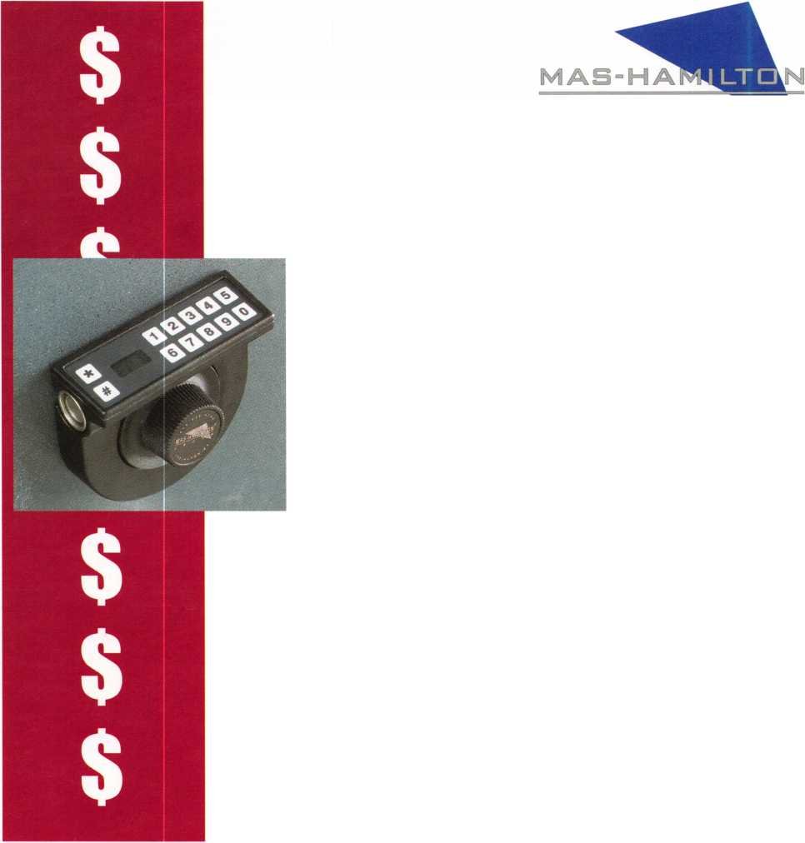

Legislative^

omment

ToKr^n!jreenan Committee Chairman

Contact your state capital and request a copy of the bill

On Thursday, Feb. 20, 1997, the ALOA Legislative Committee met with NLSA representatives, president Don Bradford and Legislative chairman Howard Johnsen in Chicago. Discussion was held on how ALOA and the NLSA could possibly work together on legislative issues that may affect the locksmith industry. The ALOA Legislative Committee has agreed to provide NLSA with copies of our monitor­ing service’s weekly reports.

Last month, we printed a list of legislation that is being consid­ered in many of the state legislatures. If there was a bill in your state, you can contact your state capital and request a copy of the bill.

After reviewing the bill, you should contact your legislators to express your opinions on these bills. If you have any questions or need some assistance, please contact myself or Charles Gibson at the ALOA headquarters.

We have arranged with our monitoring service to have the weekly reports on the ALOA web page. This will give locksmiths the most up-to-date information available. The weekly reports include newly submitted legislation and movement on any of the bills that we have identified as having potential affects on the locksmith industry. You can access the ALOA web page at ALOA.ORG.

We will also be contracting locksmiths who have signed up on the Legislative Action Contact Network with information on bills in their states. If you have not signed on yet, please do so today so that we can keep you informed on legislation in your state.

We’re still looking for volunteers to work on legislative issues, raise funds for the legislative effort and to gather or give information in this cmcial area. If you are willing to commit a little or alot of your time, contact ALOA at (214) 827-1701 or FAX (214) 827-1810. Remember—we’re counting on you—you can make a difference.

m About the Chairman: John J. Greenan represents the fifth gener-

ation of locksmiths and is vice president of Fink Safe & Lock in Chicago, IL.

A locksmith since 1985, John also serves on ALOA’s Convention and Strategic Planning committees. He is also chairman of the Allied Locksmiths of Illinois.

**STOCK THE PATIO DOOR  
LOCK THAT SURPASSES  
ALL OTHERS IN**

DURABILITY

**AND**

QUALITY!

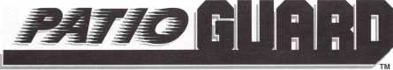

**COMBINATION HOOK LATCH & DEADBOLT**

**EASY INSTALLATION. ^ ^ ^**

* **SMOOTH OPERATION.**
* **MADE OF STEEL AND ALUMINUM.**
* **ALUMINUM, ANTIQUE BRONZE AND WHITE FINISHES.**
* **NON-HANDED.**

**ALSO USED FOR:**

Camper Tops, Pocket Doors,

Storm Doors, Cabinets, French Doors,

Mobil Homes and Recreational Vehicles.

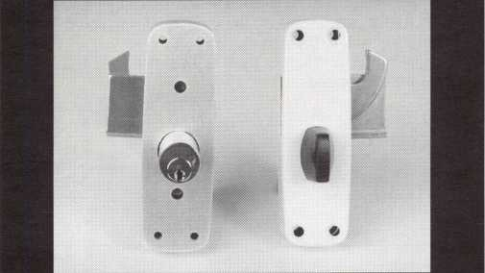

**Call Today For A Distributor Near You**

1*800*397-4631

A Division Of

MIWA Lock USA, Las Vegas, NV

Reader Service #3 April 1997

Keynotes

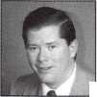

***Do you belong in the***

ALOA

President’s

Club?

How can I join the President’s Club?

You can earn membership in this  
prestigious club by recruiting just  
10 new members for ALOA.

Any ALOA member may participate.*

What do I get?

When you recruit 10 members, you receive a handsome blue blazer with  
a President’s Club crest. For each additional five members you recruit,  
you receive a lapel pin with gold-filled numbers, indicating your  
recruiting successes.

You also get the satisfaction of knowing that

you are helping your association, helping your industry grow, and you  
are helping fellow locksmiths achieve success.

How do I get started?

Contact the ALOA office for a supply of applications. One President’s  
Club credit is awarded for each new applicant. Credit is awarded only  
after the membership application is approved. However, the credit will  
apply for the period in which the application is received. Failure to  
identify yourself as the sponsor on

the application form at the time it is submitted to ALOA for processing  
will forfeit any credit.

*ALOA Board of Directors not eligible for membership in the  
President's Club.

|  |  |  |
| --- | --- | --- |
|  | PRESIDENT'S CLUB ROSTER | |
| 131 Members | 013186 | Kwok-kei Leung |
| 73 Members | 019882 | Henry Raymond |
| 67 Members | 005354 | Stewart Levine, CML |
| 58 Members | 012566 | Mary Ohmit, CPL |
| 50 Members | 022598 | Allen Konrath |
| 41 Members | ...012103 | Jack Hobin, CPL |
| 37 Members | 022907 | Toshihiro Asano |
| 36 Members | 021172 | Myeong-Rae Cho |
| 32 Members | 011133 | Salvatore Dulcamaro, CML |
| 29 Members | 006072 | Charles Robertson, CML |
| 27 Members | 008951 | William Neff, CML |
| 27 Members | 010464 | Jeanne Lodge, CML |
| 26 Members | 016675 | Roy Renderer, CML |
| 23 Members | 018521 | David Federico |
| 22 Members | 003296 | Danny Rudd, CPL |
| 22 Members | 014474 | Robert Carroll, CPL |
| 21 Members | 004371 | John Elliott, CML |
| 21 Members | 007215 | Jerome Cohen, CML |
| 20 Members | 004475 | Larry Warnick, CML |
| 20 Members | 019244 | Eugene Altobella |
| 19 Members | 019138 | Robert DeWeese, CPL |
| 18 Members | 007051 | D Lee, CPL |
| 18 Members | 009049 | John Heckman, CML |
| 18 Members | 014144 | James Fowler, CML |
| 18 Members | 014996 | David Harris, CML |
| 17 Members | 002501 | John Kerr, RL |
| 17 Members | 015283 | Ronald Heidzig |
| 16 Members | 007012 | Joseph Ferrero, CML |
| 16 Members | 008154 | Diana Barnum, CRL |
| 16 Members | 008617 | William Grant, CRL |
| 16 Members | 015696 | Barbara Watt |
| 16 Members | 018691 | Brian Reetz |
| 16 Members | 023788 | Jim Williams |
| 14 Members | 001657 | Rex Parmelee, RL |
| 14 Members | 001825 | Walter Lascar, RL |
| 14 Members | 005329 | Marian Swann, CRL |
| 14 Members | 007129 | Thomas Vandersteen, CML |
| 14 Members | 008168 | Charles Cole, CML |
| 14 Members | 008361 | James Cawby, CML |
| 14 Members | 016056 | Elvis Hammerschmidt, CPL |
| 13 Members | 007009 | John Dorsey, CPL |
| 13 Members | 008916 | James Gruber |
| 13 Members | 009172 | Peter Gauthier, CPL |
| 13 Members | 022358 | Russell Fuller, CRL |
| 12 Members | 000712 | Edwin Scott |
| 12 Members | 004361 | Robert Rodocker, CRL |
| 12 Members | 015305 | Lonnie McKinney, CML |
| 11 Members | 003430 | Lawrence Smith, CML |
| 11 Members | 009546 | Gary Teams, CPL |
| 11 Members | 010266 | William McElheney CML |
| 11 Members | 010909 | Rolando Bouza |
| 11 Members | 016525 | Philip Rovenolt, CPL |
| 11 Members | 018034 | Michael Robinson, CRL |
| 11 Members | 018805 | Robin Horsley |
| 10 Members | 004993 | Ernest Wright |
| 10 Members | 009305 | Frank Hartung, CML |
| 10 Members | 009482 | Lester Brodsky |
| 10 Members | 010602 | Herbert Dusenberry CML |
| 10 Members | 011316 | Robert Duman, CML |
| 10 Members | 016726 | Dale Knowles, CPL |

Yes! I want to join the ALOA President’s Club.

Please rush meapplications so I can start now to earn credit toward membership in the ALOA President’s club!

Name:

Company:

Address:

City: State: Zip:

Got your membership or class certificate thumb-tacked on the wall? Short of renting a spotlight and a billboard, a wooden pocket plaque is the coolest way to bring attention to your ALOA accomplishments.

Get a pocket plaque and show off a little. Because ALOA firmly believes suc­cesses should be proudly displayed. But renting a skywriter might be a little much.

Pocket plaques are on sale for 12 bucks. Get 'em while they're cheap.* After all, those thumb-tack holes start off small, but they always get bigger.



Associated Locksmiths of America, Inc. 3003 Live Oak Street Dallas, TX 75204 (214) 827-1701

While Supplies Last

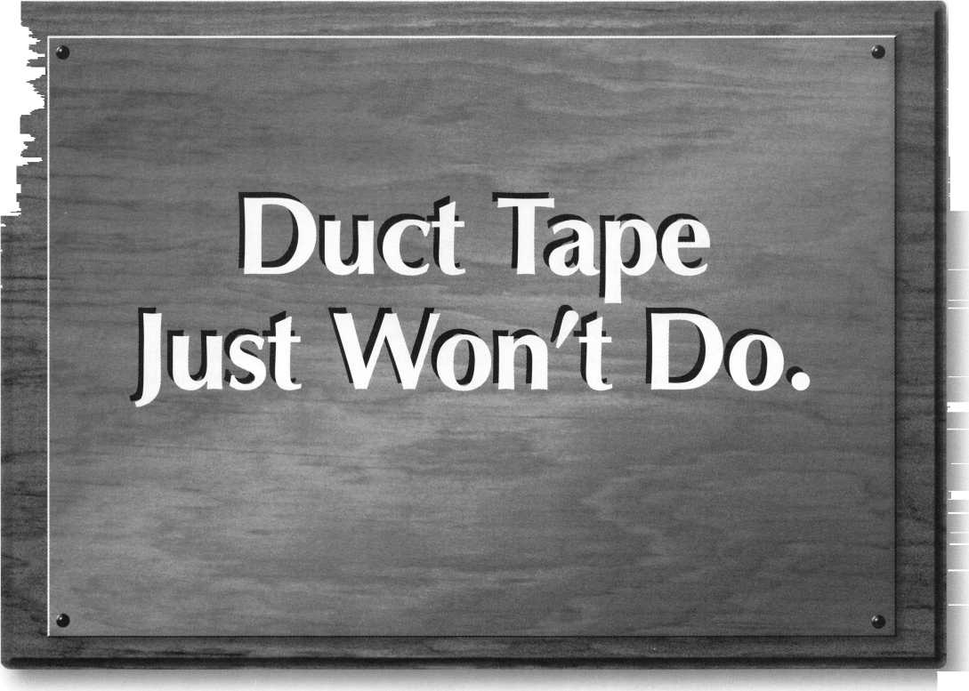

Applicants

For Membership



Dept]

***The following applicants are scheduled for clearance***

***as members of ALOA The names are published for  
member review and comment prior to May 1, 1997, to  
ensure applicants meet standards of ALOA’s Code ot  
Ethics. Protests, if any, should be addressed to the Mem-  
bership Department and must be signed\ Active Mem-  
bership applicants (A) have worked in the industry two  
or more years. Allied Membership (AL) applicants are***

***not locksmiths, but work in a security-related field.***

**Nebraska**

**Alaska**

Fairbanks

026638, John L. Harrell, A Sponsor: Peter Whitson 026639, Mark S. Moss, A Sponsor: Peter Whitson

**Arizona**

Phoenix

026674, Charles Melvin, AP 026688, Dustin R Wood, A

**California**

San Diego

026663, Michael F. Howell, A

San Francisco

026681, Lee Most, A Sponsor: Robert DeWeese

Santa Rosa

022690, Wayne M. Carrington, A

**Connecticut**

Greenwich

026640, Andrew Martin,A Sponsor: Geri Stuttig 026650, Garry Nesbitt Sponsor: Geri Stuttig

Manchester

026642, Richard T. Migliore, A

**District of Columbia**

Washington

026658, Frank E. Knight Sponsor: Clarence Wiegel

**Florida**

Spring Hill

026668, Carmine J. DeStefano, A

**Georgia**

Buford

026652, David L. Morris, A

Gainesville

026669, Volley E. Collins, A

**Hawaii**

Pearl City

026662, Alfredo H. Bacal, A

Iowa

Waterloo

026664, Chad W. Grimm, A Sponsor: Edmund Dagenais

Indiana

Anderson

026651, Gary L. Estle, A Sponsor: Jim Williams

Elkhard

026660, Kevn E. Hieber, A SPonsor: Robert Clarke

Indianapolis

026661, Lewis R. Gee, AP Sponsor: Jim Williams

Massachusettes

Acushnet

026687, Charles C. Showsky, AP

Hyde Park

026644, Michael J. O’Sullivan, A

Maryland

Hyatts

026686, Anthony A. Jones, A Sponsor: Donald Jones

Ocean City

026689, David M. Nolan, III, A

Pasadena

026647, Harold E. Fink, AP Sponsor: Robert DeWeese

Michigan

Davison

026667, Danny J. Kimosh, AP Sponsor: Salvatore Dulcamaro

Minnesota

Minneapolis

026649, Gene L. Ristvedt, AP

Pine City

026653, Nathan P. Andrews, A Sponsor: John Heckman

North Carolina

Atlantic Beach

026682, Richard D. Blum, A

Kearney

026672, Kelly D. Hardin, AP Sponsor: Charles Robertson

New Jersey

Paterson

026643, Eugene T. Bernascone, AP

New Mexico

Albuquerque

026676, David W. Straub, A

Nevada

Henderson

026654, Bruce B. Stewart, A

New York

Brooklyn

026648, Chijioke Fred, A

Ohio

Dayton

026646, John E. Johnston, A Sponsor: Mehdi Zahedi

Oklahoma

Tulsa

026645, Bradford L. Ward, A

Pennsylvania

Pittsburgh

026641, John D. Cato, AL

South Carolina

Columbia

026665, David S. Larson, AP

Tennessee

Knoxville

026675, Mary M. Peters, A Sponsor: Marian Swann

Texas

Adington

026673, David Smtih, AP Sponsor: Robert DeWeese

Atascosa

026670, John H. Rendon, A Sponsor: Joseph Fuller

Belton

026637, David R. Haire, A

Mesquite

026671, Jesse Robinson, A Sponsor: James Glazier

**Virginia**

McLean

026684, Smiley Horsley, AP Sponsor: William Breazeale

**Wisonsin**

Marshfield

026666, Douglas P. Bauer, A

**Canada**

Ontario

Collingwood

026683, Rober L. Gagne, A

Toronto

026656, Rob P. Davies, A

Willowdale

026657, Jim L. Hirlehey, A

Quebec

Greenfield Park

026677, Peter D. Johnson, A

**England** Crawley, Sussex

026685, Simon Kirkdale, A

**Japan**

Chiyoda-Ku, Tokyo

026678, Kazuhiro Aikawa, A

Fukuoka 815

026679, Wataru Ueno, A

Fukuoka 812

026680, Yoshinori Vota, A

Tennojiku, Osaka

026655, Kazuei Kitamura, A

Keynotes

April 1997

Industry

News

It’s Official

Silca and Ilco Unican have joined forces. Both companies manufacture keys, key duplicating machines and locksmith sup­plies globally.

The Silca group is headquartered in Venice and has subsidies in Germany,

France, The United Kingdom and the Unit­ed States.

This partnership allows both companies to continue to grow as industry leaders, and will enable the companies to better afford the high cost of introducing new products and technologies to the market place.

Allies

SPX Corp. and Hewlett-Packard COmpany have formed a strategic alliance to develop and market universal service solutions for the global motor vehicle service industry. Products developed will be targeted to improve productivity, customer service and quality of vehicle repair at franchised dealer­ships and aftermarket service.

On the Web

The American Society for Industrial Securi­ty (ASIS) introduces ASIS Online at <http://asisonline.org>. This web site offers direct access to all information on ASIS products and services, as well as technology resources for issues facing today’s security professionals.

Introducing a New Corporation

PRIMEX Technologies, Inc. is a new, inde­pendent corporation positioned to respond to the dynamic and competitive military, aviation and aerospace markets. This new enterprise is a result of Olin Corporation’s decision to spin-off it’s Ordnance and Aero­space divisions.

Corporate headquarters are in St. Peters­burg, Florida.

OnLine

Olympus Lock, Inc. is now online. Visit their resource link page at their web site: <http://www.olympus-lock.com>.



Now In Sales

Larry Simons has joined the DoorKing sales  
department as a regional sales manage.

Simons will be respon-  
sible for promoting  
sales in California,  
Oregon and Washing-  
ton.

Simon has 21 years of  
experience in the  
garage door and access

Larry Simons control industry. In

1975, he started his own company, Simons  
Garage Doors.

Simons will be active in the company’s  
plans for training seminars and will help to  
establish new dealers and promote products.

Jim Rowley has been  
appointed Application  
Specialist, a newly cre-  
ated position, for Sen-  
try Security Fasteners.

With 20 years of  
experience in commer-  
cial, electrical, and  
detention hardware,

Rowley has worked as a project manager  
and as a systems designer of access controls  
and electrified hardware.

New Specialist



Jim Rowley

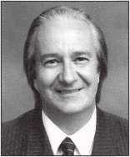

Bi-lingual Customer Service

Raquel Habib has just  
joined Security Lock  
Distributors South  
Florida customer ser-  
vice team.

Habib has worked  
in the industry for  
several years and is  
experienced in the

application and operation of access control  
hardware, including all lines that Security  
stocks.

Habib is bi-lingual and will work with customers and prospects in Latin and South America.

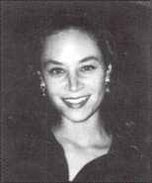

Raquel Habib

**ADI Appointees**

Tony Caputo has just been named vice pres­ident/controller of ADI. Caputo joined ADI in 1993 after over 20 years of experience as controller, general manager and vice presi­dent of a major corporation.

Sheri Bram has been promoted to vice presi­dent of Sales Administration. Bram joined ADI in 1993 as assistant to vice president of Sales. Prior to joining ADI, Bram served as marketing manager for a major industrial distributor. She holds a master’s degree in management

**Sales Manager**

Eric. A. Cechak has been named national sales manager for Dedicated Micros, Inc.

In this newly created position, Cechak will work closely with regional sales managers and manufacturers’ representatives to devel­op new markets and increase market share for the corporation.

Cechak has over 10 years of experience in the CCTV industry and holds a bachelor’s and master’s degree in business administra­tion.

**New VP**

SPX Corporation has a new Vice President, Secretary and General Council— Christopher J. Kearney.

Prior to joining SPX, Kearny was Senior Vice President and General Council of Grimes Aerospace Co. Kearney holds a bachelor’s degree from the University of Notre Dame and a law degree from DePaul University Law School.

April 1997

Keynotes

Security

Marketplace

Like the Real Thing

Samsung Opto-Electronics America intro­duces a CCTV camera that adapts to con­trast lighting the way the human eye does. The SHC-410NAD is a digital color CCD camera that uses “i Sight” technology to separately analyze and reprocess light and dark areas of an image so it can be seen as clearly as possible.

The SHC-410NAD has a built-in motion detector with alarm output, and all functions can be set by using an on-screen menu that’s controlled from a keypad on the back of the camera.

The device is compact and light weight with a 1/3-inch color CCD with 480 lines of horizontal resolution and 410,000 pixels. The SHC-410NAD will function with either AC 24V or DC 12V voltage.

For more information, contact:

Peter Sandin

Samsung Opto-Electronics America, Inc.

(201) 902-0347 ext. 121 (201) 902-9342 (FAX)

Reader Service #4

Automatic Opener

LCN introduces the new electric Auto- Equalizer, an automatic operator that opens interior and exterior doors at the touch of a button. The Auto-Equalizer has a break away function that protects the operator, door and frame from forced closings if the door is in the open position.

The unit also has a feature called “second chance.” If the door meets any resistance during the opening swing, the Auto-Equal­izer pauses for a few seconds and then tries to open the door slowly. If resistance is a momentary wind gust, the door will cycle normally. If resistance continues, it will pause, time out and then close.

The Auto-Equalizer has a “soft start” motor control that gradually applies the voltage to the motor.

For more information, contact:

LCN

(800) 326-2400 (800) 248-1460 (FAX)

Reader Service #3



Barrier of Steel

Kantero-IKA, an Israeli company specializ­ing in security systems for cars, has recently introduced a series of mechanically-operated steel barriers with safe locks. The steel barri­ers are designed to provide maximum secu­rity against automobile theft. For more information, contact:

Yosef or Ron Kantero *32 Filat St.*

Tel-Aviv, Israel 66843 972-3-682-7638(Phone)

972-3-683-7228 (Fax)

Reader Service #6

New Lock

American Lock Company introduces Verton padlocks, a series of structural composite locks engineered for lock-out applications. Verton padlocks are available with the same custom color options and imprinting capa­bilities as its aluminum padlock line. The Verton is non-conductive, lighter weight and less costly than metal.

Its bright yellow lock body color signifies “safety” in industrial setting. These locks are manufactured with a non-rekeyable, five- pin, solid brass cylinder, and a one-inch steel shackle is standard.

Verton padlocks can be custom engraved on the front and back sides.

Verton is available in eight colors.For more information, call: (800) PADLOCK Reader Service #7

First Combination

NetMedia, Inc. introduces the CAModula- tor, the first and only black and white cam­era combined with a digital video channel modulator. The modulator allows you to view the camera signal on any TV, and also combine that signal with existing cable ser­vice or other video within the home or busi­ness.

The CAModulator weights 3.5 ounces and fits in an 18+ CU. in junction box or mud ring. A 12 volt DC transformer is standard.

The unit adjusts up and down and right and left to match most installations.

For more information, contact:

NetMedia at (888) 786-8227

Reader Service #8

UL Approved

Vindicator’s MicroLock 40 has received the Type 1 Underwriter’s Laboratories mark.

The Type 1 mark is UL’s highest security listing for this type of product.

The Vindicator MicroLock 40 is a combo-key electronic safe lock. This prod­uct provides multi-door control for multiple users while maintaining a complete audit trail of all safe activity.

Standard features of the MicroLock 40 include programmable time locks and time delays, and each feature can be programmed independently for each of the four locks the MicroLock 40 can control.

For more information, contact:

Howard Dame, General Manager Vindicator Corporation (312)314-1220 [lock@vind.com](mailto:lock@vind.com) (E-mail)

Reader Service #9

Sure Lock

SureLock vehicle anti-theft computer dis­ables start mechanism. It is a fully compati­ble device that enhances all vehicle alarm systems, including Lojack. SureLock’s pro­grammable microprocessor computer system disables any electrically activated starting mechanism until the right key is inserted.

SureLock is commercially available to anyone concerned with vehicle safety and security.

For further information and pricing, con­tact:

Philip de Langis Verite’

P.O. Box 697

Harbor City, CA 90710-0697 ATTN: Department 27 (888) VERITE-2 (Phone)

(310) 346-3018 (Fax)

S urelock @worldnet.att. net *Reader Service #10*

Keynotes

April 1997

**Security**

Marketplace

New Monitor

Marshall Electronic s optical systems division introduces a four-inch Active Matrix LCD Color Video Monitor. Easily mounted to any surface, the monitor is compatible with all NTSC video signals and provides bright, high contrast color or black and white pictures.

The V-LCD4-PRO offers a wide viewing angle, compact size and low power consumption. The monitor offers separate color, bright­ness, tint controls and an on/off toggle switch.

This monitor can be used for monitoring for broadcasting, securi­ty, teleconferencing, patient rooms, babies, control access entry, RVs, trucks and merchandising displays.

For more information, contact:

Natan Mordukhay Marshall Electronics, Inc.

(310) 390-6608 (310) 391-8926 (Fax) http:/lmarshall.wincam.com *Reader Service #11*

Now Stocking

JLM Wholesale now stocks Security Door Controls Surface Mount­ed Bolt Locks. Available for a variety of application needs, these locks are designed for either single or pairs of doors and are capable of withstanding greater force than conventional electromagnetic locks. The fully enclosed 170 and 270 series are designed to mount to the top of the door frame on the push side of opening.

The locks are available in fail-safe and fail-secure models at 12 or 24 VDC. Other features door position sensors, bolt position sensors and architectural finishes.

For more information, contact: Ray Baldwin at (800) 522-2940 Reader Service **#2 2**

Linear Keypad

Linear now has a wired keypad that is weather-resistant and can be used with its AccessMaster access control system.The model AM- KP activates one relay channel and has a built-in piezo sounder that audibility confirms when a key is pressed. A red LED indicates “power” and then switches to green when a valid entry code is entered. The AM-KP is housed in a weather-resistant cast alu­minum case that call be wall or pedestal mounted. The faceplate and keys are stainless steel, and a keylock secures the keypad to its mounting backplate.

The keypad comes with a built-in downlight to illuminate in dark conditions.

For more information, contact:

Linear Corporation 2055 Corte Del Nogal Carlsbad, CA 92009 (619) 438-7000

Reader Service HI 3

NEW ILCO DISTRIBUTOR!!

Monday Security Corporation  
**1-800-886-6721**

Contact Laura for details  
on dealer discounts

We carry almost every make  
and model of new and  
used safe deposit locks,  
and safe parts, specializing  
in the antique parts.

Have you received our  
catalog?

Reader Service H14



* LCN
* Von Duprin
* ILCO
* Sargent & Greenleaf

(Arm-A-Door)

* Roton
* Detex
* Simplex
* Norton
* Stanley
* Rixson
* Glynn-Johnson
* Adams Rite
* Jackson
* Master Padlock
* Folger Adam
* Locknetics
* Rutherford

(EFF-EFF)

* Telkee

To Order Call Toll Free

Phone: 800-238-4566 • Fax: 800-538-4566



Call Or Write for our FREE Full Line Catalog

Omaha Wholesale Hardware  
P.O. Box 3628 • Omaha, Nebraska 68103



Reader Service HI5  
 April 1997

***Keynotes*** **| 13**

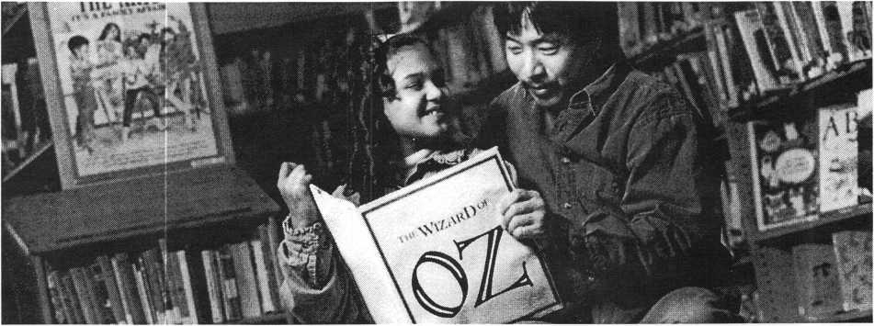

“Thanks to the  
Tin Mariy To to and Le i Tung,  
Becky o reading level  
io up two grodeo, and our  
productivity u up 21%”

-Larry Ell von, CEO, and Jim Abrahanuon, Chairman, Oracle Corporation

Employee volunteer programs benefit everyone involved.Volunteers, like Oracles Lei Tung, know they make  
a meaningful difference in someones life. Employee volunteers feel good about themselves and their company,  
which makes for improved morale and can give productivity a real boost. You can do for your employees

and your community what Oracle is doing for theirs. The Points of Light  
Foundation can help show you how. To find out more call 1-800-888-7700.

O

Points of Light

FOUNDATION

Photo: Cherry Kim

The Complete Door

Focusing on

the PRP

by Claire L. Cohen, CML

Looking at a door or locking hardware, for  
the layman, is just that—looking. But as a  
professional locksmith, many components  
that make up “the complete door” must be  
understood. The complete door is a system  
composed of many elements that work  
together. They include: the door, the door  
frame, hinges, insulation, locking hardware,  
strike(s), door closer and more.

As a professional locksmith, you may be  
asked to troubleshoot problems on an exist-  
ing lock. Other times, your customer may  
ask for a new lock to be installed. You must  
take into consideration all elements of the  
door. The successful locksmith must assess  
the situation and make recommendations to  
the customer. The result should be a profes-  
sional installation that meets necessary legal  
requirements and one that accomplishes  
what is intended for safety, security and  
operation. The outcome—a satisfied cus-  
tomer.

What does a knowledge of door hardware  
and the PRP have in common? Many of the  
PRP categories involve a knowledge of “the  
complete door.” Consider the connection of

many PRP categories as subjects that you can study together—categories that all relate to the same subject matter. Let’s concentrate on the PRP Mandatory categories and look at this in a way that will help you study for

the PRP and provide professional solutions to your customers’ needs.

Product Selection

The product selected depends on the appli­cation. Some important hardware selection criteria include: traffic flow (high to low fre­quency); security demands; user convenience; and local, state and federal code compliance. The appropriate product selected is also influenced by the existing door hardware, thickness and backset measurement of the door. Some of the questions you will need to answer are:

* Is the door hung properly?
* Is the door closing properly?
* Is the door latching properly?
* What type of door material am I working with—is it wood, metal, UL fire-rated, etc.?
* Is this an exterior or interior door?
* Can I legally install the hardware that the customer wants?
* How much use does this door get?
* What are the applicable life safety/fire codes?
* Will the type of lock meet ADA require­ments?
* What function should be used?
* What grade hardware should be used?
* What finish should be used?

Before any new locking hardware is

installed, the door must close and latch properly. These areas are all addressed in the PRP.

Function

Functions fall into two categories: keyed

and non-keyed. The American National Standards Institute (ANSI) standard govern­ing locksets is A156. Different functions exist for most styles of locks, such as key-in­knob, deadbolt, handleset, mortise, panic bar, etc. Refer to manufacturers’ catalogs and service manuals for an exact description of the function you need. Here are some of the common functions, with a brief description of each:

Passage

no key; always unlocked both sides Privacy

push button/turn button inside locks out­side; tool can open if needed (sometimes referred to as bath/bedroom)

Entry

push and/or turn buttonoutside knob needs key.

Storeroom

always locked outside; always unlocked inside Classroom

lock or unlock outside with key; inside always unlocked Communicating

cylinders both sides; each can control itself or other side, depending on func­tion.

Asylum

locked both sides—needs key to open from either side

Finish

In addition to aesthetics, considerations may include: compatibility with existing hard­ware designs, compatibility with building design, environmental conditions (i.e. corro­sive atmosphere). ANSI/BHMA have stan­dardized the coding numbers for finishes. “US” finishes indicate what the surface looks like “600” finishes indicate what the surfaces look like and the base material. Some exam­ples of finishes are:

|  |  |  |
| --- | --- | --- |
| 605 | Bright Brass | US3 |
| 609 | Antique Brass | US5 |
| 626 | Satin Chrome | US26D |
| 625 | Bright Chrome | US26 |

Door Preps

In order to purchase the proper hardware, you must measure the bore opening and the bracket. Some standard backsets are Series 160 (2-3/8 inch backset) or Series 161 (2-3/4 inch backset).

April 1997Keynotes \ 17

|  |  |
| --- | --- |
| Mandatory Categories Related to | “The Complete Door” |
| Mandatory | Cylinder Servicing Pin & Disc |
| Mandatory | Locks, Professional Opening |
| Mandatory | Lockset Servicing |
| Mandatory | Lockset Functions |
| Elective Categories Related to “The Complete Door” | |
| L-05 | Door Closers |
| L-07 | Life Safety Codes |
| L-08 | Cylinder Servicing, High Security |
| L-11 | Cylinder Servicing, Special Application |
| L-16 | Exit Hardware & Alarms |
| L-28 | Lockset, Installation |
| L-40 | Electromechanical Access Control |
| L-41 | Door Hardware, Related |

Grade

The grade of hardware to be used needs to be determined. Is this a heavily used door? The hardware chosen for an interior home door will obviously be different than that hardware selected for an outside warehouse door. There are differences in lockset hard­ware, and manufacturers have designed these with different grades based on the Builders Manufacturers Association (BHMA) stan­dards. Also, UL listed doors may require that a certain grade hardware be installed.

BHMA has product standards for bored locks and latches for grades one, two and three. Here is an abbreviated version: Handing

The hand of a door is determined by the direction it swings when viewed from the exterior or corridor side of the door. To order hardware properly, you must know if the hand is left hand, right hand, left hand reverse bevel or right hand reverse bevel. Liability

Knowing the Life Safety Codes and the ADA requirements helps to dictate what type of hardware should be used on a door. There can be liability problems resulting from the use of the incorrect function or types of hardware.

Reference Material for the PRP Where can I find material for the mandatory “complete door” subjects? You probably already have many of the references necessary to pass these categories. A standard manufac­turers’ architectural hardware catalog can be

an encyclopedia of mandatory PRP test answers! Lock manufacturers’ hardware cata­logs are excellent sources of learning material for functions, finishes, grades of hardware and handing of doors. Intended as a guide so that locksmiths can order the proper materi­als to do jobs, catalogs are loaded with great PRP material. Use these as your study guides. Some hints for the mandatory cate­gories: study functions, finishes, door preps, dimensions, learn grades of hardware, back­sets and lock/latch terminology. Get an overview of Life Safety Codes. Borrow UL standards to give yourself an understanding of UL standards. Here are more suggestions (from the PRP Resource Guide)’.

* ALOA Annual Convention and Trade Show
* association classes
* industry classes
* lockset manufacturers’ classes
* architectural hardware manufacturers’ classes
* ANSI/BHMAA156 Standards
* ANSI/BHMA A117 Standards manual
* BOCA National Building and Fire Codes
* ADA, Title III
* NFPA 101 Life and Safety Code
* NFPA 70 National Electric Code
* NFPA 80 Fire Doors and Fire Windows
* Americans with Disabilities Act

Look at the reference material and make up potential questions! Based on the materi­al you find, what questions would you ask if you were writing the PRP? Some examples

might include:

* What is the difference between a rim cylinder and a mortise cylinder?
* What is the difference between a springlatch and a deadlatch?
* Why are circular latches used?
* What is a nightlatch?
* What is the difference between a Grade 1, Grade 2 and Grade 3?

Refer to the PRP Professional Glossary of Terms relating to cylinders, keys and master keying for proper terminology used on the PRP

The professional locksmith understands the importance of “the complete door” and installs hardware that meets all legal require­ments and accomplishes what is intended for safety, security and operation. The outcome? A professional locksmith—a PRP certified locksmith and a satisfied customer.

^ the Author: Claire L. Cohen, the second woman to become a CML, has been in locksmithing since 1911 and has been writing articles for Keynotes since 1981. She is an active member of the Locksmiths Association of Washington, D.C., where she has taught many classes.

|  |  |  |  |  |
| --- | --- | --- | --- | --- |
| Component or Characteristic |  | Grade 1 | Grade 2 | Grade 3 |
| Door thickness |  | I 3/8”-2” | 1 3/8”-1 3/4" | 1 3/8”-1 3/4” |
| Door core bore diameter |  | 2 1/8” | 2 1/8" | 2 1/8” |
| Lock front facings, backing and framing |  | 2 1/4" x 1 1/8" | 2 1/4” x 1" | 2 1/4" x 1" |
| Door edge bore diameter |  | 1” | 7/8”—1” | 7/8”-1” |
| Strike |  | 2 3/4” x 1 1/8" X .08” | 2 3/4” x 1 1/8” x .062” | 2 1/4” X 1" x .045” |
| Latch bolt size |  | 7/8" x 5/8” x 1/2” throw | 11/16” x 1/2” x 3/8” throw | 5/8” x 1/2” x 3/8” throw |
| Cylinders |  | Brass or stainless steel. Plug diameter .500” min. The dis­tance from the center of the plug to the top of the pin chamber min. is .675”. Nickel silver keys. Pin springs phos­phor bronze or stainless steel. Pins, drivers and discs where used, shall be of nickel silver, stainless steel or brass. | Brass or stainless steel. Plug diameter .500” min. The dis­tance from the center of the plug to the top of the pin chamber min. is .675”. Nickel silver or brass keys. Pin springs phosphor bronze or stainless steel. Pins, drivers and discs where used, shall be of nickel silver, stainless steel or brass. | No material or dimensional requirements |

Keynotes

April 1997



*Tub*

Tach/jjcsjj JMsjws JVIcjsjsjzj/J!

*hr iiiB*

isu/Iiy *ProiBzzionh*

er International

_ International (surface) $119.00

International (surface) $65.00

□ YES!

Please

□ 3 YEARS (includes 36 issues, 3 USA $90.00

| 2 YEARS (includes 24 issues, 2 **FREE** Annual Directory* issues)

USA $64.00 Canada $91.00 International (air) $179.00 | 1 YEAR (includes 12 issues, 1 **FREE** Annual Directory* issue)

USA $38.00

.Canada $52.00

International (air) $95.00

Comprehensive guide to industry manufacturers, distributors, products and services.

**CARD INVALID UNLESS COMPLETE DATA IS GIVEN**

You must indicate your locksmithing affiliation below

1. Are you a locksmith or individual involved in locksmithing? Q YES Qj NO
2. My position is: Ql Owner/Pres. Q3 Employee Q6 Student Q9 Other
3. Business classification (check one only): A □Locksmith shop B □Hardware

CQ Wholesaler/Distributor D □Manufacturer

E □Security or Maintenance

1. □ Consultant 3 □ Industrial 5 □ Government
2. □Commercial 4 □ Institutional 6 □Police

GQ Architect/Specifier ZQ Other (specify)

1. Are you involved in purchasing or influencing the purchase of locksmith products?

**□yes Qno**

Name .

Company. Address _ City

Phone

State _ _ Fax _

Zip

Payment: (us funds only) Money Order Charge Card Check # .

Complete for Charge Orders Only: VISA Master Card

Account #Exp. Date

Signature

IM7

Send payment to: Locksmith Publishing Corp. • 850 Busse Highway • Park Ridge, IL 60068  
Phone: 847-692-5940 • Fax: 847-692-4604 • Website: [www.lnc.simon-net.com](http://www.lnc.simon-net.com)

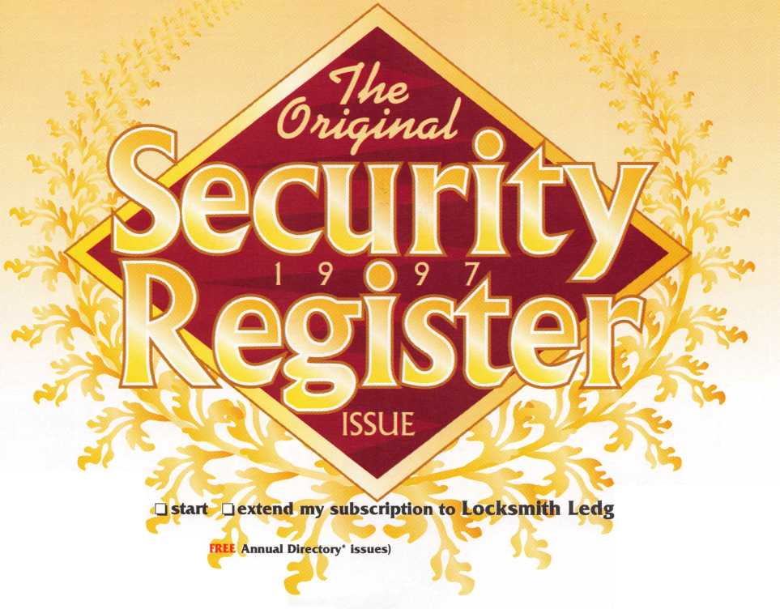

ST'

*W\**

If ;v

A man walks into Golden Gate Lock and Key.  
“I’m looking for a Scott,” he says, plunking down a set of house keys.  
“Yes, Sir. How can I help you?” says the woman behind the counter.

“What can I do for you today?” replies someone from the back.  
“Need copies of those?” asks the man carrying a stack of textbooks.

The customer slowly looks from one person to another.  
“I was told to ask for someone named Scott,” he says, confused.  
“Well, you’ve come to the right place,” the woman replies. “We’re all named Scott.”

“Now how can all of you be named Scott?”  
“Easy,” says the woman as she picks up his keys. “We’re family.”



HIS

PM * _

*fSMP'tigiA*|

P &

; f

Three generations of Scotts run Golden Gate Lock and Key. And they’ve been doing it together for over 50 years.

A Profile By Laurie **Kline**

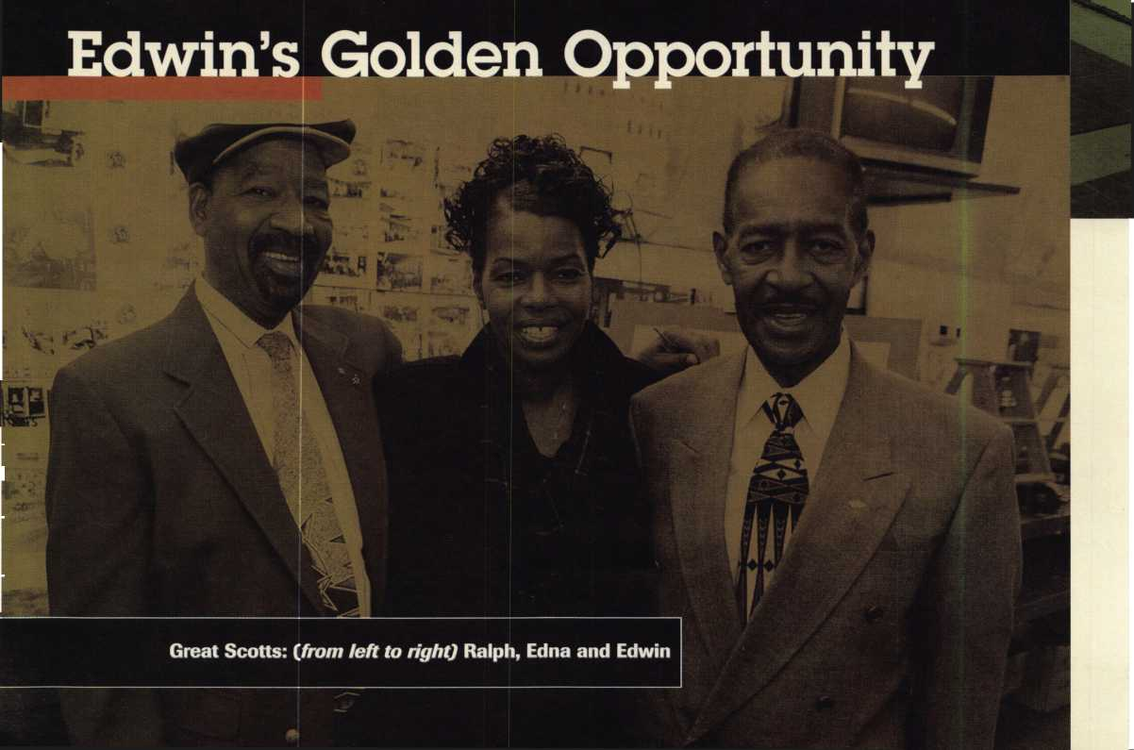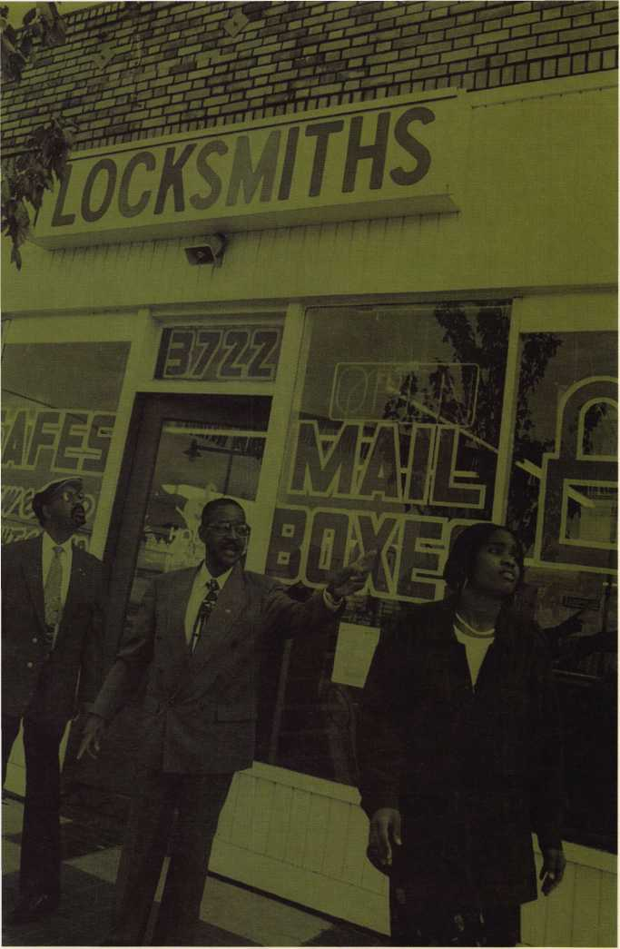

The United Force Called Family

In 1946, a twenty-something guy named Edwin Scott moved to California with $500 dollars to start a business. Today, that ambitious man has two huge suc­cesses: Golden Gate Lock and Key and the Golden Gate School of Technology.

“I tried to get some financial help, so I asked my friend one day, ‘How’d you like to be my partner?’ He said ‘Okay.’ So, I said, ‘Give me $500 and we’ll be partners.’ He went home to his wife and she said, ‘Hell no! Go get you a job!”’

Undaunted, Edwin turned to people he knew just couldn’t say no: family.

“I called my mother in New York and told her what was happening. She wanted to get my brother out so badly she put him on a plane and sent him out here. And he brought the $500!”

Brother and brother have worked side by side from the very beginning. And to this day, they have never had an argument.

“It’s because we made a bond. I was going to be the administrator, and he was going to be in charge of labor. We’ve used that since 1949 and it works for us today.”

With the growth of the business, Edwin and his brother realized they needed other employees. As soon as they were old enough to pitch in, Edwin’s sons, daughter and granddaughter and Ralph’s son joined the payroll. Despite the

family unity, Edwin learned that business is in fact busi­ness. And after years of trial and error, he has found there are three necessities for his continued success.

“Have job descriptions. That’s number one. Who’s going to do what? And then have an understanding of what the goals are. We’ve got certain things to do and everyone’s going to do it. The next thing is to pay them well. I’ve always overpaid my family. That gave me an excuse to fire them!” he jokes.

Edwin said an advantage to family business is that everyone is actually a part of the business, and that means there’s a strong impetus to work hard.

“Family business is the best business there is,” said Edwin. “Because the kids can look forward to having more than a paycheck.”

Early Days

Edwin’s Golden Gate School of Lock Technology, which began in 1968, is one of the earliest locksmith schools in U.S. history. And as the notoriety and popularity of the school grew, and as the economy changed, tuition has grown from $650 to $3500.

Classes meet five hours a day, four days a week for 12 weeks, but the students must master the first eight weeks inside the classroom before they venture outside to the shop. The school welcomes students from all over the world, and instructors teach every facet of locksmithing from master keying to fixing luggage locks.

“It’s one of the most complete schools in the California area,” said Hal Tibbets, a founding instructor for the ALOA training program.

“For every lesson, we have a video and references to go along with it,” said Edwin. “Some people can read and understand, and some can’t read at all, but when they get their hands on things, they understand.”

Students and locksmiths who are unable to attend school can also purchase the books and videotapes.

“I’ve written an apprentice training manual so a lock­smith in Texas can follow our guidelines—the same ones we use in the classroom—to train an apprentice,” said Edwin. “There’s a man in South Korea who can’t under­stand the language, so we supply him with video tapes and his daughter translates. Everybody gets it one way or another.”

Partnerships Make The Business World Go 'Round

Edwin’s business sense helped him uncover a profitable relationship between his students and his shop. Since Golden Gate School of Technology is next door to Golden Gate Lock and Key (he purchased the property on the entire block), students have the convenience of receiving an education and practical on-the-job training and experience at the same location. Currently, 12 stu­dents work in the shop.

“We want them to come in and do an internship, like a doctor. They normally stay for about a year. That was the idea of having a school—to get employees. They don’t make that much money, but they get experience. Once they get the experience, they move on to some-

April 1997



thing else.”

This partnership between students and the shop has worked since 1972.

“Knowing how to operate a business is what’s kept me here for 50 years,” said Edwin. “We have the school, which is where we get labor. They work for us, we make money, and they get the education.”

The Law of Supply and Demand Because of the racial tensions and discrimi­nation that were present in Georgia in the ’30s, the Scott family moved to New York. By the time he was 18 and finished high school, Edwin was drafted into the Navy. In 1943, the Navy moved him to California for

military training. He began his career as a laundry presser, but his entrepreneurial spirit quickly took over. He set up shop on base— a barber shop.

“During that time in the ’40s, even though there was discrimination, I cut white people’s hair ‘cause they had to have it. They couldn’t get on the base without a haircut, so they didn’t give a damn who cut it as long as they got on the base. That taught me that if you have something everybody needs, it doesn’t matter who you are—they’re going to buy it. That taught me that when I got out of the Navy, I should get something that everybody needs.”

After his stint as a barber, Edwin began working with the carpenters on base. This experience taught him the fundamentals of locksmithing. At that time, carpenters ful­filled all locksmith duties. And with the les­son in supply and demand he learned as the base barber, as well as his newfound interest in locksmithing, Edwin had no problem deciding on his career of choice.

“If you want to make money, sell some­thing everybody needs, not what they want. People don’t have time to discriminate when they can’t get in their car. I never had any problems with prejudice or discrimination ‘cause I had something everybody has to have” said Edwin. “I planned it that way.

Had I been selling insurance or real estate, I would’ve had a problem racially. You make the system work for you. “

Sign of the Economic Times

Golden Gate Lock and Key services “any-

J Keynotes April 1997

thing that locks,” including ships, office  
buildings, banks, fast food places and resi-  
dential communities.

“We do everything. We’ve got something  
everybody needs—that includes everybody.  
We don’t discriminate.”

Edwin’s foresight has allowed him to stay  
successfully in business despite flimsy eco-  
nomic times. In the ’70s, he had six shops  
and three schools, but once the ’80s and  
Reaganomics took over, Edwin had to down-  
scale.

Prior to the Reagan administration, inter-  
est rates were at a steady eight percent. With

the election of the new president, and a strict

agenda to balance the budget,  
interest rates soared to 18 percent.  
As a result of the interest rate  
increase, many small businesses  
felt a punch in the wallet.

Golden Gate Lock and Key suf-

fered from the interest rate rise like most  
other small businesses, but the effects were  
not as severe as those attacks on many other  
small business owners. Luckily for Edwin,  
owning a business has earned him the free-  
dom to make decisions that would optimize  
his financial potential.

“If someone else controls your income,  
and your car insurance goes up and your rent  
goes up, your taxes go up, you have no way  
of raising your salary. That’s one of the  
advantages of running your own business—  
raising prices to meet whatever the econo-  
my’s coming to.”

Through the ’80s, and undoubtedly in the  
’90s, security has been and will always been  
a top priority.

“As long as man is on this earth,” said  
Edwin. “Men want what the other man’s  
got. There’s no end to security. If a person  
has the proper training, he can go any-  
where.”

Business Sense

With the advent of new legislation, technol-  
ogy, and communications, the role of the  
business owner has changed in the last 50  
years, especially for African Americans. But  
one thing remains consistent: the need to  
increase profit with each business year.

“A good business has to increase profits  
by about 15 to 20 percent every year or else  
they go out of business,” said Edwin “We  
strive to increase at least 15 percent every  
year one way or another. That way we can  
maintain our budget and our gross income.”

Profit doesn’t happen simply because an

“As long as man is on this earth,” said Edwin. “Men want what the other mans got.”

entrepreneur wills it to be so. Many people who have their own business, or would like to some day, lack some of the necessary skills for a successful enterprise.

“The average business won’t survive five years. Dunn and Bradstreet says that the rea­son is lack of business administration.

African Americans are hard workers, they put their whole heart into it, but they don’t know how to do bookkeeping, inventory control or buy insurance,” said Edwin. “African Americans are going to college now, and we train African American people. Twice a week we have meetings to discuss with them how to manage their business.”

Edwin and group of other local business owners have started the Business Training of the East Bay, a non profit, volunteer training facility. This program, which has evening meetings, is set up so anyone can learn fun­damental business skills, including tele­phone etiquette.

“The most important business asset is the telephone,” said Edwin. “You’ve got to answer it correctly. So we give lectures and then we put them on videotape, and have them look at themselves to see the mistakes they’ve made.”

For the past three years, Edwin and his co-trainers have been helping African Americans, Koreans, Hispanics, and others to become productive, profitable and power­ful entrepreneurs.They consider their partici­pation in this training program a kind of payback for their own good fortune.

“We don’t get any money, but I don’t want any money,” said Edwin. “I just want to help someone else.”

The Profession of a Lifetime In addition to running a successful corpora­tion, a school, and volunteering at a training center, Edwin has been a faithful ALOA member since 1957. He even attended the 1958 Convention in Chicago, the second one in ALOA history.

He’s 72, but when it comes to the subject of retirement, it’s something he only talks about doing.

“You never retire in this business, you die in it. Most of the old locksmiths you run into are 90 years old and they’re still doing the same thing,” said Edwin. “They do it until they die and I probably will too.”

About the Author: Laurie Kline is the Associate Editor 0/Keynotes.

Just about every commercial building has at least one of them. That door that nobody ever uses—the one thats only there because of fire regulations—on the back side of the building, in a dark cor­ner where a would-be burglar can haul out the heavy artillery and never be noticed. You know that door. And you know what kind of hardware is on it, don’t you? Five will get you 10 it’s a rim exit device.

The rim mounted exit device is a useful piece of door hardware, especially from a life safety perspective. It keeps the door shut and locked while allowing immediate, unhin­dered egress. From a physical security per­spective, though, it is a compromise. The

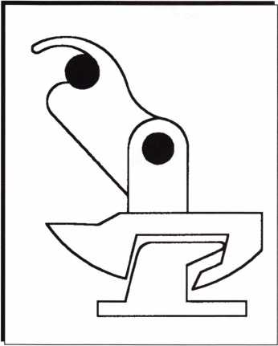

Figure 1 Pannex latch/strike interlock

exit device depends upon a spring-loaded latch that rests behind a stubby, surface- applied strike on the door stop to keep the door locked. When the hardware is perfectly installed the latch only engages about a half inch of strike, and how many of them are perfectly installed? All the perpetrator needs

PAUL F. CHANDLER CRL



All-Min

to do is spread the door and jamb a little, and he’s in.

The weakness of this type of hardware to physical attack, especially when the building is unoccupied, has resulted in building own­ers adding a variety of supplemental locking devices to these doors. Things like auxiliary deadbolts, surface slide bolts or chains with padlocks, to name a few. And while these “improvements” make it harder for the bad guys to force the door open on Saturday night, they have a way of being left in place when the workers come in on Monday morning. Then you have a fire, people are trapped and they die.

A better solution would be to use panic exit hardware that is better at thwarting physical attack, while still allowing immedi­ate egress. A few manufacturers are now

offering exactly that.

For example, Door Controls International has developed the Pannex 7 touchbar rim exit device. Pannex has a patented interlock mechanism that prevents spreading of door and frame (figure one). The strike and latch are investment cast stainless steel, heat treat­ed and tempered to achieve an approximate tensile strength of 200,000 pounds per square inch.

Pannex devices can be installed on wood, hollow metal and aluminum/glass storefront- type doors (two-inch minimum stile width). Two sizes are available and the device may be field cut to the exact length required.

Three alarmed models are available, with a choice of a built-in alarm, powered by one nine-volt battery; a remote alarm powered by a 10-26 vdc power supply or a combina-

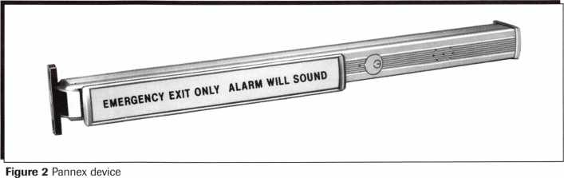

April 1997

***Keynotes*** | **23**

The standard pullman latch bolt applies 280 pounds of force laterally against the frame from a 400 pound pull on the door.

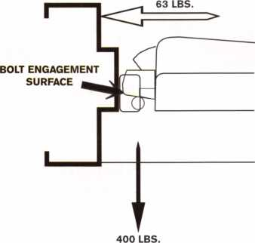

The larger bolt engagement surface of the SquareBolt exit device results in ONLY 63 pounds of force laterally against the frame from a 400 pound pull on the door, *providing* significantly more security.

Figure 3 Yale bolt vs. Pullman latch

tion local/remote unit.

Pannex may be ordered with either a sin- gle-pole/double-throw, or a double-pole/dou- ble-throw signal switch option. These switches can be used to shunt an alarm, release an electronic lock or signal a remote monitoring location. There is also an electric latch retraction option. Unlike many electric latch retraction devices, Pannex requires rela­tively low power. This means that no expen­sive power boosters are needed to allow remote unlocking or electronic access control of this device.

The basic Pannex rim exit-only device lists for only $189-50. Adding the alarm fea­ture increases it to $260.00. The electric latch retraction model, without exit alarm, lists for $340.00.

Another entrant into the higher-security exit device market is Yale, with their new “SquareBolt” panic hardware. The SquareBolt exit device is an modified version of Yale’s high-end 7000 series. Like all 7000s, this new device meets ANSI 156.3 Grade 1 specs, and is UL and ULC listed panic exit or fire exit hardware. It is available in all the popular architectural finishes and with a variety of exterior trim designs.

What makes the SquareBolt exit device unique is the two piece deadbolt mecha­nism. When the door closes, a roll back lever retracts the locking bolt until the door is fully shut. There is never any contact between the locking bolt and the strike dur­ing closing. Once closed, the bolt projects a full 3/4 inch and engages one inch of strike surface. An auxiliary latch deadlocks the bolt

24 | Keynotes April 1997

in place.

Look at figure three. The bottom illustra­tion shows a conventional Pullman latch while the top picture shows the Yale SquareBolt. Notice how the face of the Pullman latch that rests against the strike is rounded. This means that, when you pull

Figure 4 Yale Squarebolt exit device 2

the door outward , force is applied not only against the stop but also against the frame.

A standard pullman latch applies 280 pounds of force laterally against the frame when the door experiences a 400 pound pull. This means that the latch is helping the intruder to spread the jamb! By contrast, the nearly flat surface of the SquareBolt latch only transfers 63 pounds against the frame.

SquareBolt devices  
are recommended for  
doors requiring extra  
security, doors with  
excessive gaps and  
double doors with  
center mullions. The  
7150 device has a  
wide (3 1/8 inch)

case, for wood or hol-  
low metal doors. The  
7250 case is only 1  
5/8 inch wide and  
may be used on many  
aluminum and glass  
doors. Options  
include cylinder dog-  
ging, bolt status

monitor and electric latch retraction. In a  
US32D finish the 7150 lists for $598.00 and  
the 7250M has a list price of $796.00.

When outside access is required, Yale strongly recommends their “Free Wheeling Vandal Resistance” trim package be installed. Similar to the 5400LN cylindrical

lockset, the lever is not rigid when locked, but rotates to reduce stress on the lock chas­sis. In addition, these trims are through- bolted and have beveled sides and flush cylinders to resist wrenching.

For several years now, businesses have installed auxiliary locking devices on back doors such as the “Exit Security Bar” and the “Backdoor Bar.” These units, along with a

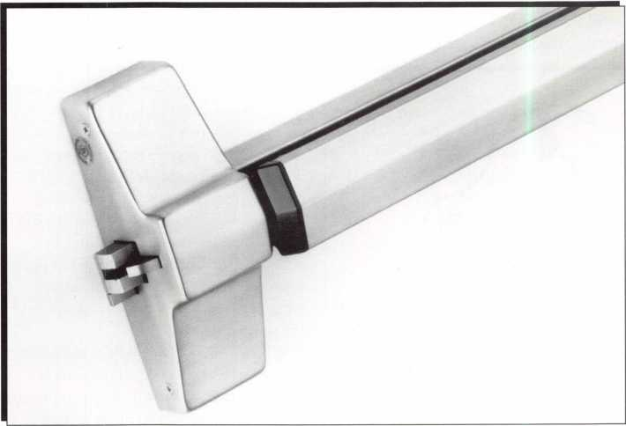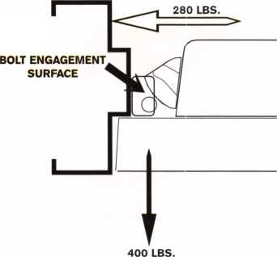

About the Author: Paul Chandler, CRL, is the manager of the Electronic Security Department for I.D.N-ACME in Houston, TX.

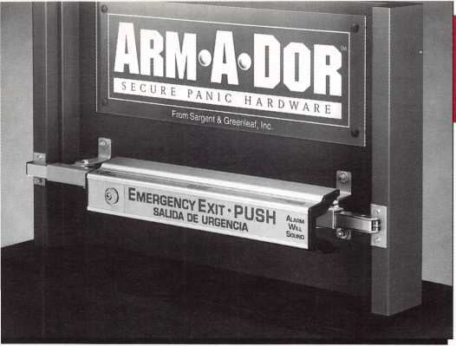

Figure 5 S&G Arm-A-Dor

helping to keep the bad  
guys out, and ensuring that  
the good guys can get out in  
an emergency. That should  
make it easier for the build-  
ing owner, and for you, to  
sleep at night.

variety of homemade copycats, span the full width of the door jamb with a bar that is hooked to or fastened to the out swinging door. When the building is occupied, these devices are supposed to be removed or rotat­ed out of the way to allow egress. When you get ready to leave at night, the bar is put in place.

Taking this concept a step or two further, Sargent and Greenleaf has introduced the Arm-A-Dor. Combining drop-bar and exit device, Arm-A-Dor isn’t going to win any beauty contests. What it will do is hold the door shut with 12 gauge steel tubing extending 11/2 inch over the door frame on both sides. Unlike drop-bars, Arm-A-Dor stays in place day and night, attached to the door with attack-resistant thru bolts and washers. In the event of an emergency all you do is push gently (less than 15 pounds), the steel tubes retract and the door opens. Security and life safety—in one piece of hardware (figure five).

The Arm-A-Dor can be installed on door openings from 36 inches to 48 inches wide. It can be used on door jambs up to 6 3/4 inches deep. If you encounter extra deep jambs, a low profile kit is available. That allows the device to lock into the jamb, rather than overlapping it. There is no pro­vision for unlocking the door from the out­side.

Arm-A-Dor is available in automatic relock and manual relock models. It is also available with a stand-alone exit alarm mod­ule. The alarm module is weather resistant and has auxiliary contacts included to oper­ate external alarms or other security devices. Without alarm the list price is $595.00. With the alarm the list is $695.00.

So, the next time you survey a back door that has been spread open in the middle of the night, or you find one that the owner is chaining and padlocking, why not suggest one of these security panic devices? You’ll be

The Beginning of a

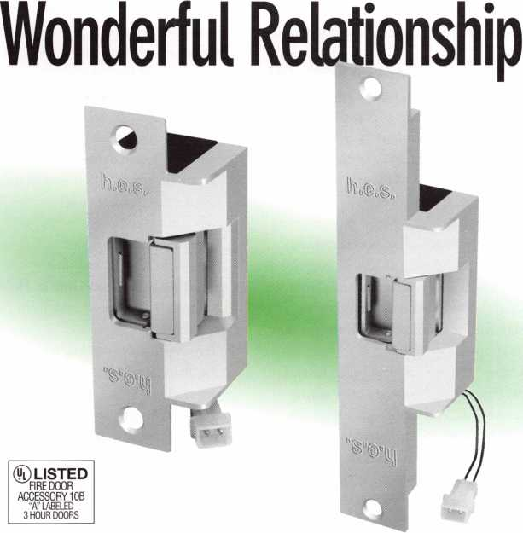

Behind the clean, sharp lines and  
seamless appearance lies the most  
advanced electric strikes manufactured  
today. The 7500 series, tmly the first elec-  
tric strikes designed to be "installer friend-  
ly." Each unit is field selectable* from fail

secure to fail safe.

The solenoid is internally mounted for compactness, making them very easy to install in any type

of door jamb. To further simplify their  
installation, these strikes will operate  
under an excessive amount of door load-  
ing, caused by a warped or misaligned  
door, weather stripping or any other con-  
dition that may bind the door. The 7500

series are complex yet simple,  
rugged yet elegant and soon to  
be your strike of choice.

*U.L. Fire door listed as a fail secure device only.

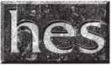

Hanchett Entry Systems, Inc.

2040 West Quail Avenue, Phoenix, Arizona 85027

(602)582-4626

April 1997

***Keynotes \*** 25

Reader Service #17

The versatility of an overhead stop/holder, combined with new kits that simplify con­version between different functions, can reduce both inventory costs and problems in the field. Because these units can be convert­ed quickly and easily, distributors now need stock only one or two of the most popular configurations and can convert to the others when needed. In the field, if the wrong over­head is ordered or a change is made to an opening, its easy to convert to the proper function on the spot. Here are six simple conversions for a Glynn-Johnson 90 Series Overhead Stop/Holder.

In some cases, there is a quick conversion method as well as an optional, more compre­hensive method. Other series overheads offer similar versatility, and conversion instruc­tions are available for these from the manu­facturer.

Converting from Hold-Open to Stop Only

Quick Method—Remove the two screws on the bottom of the channel (figure one). These hold the flip trigger assembly in the channel. Then move the slider away from the spring end of the channel, and remove the trigger assembly from the channel.

Optional Method—Note: With the trig­ger assembly removed, the overhead will function as a stop only. It is not necessary to remove the hold-open components from the slider. If desired, proceed as follows:

1. Remove the overhead unit from the door and frame.
2. Remove the end cap key from the end of the channel without the shock spring.
3. Remove the end cap by knocking the slider against the end cap until the cap comes out of the channel.
4. Slide the arm assembly out of the channel.
5. Remove the screw at the end of the slider.

The square nut and spring will drop out of the slider.

1. Remove the roll pin from the side of the slider. The rocker arm will drop out of the slider.
2. Slide the arm assembly into the channel,

with the short end of the slider toward the shock spring in the channel.

1. Replace the end cap.
2. Replace the end cap key.
3. Reinstall the overhead unit.

Converting from Friction Hold-Open to Stop Only

Quick Method—Simply remove the set screw from the top of the slider (figure 2).

Optional Method—Note: When the set screw is removed from the slider, the over­head will function as a stop only. It is not necessary to remove the friction components from the slider. If desired, proceed as follows:

1. Remove the overhead unit from the door and frame.
2. Remove the end cap key from the end of the channel without the shock spring.
3. Remove the end cap by knocking the slider against the end cap until the cap comes out of the channel.
4. Slide the arm assembly out of the channel. The friction pad and spring assembly will drop out of the slider.
5. Slide the arm assembly back into the channel, with the short end of the slider toward the shock spring.
6. Replace the end cap.
7. Replace the end cap key.
8. Reinstall the overhead unit.

Converting from Stop Only to Hold-Open

1. Remove the overhead unit from the door and frame.
2. Remove the end cap key from the end of the channel without the shock spring (fig­ure one).
3. Remove the end cap by knocking the slider against the end cap until the cap comes out of the channel.
4. Slide the arm assembly out of the channel.
5. Place the rocker arm inside the slider as shown.
6. Install roll pin through slider and rocker arm.
7. Put screw through the top of the slider, in the hole nearest the end of the slider.
8. Place spring over the screw inside the

slider.

9- Put square nut on the screw and tighten about four turns.

1. Place the flip trigger assembly inside the channel, with the short end of the assem­bly toward the shock spring.
2. Secure the flip trigger assembly through the bottom of the channel, using two screws.
3. Grease the rocker arm and the flip trig­ger with a graphite or white lithium- based grease (not included in the conver­sion kit).
4. Slide the arm assembly back into the channel, with the short end of the slider toward the shock spring end of the chan­nel.
5. Replace the end cap.
6. Replace the end cap key.
7. Reinstall the overhead unit.
8. Adjust the hold-open tension as described in the installation instructions.

Converting From Stop Only to Friction

Hold-Open

1. Remove the overhead unit from the door and frame.
2. Remove the end cap key from the end of the channel without the shock spring (fig­ure two).
3. Remove the end cap by knocking the slider against the end cap until the cap comes out of the channel.
4. Slide the arm assembly out of the channel.
5. Remove any grease from the inside bot­tom of the channel.
6. Place the friction pad and spring assembly into the slider as shown.
7. Slide the arm assembly back into the channel with the short end of the slider toward the shock spring end of the chan­nel.
8. Put the set screw into the top of the slider.
9. Replace the end cap.
10. Replace the end cap key.
11. Reinstall the overhead unit.
12. Adjust the friction hold-open tension as

BY

**Coinverting an overhead stop/holder to**

**the function you need takes just a few**

**minutes and a screwdriver** DONNELL SIEBERT

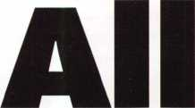

. Keynotes

April 1997

described in the installation instructions.

Converting from Friction Hold-Open to Hold-Open

1. Remove the overhead unit from the door and frame.
2. Remove the end cap key from the end of the channel without the shock spring (fig­

ures ones and two).

1. Remove the end cap by knocking the  
   slider against the end cap until the cap  
   comes out of the channel.
2. Slide the arm assembly out of the channel.  
   The friction pad and spring assembly will  
   drop out of the slider.
3. Remove the set screw from the  
   middle of the slider.
4. Place the rocker arm inside the  
   slider as shown.
5. Install the roll pin through the  
   slider and rocker arm.
6. Put the screw through the top  
   of the slider in the hole nearest to  
   the end of the slider.
7. Place the spring over the screw  
   inside the slider.
8. Put the square nut on the  
   screw and tighten about four  
   turns.
9. Place the flip trigger assem-  
   bly inside the channel with the  
   short end of the assembly toward  
   the shock spring.
10. Secure the flip trigger assem-  
    bly with two screws through the  
    bottom of the channel.

13- Grease the rocker arm and  
the flip trigger with a graphite or  
white lithium-based grease (not  
included in the conversion kit).

1. Slide the arm assembly back  
   into the channel, with the short  
   end of the slider toward the shock  
   spring end of the channel.
2. Replace the end cap.
3. Replace the end cap key.
4. Reinstall the overhead unit.
5. Adjust the hold-open tension  
   as described in the installation  
   instructions.

Converting from Hold-Open to  
Friction Hold-Open

1. Remove the overhead unit

from the door and frame.

1. Remove the end cap key from the end of the channel without the shock spring (fig­ures one and two).
2. Remove the end cap by knocking the slider against the end cap until the cap comes out of the channel.
3. Slide the arm assembly out of the channel.
4. Remove the two screws on the bottom of the channel These hold the flip trigger assembly in the channel.
5. Remove the trigger assembly from the channel.
6. Remove any grease from the inside bot­tom of the channel.
7. Remove the screw at the end of the slider. The square nut and spring will drop out of the slider.
8. Remove the roll pin from the side of the slider. The rocker arm will drop out of the slider.
9. Place the friction pad and spring assem­bly into the slider as shown.
10. Slide the arm assembly back into the channel, with the short end of the slider toward the shock spring end of the chan­nel.
11. Put the set screw into the top of the slider.
12. Replace the end cap.
13. Replace the end cap key.
14. Reinstall the overhead unit.

These six conversions can each be done in a matter of minutes, but they’ll save you a trip back to the shop or even more time if you’d otherwise have to wait for a delivery. Stocking a few conversion kits is good insurance against wasted time and delays on the job.

Copies of overhead conversion instructions for other Glynn-Johnson overhead stop/holder series are available on request from Glynn- Johnson representatives or from the customer service department of Glynn-Johnson, P.O.

Box 6135, Indianapolis, IN 46206. Telephone 1-800-525-0336. Fax 1-800-525-0337.

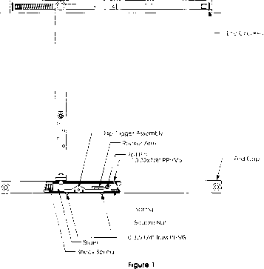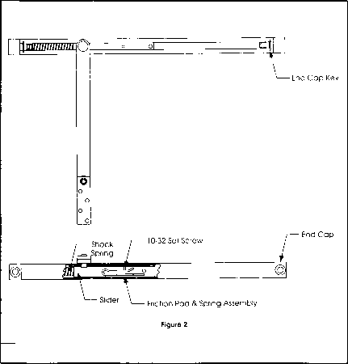

Of The Above

APPLICATIONS ENGINEER, INGERSOLL-RAND ARCHITECTURAL HARDWARE, GLYNN-JOHNSON DIVISION, INDIANAPOLIS, INDIANA

April 1997

***Keynotes***



Americans With Disabilities Act

If s Your Business

Winterha

ter

Understanding the Americans with Disabilities Act

(ADA) can earn you new business and differentiate you

om your competition.

When Congress passed the ADA in July of 1990, did

any of us realize this act would pour millions into the  
locksmith industry? The act was designed to do the fol-  
lowing:

“To establish a clear and comprehensive prohibition of discrimination on the basics of disability.”

What this means is that people with physical disabili­ties must have equal access to public areas and build­ings, both publicly and privately owned. Although this act covers thousands of pages and issues from wheelchair access to services for the hearing impaired, what most concerns us is Title 28 Part 36 Subsection 4.13-Doors.

This section mandates requirements for nearly every building accessible to the public, including: retail stores, offices, manufacturing facilities, apartments, hospitals, schools, libraries and government buildings—just to name some. If an owner or manager of an existing struc­ture wants to make changes in any way that requires a building permit, they may very well need the services of a licensed locksmith! How can a job involving a tradi­tionally non-lock-related job like roofing or electrical work involve you? In a typical scenario, somebody wish­ing to modify a public access building would call their city’s building inspector to acquire the proper building permits. Building inspectors are not only allowed, but required to cite code violations they witness at any loca­tion. So, if any inspector is examin­

ing a new roof, they may notice that an entrance door’s hardware does not meet ADA or local building code requirements, and may require modifications. This could mean headaches and big bills for the owner, unless they call you.

Being familiar with ADA provisions, you will be able to speak knowledgeably about the situation. The cus­tomer will quickly consider you an expert who they can trust to properly and economically remedy the situation. The two most common issues that you may encounter involve door hardware and door closers.

Door Hardware

Subsection 4.13-9 states, “Handles, pulls, latches, locks and other operating devices on accessible doors shall have a shape that is easy to grasp with one hand and does not require tight grasping, tight pinching, or twisting of the wrist to operate.”

Most commonly, this means that an old style ball lockset will need to be replaced with a cylindrical lever. Whereas, the ball type lockset requires full use of one’s hand and fingers to operate, the cylindrical lever can be operated with limited mobility or even with an artificial, prosthetic limb.

In our scenario, the locksmith may choose to use a very durable grade-I cylindrical lever—#32-7953. This lever is ideal as an upgrade because it features an internal clutch, a 2 5-year manufacturer’s warranty and is compet­itively priced. When the cylindrical lever is in the “locked” position, the lever will freely pivot 90 degrees

28

Keynotes

April 1997



To learn more about ADA standards, contact:

**American's with Disabilities Information Line**

1-800-514-0301 1-800-514-0383 (TDD) or on the internet at: [www.usdoj.gov/crt/ada/adahoml](http://www.usdoj.gov/crt/ada/adahoml) .htm

To learn more about product applications, please contact:

Tom Winterhalter Taymor Industries P.0. Box 56148 Hayward, CA 94545-6148 1-800-388-9887

in either direction, reducing excessive abuse and wear on the lock mechanism. When the lever is released, it will automatically return to the horizontal. This is accomplished by a return spring concealed beneath a rosette.

Door Closers

Subsection 43.10 states, “If a door has a closer, then the sweep period of the closer shall be adjusted so that, from an open position of 70 degrees, the door will take at least three sec­

onds to move to a point-three inches (75mm) from latch, measured to the leading edge of the door.”

Although this section does not require a closer on doors not originally equipped with one, it does not exclude their use to upgrade a door. A versatile, yet competitively priced closer for our application would be the model #13-1900BFDAAL from Taymor (pictured). This durable grade-II closer easily meets requirements of ADA and Title 24 (an

accepted industry standard), with a maximum opening force of 8.5 LBF for external hinged doors, 5.0 LBF for interior hinged doors and 15.0 LBF for fire-rated doors. In addition, this closer exceeds the minimum sweep period by being adjustable up to 90 seconds, and has a latch speed adjustment and back check value. Check your city’s local building codes as codes vary by state.

Many of us are missing business from our existing customers because we have not thought of locksmiths as being knowledgeable about ADA issues. A few minutes spent discussing these issues with commercial property managers can pay off with new “plus business.”

About the Author: Tom Winterhalter is the Technical Services Manager for Taymor Industries. He has a C61 Contractors License Specializing in Door and Window Installation.

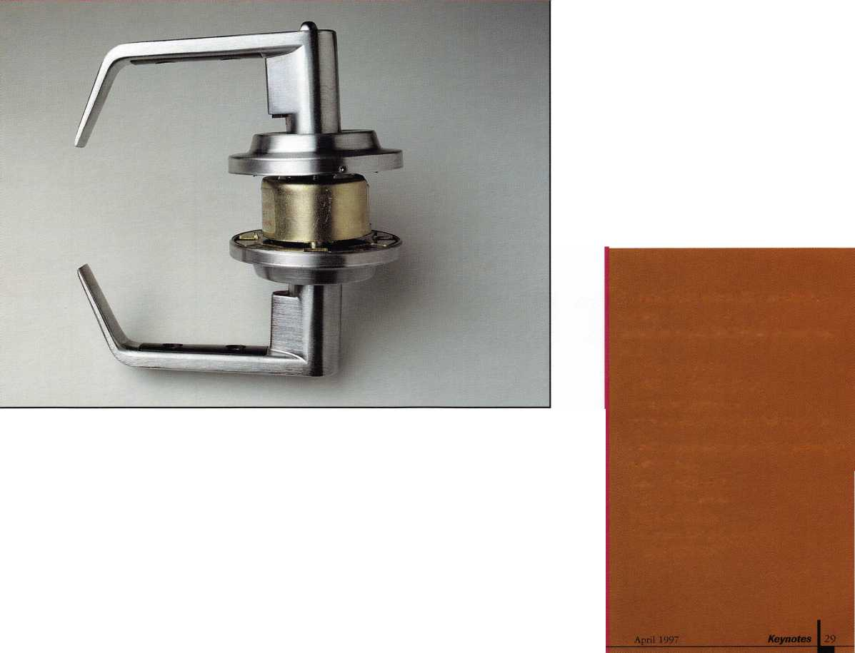

**NT OUAUT HARDWAR]**

**by lisa manning**

During the 29 years that Greg Rash has been a locksmith, he has experienced his share of frustrations with ordering custom door hardware. When Rash needs door hardware for his growing contracting business in Sequim, WA, he deals with one of three supply houses in Seattle, more than 60 miles away, to get the exact hardware he needs for the job.

Most days he gets lucky. Each warehouse stocks thousands of items and the suppliers generally keep a large inventory of high- demand door hardware in stock. But on occasion, usually when scheduling is the tightest, the hardware he needs is available only through special order, or the item he ordered by catalog turns out to be a poor fit for the required application.

Until recently, selecting door hardware for a construction or renovation project might require hours of research to compare the compatibility of a vendor’s products with the requirements of the

job. With more than 21,000 manufacturers of locksmith supplies worldwide, the task of matching vendors with door hardware function and design becomes a test of memorization and ingenuity.

Once the correct product is selected, more time can go into preparing cut sheets to order the requisite hardware. The fact is, locksmiths, architects, building contractors and engineers have mor< constructive ways they could be spending their time.

Thanks to the continued growth of Internet commerce and new

technologies in database applications, construction industry

|

professionals can now fill their architectural door hardware needs in a fraction of the time by referencing Newman Tonks’ new Information-on-Demand (IOD) web site at [www.newmantonks.com](http://www.newmantonks.com). The Newman Tonks IOD web page combines an easy to use browser interface with the power and expanse of the architectural door hardware manufacturer’s product, marketing and operations databases.

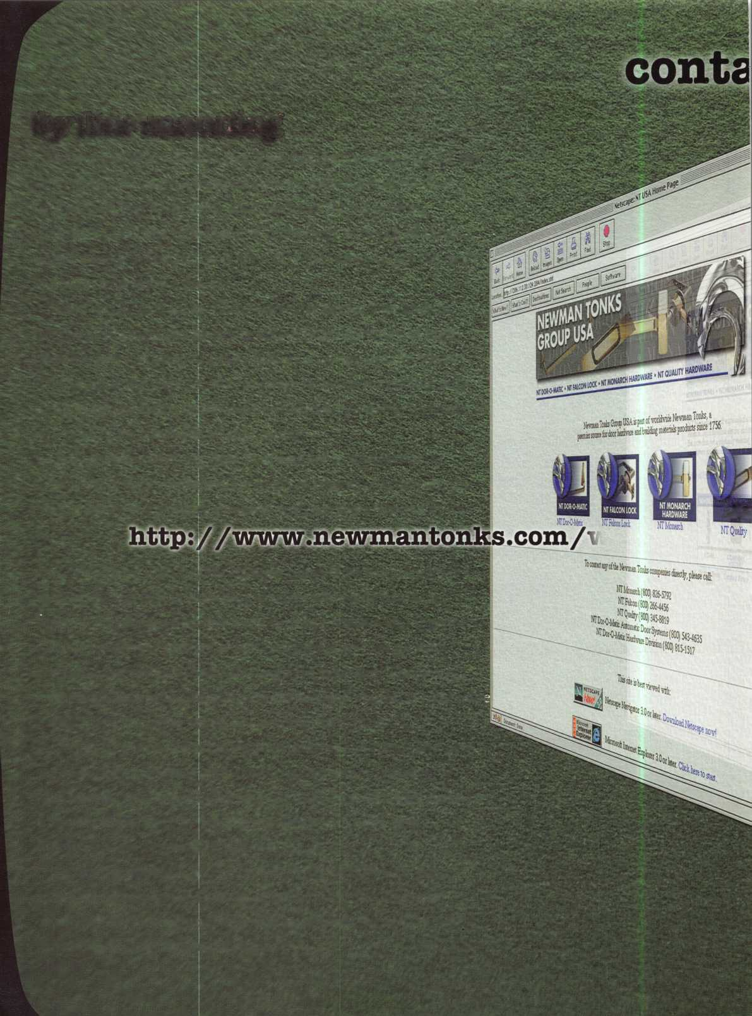

s.com

% of 92k (at; 2.6k/sec

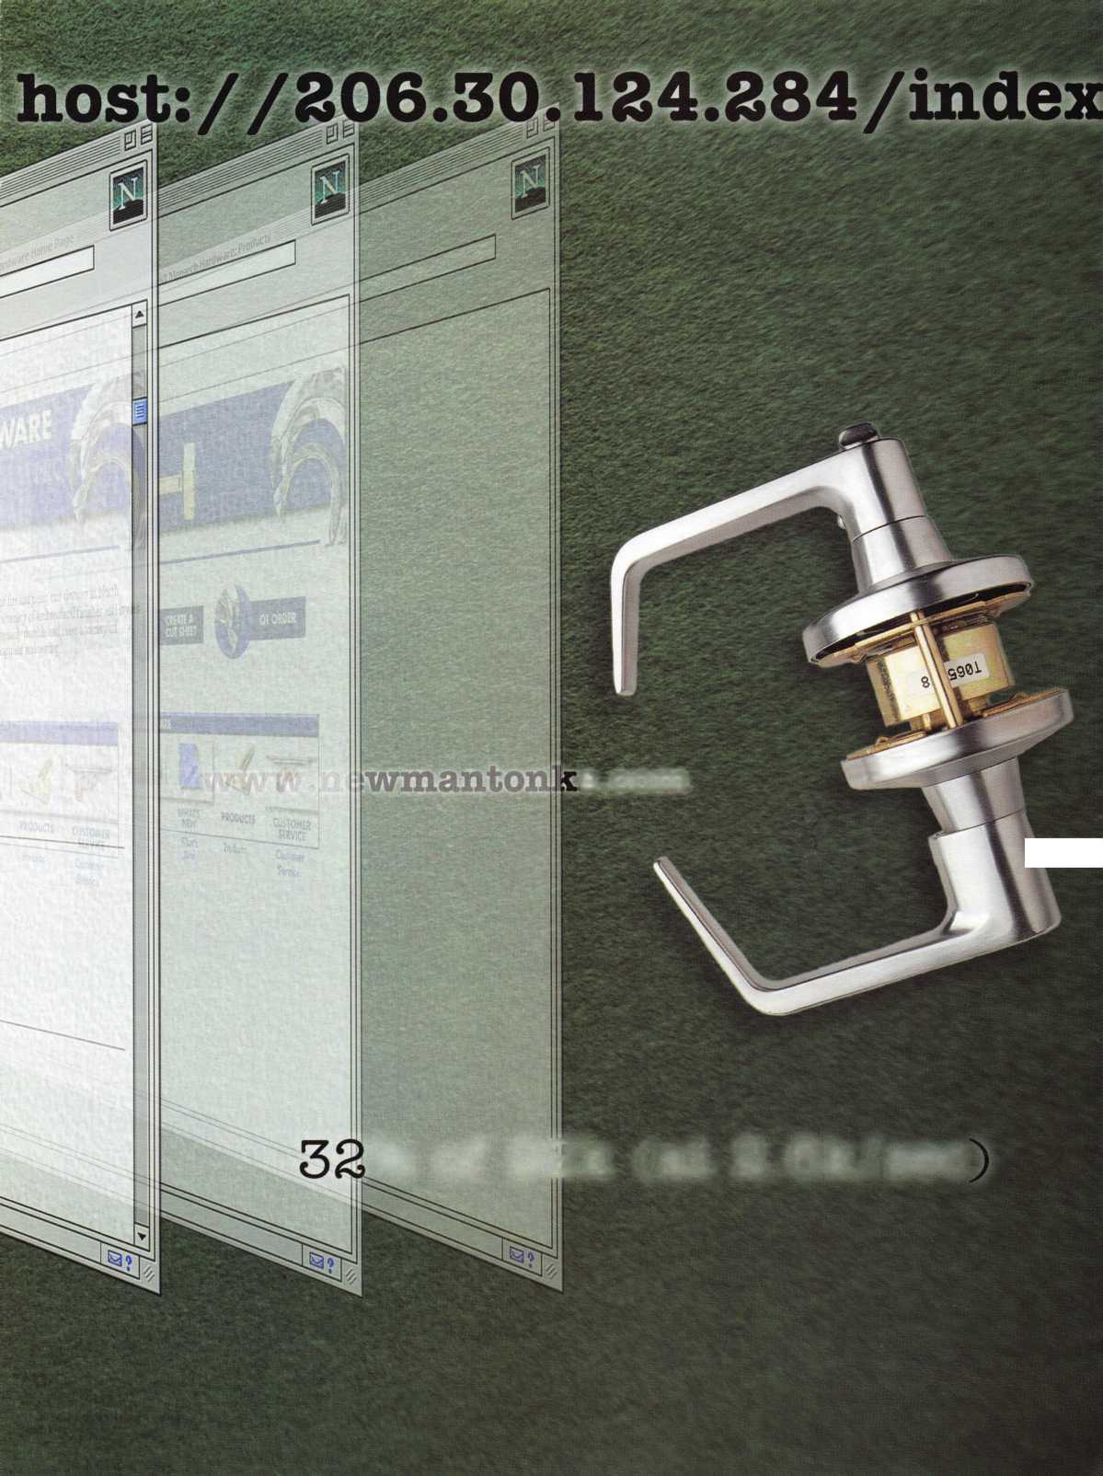

“In the past, special orders from the manufacturer have been the worst nightmare a locksmith could go through. Delivery could take from eight to 10 weeks and the items didn’t always fit the application,” said Rash. “I have a library of reference volumes from Sweets’ to individual vendor catalogs. But catalogs aren’t always logically laid out, diagrams can be inaccurate and just seeing the item in a catalog doesn’t mean it is available in stock. If there was a better way to order door hardware, I would definitely use it.”

Rash, like most professional locksmiths, approaches commercial installation and retrofit jobs by carefully reviewing the building plans, evaluating the door hardware needs and locating a vendor with high-quality compatible products.

The evaluation of door hardware needs is often a complicated process that brings several factors into consideration. The first criterion of evaluation addresses function and security: What type of door is it? (entrance, passage/closet, privacy, restroom, storeroom, dummy) and what type of security is needed (Five, six or seven pins)? Function and security will generally determine what grade of hardware is required for the job and what type of cylinder should be installed in the lock.

The second criterion includes specifying trim and finish: What is the desired appearance (style, color, alignment, placement)? Trim and finish identify the “look” of the door, with thought to how the hardware fits in with its immediate surroundings and the architectural style of the building.

The third criterion entails choosing details such as latch strike specifications, accessories and measuring door thickness. Such details consider special uses of the door and provide a better fit of door hardware. After these issues have been addressed, the contractor can move forward with the steps of selection and ordering.

“We understand how frustrated construction industry professionals are with the outdated system of vendor reference catalogs and cut sheet generation,” said Ashley Rolfe, group vice president of sales and marketing for Newman Tonks Group USA. “We estimate that more than 60% of construction industry professionals, including architects, engineers and head contractors, now have access to online technology. So Newman Tonks found a way to use the Internet to facilitate all phases of the door hardware ordering process.”

An IOD web site for NT Monarch Hardware, producers of the most extensive range of fire and panic exit devices in North America, recently went online in January 1997, with their full product line available for purchase over the Internet. A series of interactive screens, requiring responses to standard selection criteria, guides the first time user through the most complicated parts of the door hardware evaluation and ordering process by automatically selecting only hardware that is compatible for the user’s specific application. Online users can also create an electronic cut sheet that is automatically sent to the supplier via e-mail and can be printed as a

http: / /2

permanent record.

By spring of 1997, NT Falcon Lock, the company’s architectural lock and hardware division, will offer similar selection and ordering services to locksmiths and other construction industry professionals. NT Dor-O-Matic, the manufacturer of a full line of power door operators and hardware, is also scheduled to go online early next year.

“The NT Monarch web site leads the first time visitor through a series of interactive screens by feeding the user lead questions pertaining to the specifications of a project and capturing the responses in database form,” Rolfe said. “The job specs are then compared to existing product databases to determine compatibility with a desired application. Only those products that match the specific door design, construction and fire rating, as well as device style, application, function, trim and finish are listed on the ordering page. Return visitors who know exactly what their hardware needs are can always bypass the IOD portion of the site and make a QT Order online.”

Rolfe distinguished the new Newman Tonks IOD web site from the static web pages other vendors have posted on the Internet. The NT Falcon site under development will prompt the user for all standard hardware selection criteria including function and security, style, design and accessories. When complete, the IOD web page will provide valuable information on stock inventories, shipping and order confirmation.

The Newman Tonks web site, designed and developed by Kleier Communications, Inc. of Louisville, KY, premiers in The Construction-Zone ([www.construction-zone.com](http://www.construction-zone.com)), an Internet mall dedicated to the commercial construction industry.

To complement its new Internet ordering system, Newman Tonks will also roll out Quick Ship, a vendor service providing delivery of special order NT Quality and NT Falcon products anywhere in the United States within two to 10 days. NT Quality hardware will provide shipment to any of the western states or KY within two days, and anywhere in the United States within five days. NT Falcon can ship the majority of their catalog items anywhere in the United States within 10 days.

“As both a products and service driven company, we are dedicated to helping construction industry professionals make their jobs a little bit easier,” Rolfe added. “Our new IOD web page and Quick Ship program are just two more ways Newman Tonks has anticipated and responded to the needs of the construction industry.”

About the Author: Lisa Manning is a marketing veteran with more than 18 years industry experience, from computer lay­out artist to interactive advertising executive. Manning has college degrees in advertising and marketing, and as chief operating officer of Kleier Interactive, she recently founded the agency’s internet/intranet and computer presentation develop­ment team.



April 1997

Keynotes

34

**The ALOA Mentor Program**

**By Bob DeWeese, CPL**

**When I started in the locksmithing industry,**

**I was hi red "off the street" and was given the opportunity to Learn the business from the ground up.**

I had been working for one of the large Exxon stations as an auto mechanic/tow truck driver/pump jockey/night manager ever since I was a junior in high school. One day, a guy who worked for a locksmith com­pany that parked their trucks on the station’s lot overnight for safe keeping, asked me if I was still interested in that job I’d been bug­ging him about on and off for the last few years. I showed up at Dependable Lock and Key Service on the following Monday morn­ing ready to learn. And learn I did!

For the first week, I was kept in the shop. I learned to answer a telephone properly, operate a cash register, identify key blanks, cut keys, shim cylinders and rekey locks. I already had lots of experience in sweeping up and emptying trash cans.

On Monday of the second week, I was put on a truck for two days with their best lock­smith. I learned how to install a deadbolt, tear down a GM column, make keys by impression and open cars with something besides a coat hanger. (In those days, that consisted of a slim jim and a “J” tool.) I already had lots of experience washing and servicing company vehicles.

On Wednesday morning, when I showed up for work, one of the owners met me at

KeynotesApril 1997

the door. He handed me a stack of job tick­ets and a key to the oldest truck and said, “Here’s your key. There’s your truck. If you have a problem, call the number on the side of the truck.” And that, my friends, is the best way in the world to learn this business.

Most of the people who become lock­smiths aren’t so fortunate. They see an ad— usually in the back of some magazine— telling them how, in no time at all, they can kiss their nine-to-five job goodbye and make a small fortune by taking a “certified lock­smith” course. Now, don’t get me wrong— locksmithing schools, for the most part, do a fine job of teaching the basics. The problem is, when correspondence school graduates finally hit the streets—armed with just enough knowledge to make him or her dan­gerous—they quickly come to a sobering realization that much of this business can’t be learned from a book, or even a classroom. The real intricacies of locksmithing are learned either from someone who has been there and is willing to share their knowledge on a one-to-one basis, or on your own through a seemingly endless gauntlet of embarrassing (and sometimes very costly) mistakes. Unfortunately, the latter is how most people enter locksmithing. Which

ALOA

Mentor Program

Rules

* Apprentice locksmiths who partici­pate in the ALOA mentor program would be required to adhere to the following rules:
* Always try your best to solve the problem on your own, first.

Thinking your way out of a situa­tion is one of the best ways to sharpen your locksmith skills.

* Never call a mentor at an unrea­sonable hour unless he/she per­sonally tells you it is alright to do so.
* Always respect the fact that the mentor is not only giving you his/her knowledge, but he/she is also giving of his/her time. Get right to the point. If the person you call is in the middle of something- for example: on another line, deal­ing with a customer, etc.—briefly describe your problem and leave a number where they can call you back. Tell him/her to call collect if you’re at a long distance number.
* Never, under any circumstances, call a mentor “collect” or on an 800 number.
* Always offer the job to a local mentor if you find that it is beyond your present capabilities. Then, if at all possible, stick around and watch. He/she gets the money and you get the free education.
* Never be too embarrassed or proud to admit you’re in over your head. Butchery reflects poorly on the entire industry.
* Always invest in the proper tools and equipment to practice your profession. Most people are very touchy about loaning out their tools. Don’t ask!
* Never use the mentor program as a “code hotline.” Every locksmith should have his or her own set of up-to-date code books.
* Always remember the help you got, and be willing to return your knowledge to the industry when it becomes your turn.



brings me to my point.

Lately, more and more “new” locksmiths have been joining ALOA. By “new,” I’m referring to locksmiths with less than two or three years of experience. And while it’s very encouraging to see these folks show this kind of commitment to the industry this early in their careers, most would agree that they need far more from ALOA than the more experienced members.

It is just as encouraging to see the atti­tudes of experienced locksmiths changing in regards to helping a beginner. We, as a group, are beginning to realize the logic in sharing information with those who are new to the trade. Industry-wide professionalism is good for everyone’s business.

When an inexperienced locksmith does an unprofessional job (whether it be destroying a plastic steering column or breaking a cast iron mortise lock case while trying to wrench out a cylinder on a lock-out), it leaves a lasting impression on that customer. This impression is conveyed to his or her family, friends and colleagues every time they hear the word “locksmith,” much like a Pavlovian dog salivating at the sound of a bell. Rarely will the customer mention the fact that the person was a new locksmith—if they even knew.

In defense of the beginner: Does anyone here remember the first time they had to rekey a Lori double cylinder deadbolt and

couldn’t figure out how to get it off the door? If you were working for someone else, help was usually at the other end of the phone. If not, and you had a problem, you really had a problem.

Wouldn’t it have been great to have had a network of fellow locksmiths willing to help out by answering a question, explaining a procedure, or even coming in to take over if you found that you had gotten in over your head?

A convenient way to match up those will­ing to learn with those willing to teach would be through an ALOA mentor pro­gram. The purpose of the mentor program will be to help the new locksmith with advice on everything from technical proce­dures to ethical standards.

As a mentor, you would be helping the industry by promoting quality workmanship and ethical practices. Being a mentor would­n’t require a lot of time, and you shouldn’t be surprised when a local locksmith who you’ve been helping out starts sending you jobs that are beyond his/her abilities. There would also be a specific list of guidelines in place to ensure the least amount of inconve­nience to mentors. As an apprentice, just think of the embarrassment (and money) a program like this could save you.

With the help of fellow ALOA members, we should be able to have this program up and running in the next several months. The

first thing we need to do is establish a list of experienced locksmiths who are willing to be mentors. If you feel you’ve got what it takes and want to give something back to the industry, please fill out the ALOA men­tor form and mail or fax it to ALOA. I will create a database that we can use to pair up beginners and experienced locksmiths with similar interests and geographic locations.

A couple of years ago, I started a column called “Apprentices’ Corner” that has been very well received, with the exception of that double-sided Chrysler bitting fiasco. (I still haven’t figured out how that happened.) “Apprentices’ Corner” was step one in addressing the special needs of the begin­ning locksmith. The next logical step is the ALOA mentor program.

About the Author: Bob De Weese,

CPL, #19138, owns and operates Bear Lock and  
Security Service, Inc. in Baltimore. He has been a  
locksmith for 13 years and an ALOA member  
since 1990. He was awarded MLA’s President’s  
Awardfor his efforts on behalf of locksmith educa-  
tion, was named Keynotes’ 1994 author of the  
year and has received MLA’s 1996 Ernest  
Johannesen award.

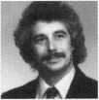

ALOA#

**Sunday**

ALOA, 3003 Live 214-827-1810 FAX

***Keynotes*** | 35

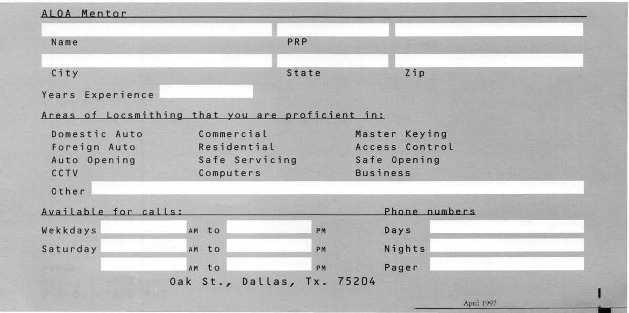

B Y

Dulcamaro,

C M L

In part two, I explained the details of impressioning. Like many other skills unfortunately, knowing what to do is quite different from actually doing it. If you want to be more profi­cient at impressioning, you must practice, practice, practice!

In the process of teaching many different students over the years, I have been somewhat amazed to see the dramatic differences between each persons ability to pick up the skill. I would start out with students whose previous knowledge of the subject was pretty much non-existent. A room full of people who were taught (and understood) the fundamental con­cepts of impressioning had such different rates of success.

For the majority of us, practice is the greatest factor that distinguishes mediocre skills from an excellent impressioning technique. For others, highly developed senses, or (by contrast) seemingly nonexistent senses, dictate the potential for success. Extremely poor eyesight is something that is difficult to overcome. The person with incredible eyesight has a distinct advantage over the rest of us with just average eyesight. We struggle to see the ever elusive impression marks, and sometimes with the aid of magnification or additional light, we man­age to impression a working key.

In this final part of the series, I will try to explain some of the pitfalls and a variety of spe-

**Impressioning**

cialized techniques for impressioning. I would like to preface that by stating the obvious: a lock with two tumblers impressions easier than one with five tumblers. I make that state­ment to encourage locksmiths who have attempted to impression, but have had little or no success.

Just as in lock picking, having more tumblers in a lock makes the job more difficult.

When there are more tumblers, there are obviously more places on the key surface that you will have to look to potentially find them. I won’t suggest that beginners should never start out trying to impression a key to a lock with five tumblers. What I will suggest is that if you start with a five-tumbler lock and have absolutely no success, don’t just quit and assume you will never be able to learn impressioning. I might advise you to take some of the tumblers out of the lock. You might start with a two- or three-tumbler lock, and if you have success at that level you could add more tumblers (one at a time) until you finally succeed at impres­sioning a five-tumbler lock.

Some locks will be much more difficult to impression than others. As a novice, don’t sabo­tage yourself by challenging one of the tough ones. If the tumbler surface (that makes con­tact with the key) is fairly flat or blunt, it will generate a less visible mark than a tumbler that more nearly comes to a point. Start out with easier locks, and as your skills improve, then challenge the tougher locks.

Seeing the Marks

Seeing the impression marks is one of the critical elements of impressioning. Being able to see the marks relies very heavily on your ability to generate those marks. The clearer the marks you can generate, the less work you will place on your eyes. I explained in part two that impression marks are gener­ated by the interaction of the tumbler with the key blank, where they make contact with each other. The harder the material that makes up the key blank, the greater the force that will have to be generated to cause the tumbler to penetrate the key surface.

I had mentioned earlier in the series that brass key blanks are the most commonly used for impressioning. They are soft enough to generate clear marks, but are strong and durable enough to withstand the torque required to bind the tumblers. Compared to

Part

everything else, they are probably the most cost effective. Over the years, there have been specially modified key blanks with lead (or a similar substance) in the path of the tumblers, which is softer than brass and easi­er to mark. I will discuss them later in this article. For the moment we will presume the use of brass key blanks.

When it comes to pin tumblers, the shape of the tumbler surface (that makes contact with the key) has considerable bearing as to how clearly the key will mark. Figure one shows the three tumbler profiles. “A” shows the most common style pin tumbler where the bottom surface almost comes to a point. “B” shows a broad and very blunt surface. The (general) shape in “B” is rarely found in new tumblers. Not many brands of locks come new with tumblers of that shape. You will more likely see that shape on severely worn tumblers—tumblers that probably (when they were brand new) looked like “A.” “C” shows a tumbler with a wide

chamfer and a rather broad, flat surface in the center. This tumbler shape can be found on Kwikset original pins and a few other brands.

Penetrating the Surface

During the process of impressioning, you apply torque (clockwise or counterclockwise) to the key blank to bind the tumblers.

When you bump the key blank up and down, you press the top surface of the key blank into contact with the bottom pin of a particular pin chamber. In figure two, “A” illustrates how the pointed end of the tum­bler penetrates the surface of the key blank. “B” shows the size of the mark left behind. If you can generate sufficient force (and move­ment) to cause deeper penetration as in “C,” the impression mark will be considerably larger as in “D.”

Three

If you take one of your fingers and push it into wet sand, you come against minimal resistance. If you take the palm of your hand and press it into the same wet sand, you will feel dramatically stronger resistance. You will also notice that the wide surface area of your palm greatly reduces the depth of pene­tration into the sand. The narrow surface area of your finger tip will allow much deep­er penetration.

Figure three illustrates the same principle with blunt surface tumblers. The wide sur­face area of the tumbler in “A” allows for very shallow penetration of the key blank surface. The dotted outlines of the impres­sion mark in “B” illustrate the reduced visi­bility of that mark compared to a mark that penetrates more deeply. The same applies in “C” with a Kwikset style pin, and the result­ing impression mark in “D.”

You See It, Why Can’t I?

I wish I could tell you that you will be

able to see real impression marks as easily as you see the neat little circles in these illustra­tions. Unfortunately, I can’t. It takes a trained eye to see impression marks, even with excellent eyesight.

You will be looking for a very minute indentation on top of a key blank surface that is about thirty five thousandths of an inch wide. Depending on the lighting avail­able, you will likely find yourself tilting the key at various angles until the light just barely reveals the location of the impression mark. You will have to distinguish it through the file striation marks (and other stray marks, such as specks of dirt and debris).

I know some of my descriptions here seem to imply that impressioning might be more difficult than brain surgery (then again, I don’t know any brain surgeons who

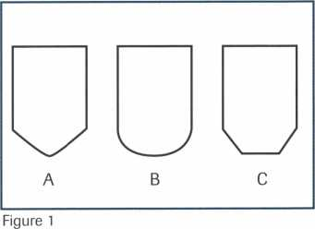

|  |  |  |  |  |
| --- | --- | --- | --- | --- |
| Side view | |  | Side view |  |
|  | k y | Key Surface |  |  |
| Top view | | A |  | c |
| O | |  | o |  |
|  | | B |  | D |
| Figure 2 | | | | |
| Side view | |  | Side view |  |
|  | \1 | Key Surface | \ / |  |
| Top view | | A |  | C |
|  | | | | |
|  | | B |  | D |

Figure 3

April 1997

Keynotes

can impression keys). It’s not an unattainable skill. With rare exceptions, those locksmiths who excel at impressioning got there by hard work, dedication and practice. If you are a serious student, you can probably become very good at impressioning—if you work at it.

In my years of teaching impressioning, I have only had one student who absolutely amazed me at how fast he learned how to do it. If my memory serves me, he had impres- sioned a key to a five-pin tumbler lock with­in one and a half hours of the start of the class. Then he impressioned a key to a sec­ond lock in about 10 to 15 minutes. I’ve had

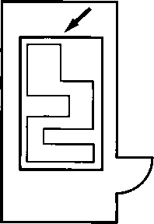

Figure 4

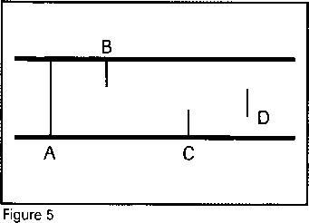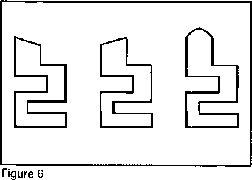

quite a few students successfully impression keys to five pin tumbler locks by the end of the class session, but nobody else has even come close to that one amazing student.

Improving Visibility

The highly reflective surface of the brass key blank is one of the stumbling blocks to seeing impression marks. Depending on your light source, you can catch a lot of glare in your eyes while trying to see them. There are a number of techniques that help you improve the visibility of impression marks.

Come to think of it, that one amazing student did use a special technique that may have contributed to his success. He was skilled as a machinist and had blue layout dye, which he brought with him to class. He used the blue dye to coat the surface of the prepared key blank. When the tip of the pin tumbler penetrated the surface of the key blank, it punched through the dull blue coating and left a shiny brass spot that stood out in contrast. The colored dye cut out the glare normally produced by the bright brass surface. It improved the visibility of the impression mark, making it easier to find.

I advise caution when using any type of coating over the key blank surface when impressioning. If you choose to use some kind of dye or marker, it should dry quickly. If the dye remains wet when you insert the key blank into the lock, it will leave a residue in the lock. That residue could either gum up the lock or find itself back on the key blank at times or spots where it inter­feres with your ability to see impression marks.

Also, the coating should not be excessive­ly thick. If the coating is too thick, the tum­bler will not break through and leave a clear­ly visible mark. And finally, it should not rub off easily. If it mbs off easily, the mere insertion of the key into the lock could remove the coating. The force of the tumbler springs could cause the bottom pins to drag across the top of the key surface and mb off the coating.

The same cautions apply for locksmiths who use a lit match or candle to create a thin layer of carbon or soot on the key surface, in order to improve impression marks. If the layer of carbon mbs off too easily, it just

makes the lock dirty and does not help at all.

Disc Tumbler Locks

The basic impressioning techniques that I described in part two (referring to pin tum­bler locks) generally apply to disc tumbler locks. You bind the tumblers, and bump the key up and down to create impression marks. Although you will probably use sim­ilar methods for impressioning either type of lock, the interaction between key and tum­bler is somewhat different for disc tumbler locks.

We are used to seeing somewhat circular impression marks when dealing with pin tumbler locks, because of the round shape of the tumblers. You should expect to see impression marks that appear more as lines than dots when you impression keys for disc tumbler locks. Figure four shows how the key fits within the tumbler inside a disc tumbler lock. There is a straight side to side surface (not unlike a knife blade) that makes contact with the key and creates whatever impression mark you will see.

Figure five shows a few examples of impression mark shapes for disc tumbler locks. “A” is a straight line that goes com­pletely across the surface of the key. “B” and “C” are incomplete lines that usually start at one edge or the other. “D” is an incomplete line that tends to straddle the center. More often than not, if you get a deep and clear impression mark for a disc tumbler lock, it will look like “A.”

The incomplete line impression marks are sometimes caused by angled file strokes by the impressioning locksmith. Figure six shows how angled surfaces don’t make com­plete contact with the tumbler surface. Similar shape impression marks are some­times found when impressioning master keyed disc tumbler locks. Figure seven shows a key blank within a mastered disc tumbler. Normally one key blank profile would operate the surface on the left end of the tumbler while a different key blank pro­file would operate the surface to the right. The key blank profile inside this tumbler shows the key surface in contact to be some­where in the middle and the likely impres­sion mark would probably not go complete­ly across the key surface. The force of

***Keynotes***

April 1997

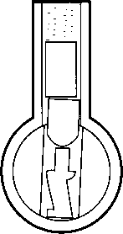

pins that will continue to mark after they’ve reached the shear line.

Another complication occurs with pad­locks that have (what I call) free floating lock cylinders, or other types of locks with simi­larly constructed lock cylinders. A prime example is some of the Master brand lami­nated pin tumbler padlocks. This circum­stance can occur in both rekeyable and non- rekeyable padlocks.

A lock cylinder, which is a separate com­ponent from the actual padlock body, fits within a cavity inside the padlock body. An opening in the bottom laminated plate, reveals the cylinder plug and the keyway broaching within it. A side cutaway view is illustrated in figure 12. The arrow points to the key shoulder that, with the addition of the rest of the key blade height, nearly fills the opening. If the key was rotated suffi­ciently to bind the tumblers, the upward motion (to press the key surface into the tumblers) would be limited by the opening. Since the lock cylinder does not fit tightly within the cavity in the padlock, the initial upward movement would not bump the tumblers. Instead, that movement would first lift the whole cylinder upward and, before the cylinder could be anchored by the inside surface of the cavity, the key would stop when the shoulder of the key hit the top of the opening. Since the key could not move any higher, no impression marks could be obtained.

A way around this complication would be to file down the shoulder (to the dashed lines near the arrow). It would give additional clearance and allow the key to lift high enough to first anchor the lock cylinder and then to move the key further to engage the tumblers and generate impression marks.

Speed Techniques

I have found a few useful techniques for speeding up the impressioning process. My favorite method involves cutting full depth increments when you see an impression mark. I use this method primarily on auto­motive locks, but also use it with commer­cial lock cylinders.

Whenever possible with this method, I prefer to use a motorized code machine. Punch machines tend to leave rough key cut

401 KeynotesApril 1997

surfaces that don’t reveal impression marks as easily. I usually start out with a prepared key blank cut with the shallowest depth in every tumbler position. That would normal­ly be #1 depth cuts in every position.

A motorized code machine tends to leave a nearly pristine surface. It’s extremely smooth and reveals impression marks very well. Also, when the tumbler spacing is set by the code machine, you know approxi­mately where to look for impression marks. I’ll use a Chrysler pin tumbler lock as an example.

The shallowest depth for the Chrysler pin tumbler locks was the #1 depth (.246 inch). After binding and bumping with a key cut to the #1 depth in every position, you will generate impression marks in one or more of the five tumbler positions. Everywhere that you’d find an impression mark, you’d cut the key down one depth. That means a #2 depth (.226 inch) cut for every impression mark.

If no mark showed up for particular pin positions, no cutting (for the time being) would occur. When another mark showed up, the key would be cut in full increments of .020 inch, instead of cutting five to ten thousandths at a time. Cutting in full incre­ments at a time speeds things up, and reduces the torque and strain on the key, which might otherwise cause premature key breakage while impressioning.

I’ve also used a variation of this technique with a hand file, although I’ll usually pre­pare the starting (shallowest) depth on a code machine to identify my cut spacing. I estimate the approximate amount of material that I cut per file stroke, and then determine the number of file strokes required to make one full depth increment. When I see an impression mark, I make enough file strokes to generate one full depth, then I verify that amount by measuring the key with a dial caliper. If it is not cut deep enough, I take a few more strokes to approximate a full depth. Once I am at full depths, I bind and bump again to find more impression marks. The procedure is repeated a full depth at a time until the key finally turns.

Special Tools, Etc.

Specially modified key blanks have been available through a number of different

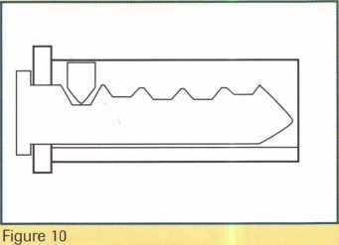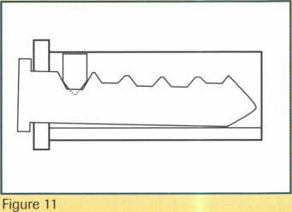

Figure 12

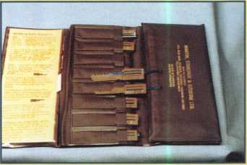

Photo 1

sources to presumably make impressioning easier. I’ve seen a couple different types with a lead-like substance in the path of the pin chambers, and they have definitely improved the ability to generate impression marks.

You have to be extra careful with those key blanks, because they show the false marks more easily and sometimes make you think you have to file even when you shouldn’t. With a slight modification in technique,

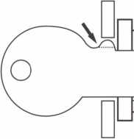

those kinds of blanks can be useful for locksmiths with less than adequate eyesight who have problems seeing marks on brass keys.

Many years ago, an absolutely fascinating set of plastic impres- sioning tools was available from a Canadian company. Shown in photo one, they were plastic base keys with slots made to the deepest possible depths in each tumbler position for a variety of domestic and import car locks. Adhesive backed foil was wrapped over the key blade area, and the normal binding and bumping action of impressioning actually caused the tumblers to physically cut into the foil and find the tumbler depths automatically. No fil­ing was required, but instead, after the tumblers found the depths from the impressioning motions, the base key finally turned and operated the lock. A special spring steel slide was slid into the tool to push the tumblers out of the slots, so the tool could be removed and decoded.

They were excellent tools and made impressioning almost effortless. Unfortunately, the tools were limited to certain simple keyway profiles and, even worse, the company eventually folded. Tools were never made for commercial lock cylinders by that com­pany, but very recently I have run into a brand new tool that works on the same basic concept (watch for the article in the June “Tools” issue of Keynotes).

Improving your impressioning skills can do nothing but help you as a working locksmith. Being able to impression can get you out of a jam and otherwise make your work day easier when deal­ing with locks without keys. If you don’t already impression fairly well, I would urge you to practice to improve. Or, even better— next time your local (or national) association puts on an impres­sioning class, take full advantage of that educational experience. It will pay off very well in the long run.

About the Author: Sal Dulcamaro, CML, has been in the  
locksmith business for over 21 years. He is the president of All Pro Security,  
Inc. in Michigan and has been an ALOA member for 13 years. A past  
president of the Locksmith Security Association of Michigan, Sal currently  
serves as editor of the association newsletter. He was named “Keynotes  
Author of the Year” for 1996.



Not only are we stocked with the products just an “order taker” you are getting a you see below but we are equally stocked security hardware professional that really with quality people too. JLM’s technical knows what they are doing. Offering ability to solve your problems wholesale prices, superior

are second to none. With years Stock! sa^es assistance, top of the line

of experience in the security *** * products, large inventory and

hardware business, JLM provides sales a customer focused attitude, JLM can assistants that are trained and up to date lead you to new areas of higher profits and on the latest advances in the industry, success rather than leaving you wonder- When you call JLM, you are not getting ing what went wrong.

Aiphone / Altronics l Adams Rite / Alarm Lock / Folger Adam Security  
Glynn Johnson / LCN Closers / Locknetics Security Engineering  
Select Products / Roton / Securitron / Security Door Controls / Von Duprin

Wholesale Prices Superior Service

Phone: 800-522-2940 / 810-628-6440  
Fax: 800-782-1 160 / 810-628-6733  
Website: [www.jlmwholesale.com](http://www.jlmwholesale.com)

Reader Service #18

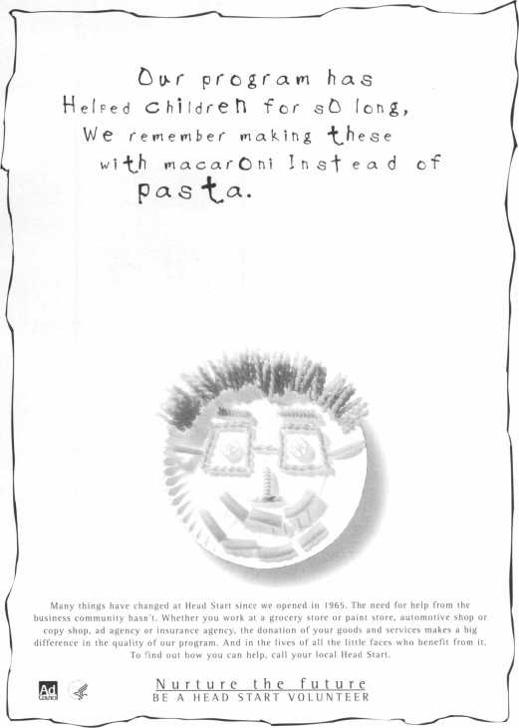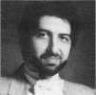

April 1997

Keynotes



Some of the educational activities are fun, and some things are scheduled just for the purpose of having fun.

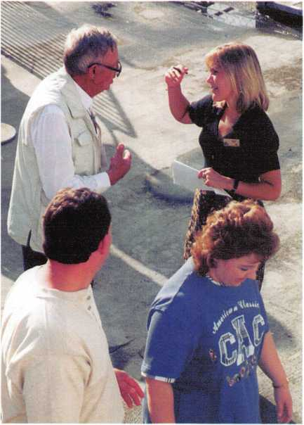

with a spectacular view of the mountains and the valley. The tournament entry fee of $150 is not much when you consider that this includes breakfast, lunch and dinner, as well as unlimited free drinks during play Everyone who enters will also receive a prize of some sort. Anyone who likes to play golf, and maybe some who don’t, will enjoy play­ing at the ALOA Open.

From 8 o’clock each morning to as late as you care to be awake each evening, there is something useful to do at the ALOA convention. Some of the educational activi­ties are fun, and some things are scheduled just for the purpose of having fun. While the convention may never rival Disney World as America’s most popular tourist destination, it is, and will remain, a very popular event for locksmiths and other security professionals.

About the Author: Charles W. Gibson,

Jr. is the Staff Administrator at ALOA.

When I write this article about convention, I  
am usually trying to demonstrate to people  
who have not attended that going is a good  
idea. I’ve explained that there are opportuni-  
ties to learn through the classes and the  
trade show. I’ve talked about the free semi-  
nars and the manufacturers’ classes. I’ve  
mentioned the chance that all in attendance  
have to meet other professionals who share  
their interests and concerns. All of these are  
very good reasons to attend the ALOA con-  
ventions. One thing I don’t talk about  
enough is the opportunity to have fun.

Some of the things I think are fun would-  
n’t appeal to some of you. The nice thing  
about the convention week is that there are  
so many different things to do that some-  
thing must be there that will appeal to you.

The convention committee  
attempts to start the “fun”  
process by selecting a city that  
has its own unique character.

This year’s choice, Reno, is a city  
that offers quite a lot. There are  
casinos for those who think lock-  
smithing isn’t enough of a gam-  
ble. There are the Las Vegas style  
shows, magicians, acrobats,  
comedians, dancers and more.

Reno is not far from Tahoe,  
which offers beautiful scenery and  
outdoor recreation.

Aside from what the city offers  
without any help from us, there  
are some special arrangements  
made by ALOA. We have sched-  
uled tours on three days. If you  
are in class each day, you won’t be  
able to go on one of these. But  
many of you don’t go to class on  
all of the class days. Those who  
bring guests normally appreciate  
the tours being available. This

year’s tours will take those participating to  
some of the unique attractions of the area.  
There is a lake cruise, a trip to shop for  
antiques and a trip to Virginia City, where  
some of the flavor of America’s wild west  
past is preserved. Other events are scheduled  
as part of the convention program.

The banquet this year fea­tures the sounds of a “big band,” as well as a comedi­enne. There will be a recep­tion Wednesday night before the opening of the trade show. The details of this event are not yet final, but it will be an enjoyable evening as it always has been in the past.

One thing that is not only fun, but helpful to the profes­sion, is the ALOA Open Golf Tournament. Last year this tournament, sponsored by Yale Security Products, result­ed in a $10,000 donation to the ALOA Scholarship Foun­

dation. The Foundation has been helping locksmiths attend classes or many years and depends on the tournament for much of its financial support. The tournament this year will be played at the Wild Creek Country Club. I played this course last year. It’s a challenging course, situated on rolling hills

42

Keynotes

April 1997

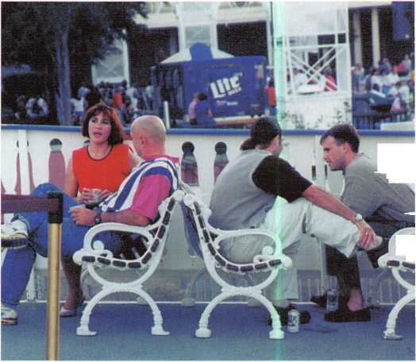

ALOA Video Library

**Order Form**

Policies of the ALOA Video Tape Library and procedure for ordering videos:

1. Videos are loaned to ALOA members, chapters and local associations for a period of one (1) week. All tapes

are VHS format. Notice: All video tapes are protected under the US copyright laws and may not be duplicated.

1. Only one tape per order is allowed unless prior arrangements have been made with the ALOA office; e.g., chapters holding educational events.
2. Charges: $5.00 per tape for shipping and handling.

$10.00 per day late charge. Late charges are assessed for tapes more than 2 days late.

$100.00 per tape for loss or damage.

1. Payment for shipping and handling must accompany the order, except for faxed orders. Any additional charges will be billed to the borrower.
2. A credit card account number must be included on the video order form as a deposit. If the video is not returned, your credit card will be billed for late charges or for loss/damages.

Credit card # Expiration date

1. It is the responsibility of the borrower to insure each tape for the $100 against loss or damages when returning videos to the ALOA Library.
2. Failure to remit shipping and handling, late, or any other charges may result in suspension of borrowing privileges.
3. To order a video, indicate 1st, 2nd, and 3rd choices on this form, fill out the bottom portion completely, and

mail the entire form to: ALOA Video Department, 3003 Live Oak St., Dallas, Tx 75204

1. Orders may also be faxed to (214) 827-1810.

|  |  |  |
| --- | --- | --- |
| □ | 99 Rim Device Installation | □ |
| □ | Advanced Door Panel Servicing | □ |
|  | Volume 1 | O |
| □ | Air Bag Steering Columns | □ |
|  | Volume 1 | □ |
| □ | Air Bag Steering Columns | □ |
|  | Volume 2 | □ |
| □ | Auto Lock Servicing Update #1 | □ |
| □ | Automatic Dialer | □ |
| □ | Basic Car Opening, Vol. 1 | □ |
| □ | Basic Door Panel Servicing | □ |
| □ | Basic Locksmithing, Volume 1 | □ |
|  | Beretta & Corsica: Opening | □ |
| □ | and Fitting Keys | □ |
|  | Business Locks and | □ |
| □ | Locking Devices | □ |
| □ | Car Opening Update #1 | □ |
| □ | Car Opening Update #2 | □ |
| □ | Car Opening Update #3 | □ |
| □ | Car Opening Update #4 | □ |
| □ | Car Opening Update #5 | □ |
| □ | Car Opening Update #6 | □ |
| □ | Car Opening Update #7 | □ |
| □ | Car Opening Update #8 | n |
| □ | Chrysler Double-Bitted Locks | n |
| □ | Chrysler Pin Tumbler Locks |  |
| □ | Chrysler Steering Columns |  |

* except for faxed orders and orders from outside the US

Detention Locks

The Door to Business Security

The Door to Home Security

Filing for Dollars

Ford Locks

Ford Steering Columns GM Locks

GM Steering Columns

Home Security Alarms

Home Security Survey

Import Models, Volume 2

Impressioning GM/Ford Sidebar Locks

Labeled Fire Door

Lock Mortiser

Mastering the Art of Impressioning

On the Home Front

Padlocks

Pinning KABA

Plugging for Profit

Precision Key Machines

Residential Locks and Locking Devices

Residential Magnetic Contact Applications

Robbery Prevention Techniques

S&G 6120 Series

S&G Combination Lock Fundamentals for the R6730-TOR (5/90)

Q S&G Commercial Products (2/90)

Q S&G Government Products (8/89)

* S&G Integrating High Security with Life Safety
* S&G Locking Mechanisms (6/89)

**[~j** S&G R6730-TOR Combination Lock pT (8/90)

S&G Scrambler Servicing

* Safe Deposit Locks, Volume 1
* Safe Deposit Locks, Volume 2 Q Safe Deposit Locks, Volume 3 Q Servicing the Honda and Acura

Q Servicing the Toyota & Similar Locks

* Shock and Moisture Sensors:

High Security Risks

* Somebody's Watching
* Standard Steel Door Frames Q Standard Steel Doors

**Q** Thief on the Loose!

Commercial Glass Break Applications Q Toyota Split - Tumbler Locks: Use and Adjustment of Gemini Key

* V.A.T.S. Made Simple

Q What's Behind a Fire Door Test Label? Q Yale Door Closers

**1/97**

ALL INFORMATION MUST BE COMPLETE OR PROCESSING MAYBE DELAYED

ALOA Member # Date Needed:

Name **Phone #**

Address (No P.O. Box)

City State ZIP

Enclosed is ^ Check Money Order for shipping & handling

|  |  |  |  |
| --- | --- | --- | --- |
| Associ | iai | te | / |
| Members | | | \ |

■0

|  |  |
| --- | --- |
| Manufacturers | Alarm Lock Systems, Inc.  345 Bayview Ave.  Amityville, NY 11701 (800) ALA-LOCK; (516) 789-3383  © |
| A & B Safe Corp.  171 S. Delsea Dr.  Glassboro, NJ 08028  C800] 253-1267; FAX (609) 863-1208  (g (fj |g) | All-Lock Company  900 Ravenwood Dr.  Selma, AL 36701  (334) 874-9001; FAX (334) 874-6011  g g |
| Access Protection Mfg.  216 Plaisto Rd.  Plaisto, NH 03865  (603) 382-0822; FAX (603) 382-0833  © | Allied-Gary Safe Company  West 425 2nd Ave.  Spokane, WA 99204 (509) 458-2633; FAX (509) 458-2633  (0 § |
| Adesco Safe Manufacturing Co.  16720 S. Garfield Ave.  Paramount, CA 90723 (800) 821-6803; FAX (310) 408-6427 | American Lock Co.  3400 West Exchange Road  Crete, IL 60417-2099 (708) 534-2000; FAX (708) 534-0531  © © |
| ASSA Inc.  10300 Foster Ave.  Brooklyn, NY 11236 (718) 927-2772; FAX (718) 257-2772  © | American Security Products  11925 Pacific Ave.  Fontana, CA 92337-6963 (909) 685-9680; FAX (909)685-9685  g ^ |
| Abloy Security, Inc.  6015 Commerce Drive Ste. #450  Irving, TX 75063  (972) 753-1127; FAX (972) 753-0792  © | Arrow Lock Company  10300 Foster Avenue  Brooklyn, NY 11236 (718) 257-4700; FAX (718) 649-9097  g g © © |
| Abus Lock Company  P.O. Box 47507  Plymouth, MN 55447-0507 (800) 225-5348  © | Auto Security Products (A. S. P.)  P.O. Box 10  Redmond, WA 98073-0010 (206) 556-1900; FAX (206) 558-1205  g g |
| Adams Rite Manufacturing Co.  4040 S. Capital Ave.  City of Industry, CA 91749 (310) 699-0511; FAX (310) 699-5094  (g| (g | Baton Locks & Hardware Co.  14275 Commerce Dr.  Garden Grove, CA 92643 (714) 265-3636; FAX (714) 265-3630  g (g) |
| Adrian Steel Company  906 James St.  Adrian, Ml 49221  (517) 265-6194; FAX (517) 265-5834  ® | Best Locking Systems of Louisville  10310 Bluegrass Pkwy  Louisville, KY 40299 (502) 491-4042 |
| Aiphone Intercom Systems  1700-130th Avenue, NE  Bellevue, WA 98005 (206) 455-0510; FAX (206) 455-0071  g g (g | Cannon Safe, Inc.  9358 Stephens St.  Pico Rivera, CA 90660 (800) 242-1055; FAX (310) 692-7252  g |
|  |  |

Associate members of the Associated Locksmiths of America (ALOA) manu­facture or distribute materials or equip­ment, or provide services, for the securi­ty industry. Many have donated money, services and equipment to ALOA in addition to their annual dues. Their sup­port of ALOA projects enhances overall membership benefits and we encourage our members to patronize these firms. If you know of a potential candidate for associate membership, please contact the ALOA Sales staff at (214) 827-1701. Associate member dues are $500 per year and entitle the payor to use the ALOA logo, and selected discounts on ALOA products and services.

Legend

® Alarms: Personal, vehicle, electronic, fire, burglar, and exit

@ Bank security equipment

® Automotive: Lockout equipment, key chains/rings

*§ Builders Hardware: Door closers, furniture/decorative hardware, viewers, emergency exit devices

® Business/Technical & Educational:

Books, reference guides, publications, computer software

® CCTV/Photo Imaging: Cameras, monitors, photo ID equipment, cables

@ Electric/Electronic Security: Card access control and readers, surveil­lance, electric/magnetic locks and strikes, keypads

® Lock Devices: Auto locks, cylinders, emergency exit/entrance control, locks (various types), strikes

® Tools & Supplies: Key blanks, cutters, picks, rings/hooks, custom van/truck supplies

® Safes/Vaults

® Other

Associate

Members

|  |  |  |
| --- | --- | --- |
| Chicago Lock Company  10100 88th Ave.: P.O. Box 0069  Pleasant Prairie, Wl 53158-0069 (414) 947-7177; FAX (414) 947-7178 | Fort Lock Corp.  3000 N. River Rd.  River Grove, IL 60171 (708) 456-1100; FAX (708) 456-9476 | Industries, C.L. Inc.  9730 Gouin Blvd. West  Pierrefonds (PQ) H8Y 1R5 (514) 683-6282; FAX(514) 683-9015 |
| 0 | 000000 | 0 0 |
| Corbin Russwin Architectural Hardware  P.O. Box 25288  Charlotte, NC 28229 (704) 283-2101 | Gardall Safe Corporation  P.O. Box 30  Syracuse, NY 13206 (315) 432-9115; FAX (315) 434-9442 | International Electronics, Inc. (I.E.I.)  427 Turnpike St.  Canton, MA 02021 (800) 343-9502; FAX(617) 821-4443 |
| • • • • | 0 | 0 |
| Curtis Industries  6140 Parkland Blvd.  Mayfield Heights, OH 44124 (800) 555-5397 | Glenncraft Corporation  205 Fortin Dr.  Woonsocket, Rl 02895-6116 (401) 769-0101; (401) 766-1170 | Jet Hardware Mfg. Co.  800 Hinsdale Street  Brooklyn, NY 11207 (718) 257-9600; FAX(718) 257-0973 |
| 0 0 |  | 0 |
| DETEX  302 Detex Dr.  New Braunfels, TX 78130 (800) 729-3839; FAX (210) 620-6711 | Grobet File Co. of America  750 Wasahington Ave.  Carlstadt, NJ 07072 (800) 962-7242; FAX (800) 243-2432 | KABA High Security Locks  P.O. Box 490  Southington, CT 06489 (860) 621-3601; FAX(860) 621-9727 |
| 00 0 0 | 0 | 0 |
| DOM Security Locks North America  100 Central Ave,  Brockville, Ontario, Canada K6V 5W6 (800)363-4803; FAX (613) 498-5820 | GT-85 International, Inc.  P. 0. Box 21185  St. Petersburg, FL 33742-1185 (800) 525-GT85; FAX (813) 526-1234 | Kenstan Lock Company  101 Commercial St.  Plainveiw, NY 11803-2412 (516) 271 -2700; FAX(516) 271 -2759 |
| 0 | 0 | 0 0 |
| Don-Jo Manufacturing, Inc.  P.O. Box 929  Sterling, MA 01564 (508)422-3377; FAX (508) 422-3467 | H.E.S., Inc.  2040 W. Quail Ave.  Phoenix, AZ 85027 (602) 582-4626; FAX (602) 582-4641 | KEY-BAK; Div. of W. Coast Chain Mfg. Co.  1460 S. Balboa Ave.  Ontario, CA 91762 (909) 923-7800; FAX(909) 923-0024 |
| 0 0 | 0 0 0 | 0 0 0 0 |
| Door Controls International  2362 Bishop Circle East  Dexter, Ml 48130  (800) 742-3634; FAX (800) 742-0410 | Highland Glen Products, Inc.  218 Parkdale Ave.; P.O. Box 924  Buffalo, NY 14213 (716) 883-1110; (800) 248-KEYS | Knaack Manufacturing Co.  420 E. Terra Cotta Ave.  Crystal Lake, IL 60014 (800) 456-7865; FAX(815) 459-9097 |
| 00 0 0 | 0 0 | 0 |
| Emtek Products, Inc.  15250 E. Stafford St.  City of Industry, CA 91744 (800) 356-2741; FAX (800) 577-5771 | Hill Security Products  711 East Walton Avenue  Spokane, WA 99207 (509) 487-1142; (800) 722-1142 | Kwikset Corp.  One Park Plaza, Suite 1000  Irvine, CA 90638  (714) 474-8818; FAX (714) 474-8879 |
| 0 0 | 0 | 0 0 |
| ESP Lock Products, Inc.  375 Harvard Street  Leominster, MA 01453 (508) 537-6121; FAX (508) 537-1699 | HPC, Inc.  3999 N. 25th Avenue  Schiller Park, IL 60176 (847) 671-6280; FAX(847) 671-6343 | LCN Closers (Division of Ingersol)  121 W. Rail Road Ave.  Princeton, IL 61356 (815) 875-3311; FAX (815) 875-3222 |
| 0 | 0 0 0 | 0 |
| Federal Lock Company  14247 E. Don Julian Rd.  City of Industry, CA 91746 (800) 682-9851; FAX (708) 378-4767 | Hurd Corporation  Box 1450  Greeneville, TN 37744-1450 (423) 787-8800; (423) 787-8817 | LAB Security  700 Emmett St.  Bristol, CT 06010  (800) 243-8242; FAX (203) 583-7838 |
| 0 | ^ | 0 |
| Folger Adam Security, Inc.  16300 W. 103rd Street  Lemont, IL 60439  (630) 739-3900; FAX (630) 739-6138 | llco Unican  400 Jeffreys Road  Rocky Mount, NC 27804 (919) 446-3321; FAX (919) 446-4702 | La Gard, Inc.  3330 Kashiwa Street  Torrance, CA 90505 (310) 325-5670; FAX (310) 325-5615 |
| 0 0 | 0000000 | 0 |
|  | 0 Business/Tech & Ed.  0 CCTV/Photo 1Imaging  0 Electric/Electronic Sec. | 0 loals&Supplies  0 Safes/Vaults -0 Other |

April 1997

Associate

Members

|  |  |  |
| --- | --- | --- |
| Locksmith Publishing Corp.  850 Busse Hwy.  Park Ridge, IL 60068 (847) 692-5940; FAX (847)692-4604 | MUL-T-LOCK USA, Inc.  300-1 Route 17 South Suite A  Lodi, NJ 07644  (800) 562-3511; FAX (201) 778-4007 | Rofu International Corp.  2004-B 48th Ave.; Court E  Tacoma, WA 98424 (800) 255-7638; FAX (206) 922-1728 |
| • | • • • | 0 |
| Lockmasters, Inc.  5085 Danville Rd.  Nicholasville, KY 40356 (606) 885-6041; FAX (606) 885-7093 | National Cabinet Lock  200 Old Mill Road, P. 0. Box 200  Mauldin, SC 29662 (864) 297-6655; FAX (864) 297-9987 | Rutherford Controls Inc.  2697 Internal Pkwy, Bid 5 #100  Virginia Beach, VA 23452 (757) 427-1230; FAX (804) 427-9549 |
| • • • • • | • | 9 |
| Lori Lock/Delta  P.O. Box 1040  Southington, CT 06489 (203) 621-3605; FAX (203) 621-5972 | The National Locksmith Magazine  1533 Burgundy Parkway  Streamwood, IL 60107 (630) 837-2044; FAX (630) 837-1210 | Sargent & Greenleaf, Inc.  P.O. Box 930  Nicholasville, KY 40340-0930 (606) 885-9411; FAX (606) 887-2057 |
| • 0 | ® | 9 0 0 9 |
| Lucky Line Products  7890 Dunbrook Rd.  San Diego, CA 92126 (619) 549-6699; FAX (619) 549-0949 | New England Lock & Hardware  46 Chestnut St.  South Norwalk, CT 06856 (203) 866-9283; FAX (203) 838-4837 | Schlage Lock Co.—PRIMUS  3899 Hancock Expy.  Security, CO 80911 (719) 390-5071 |
| 0 | • e | 9 9 |
| Lund Equipment Co.f Inc.  P.O. Box 213  Bath, OH 44210  (216) 659-4800; FAX (216) 659-9347 | Newman Tonks  P.O. Box 548  Shepardsville, KY 40165 (502) 543-2281; FAX (800) 777-8229 | Schwab Corporation  PO Box 5088  Lafayette, IN 47903-5088 (317) 447-9470; FAX (317) 447-8278 |
| 9 • • | • e | 9 |
| M.A.G. Engineering & Mfg. Inc.  15261 Transistor Lane  Huntington Beach, CA 92649 (714) 891-5100; FAX (714) 892-6845 | NT Falcon Lock  2650 Orbitor Street  BreaCA, 92621-6265 (800) 266-4456; FAX (800)777-8229 | Securitron Magnalock Corp.  550 Vista Blvd.  Sparks, NV 89434  (800) 624-5625; FAX (702) 355-5636 |
| • • • | 0 • | 9 0 |
| MARKS USA  5300 New Horizons Blvd.  Amityville, NY 11701 (516) 225-5400; FAX (516) 225-6136 | Pach & Company  941 Calle Negro  San Clemente, CA 92672 (714) 498-2951; FAX (714) 498-6879 | Security Door Controls  P. 0. Box 6219  Westlake Village, CA 91359-6219 (805) 494-0622; FAX (800) 959-4732 |
| 0 | 0 0 | 9 |
| Master Lock Company  2600 North 32nd Street  Milwaukee, Wl 53210 (414) 444-2800; FAX (414) 449-3114 | Prime Line Products Company  4185 Hallmark Pkwy.  San Bernadino, CA 92407 (909) 887-8118; FAX (909) 880-8968 | Sentry Group  900 Linden Ave.  Rochester, NY 14625-2784 (716) 381-4900; FAX (716) 381-8559 |
| • • | 0 0 | 0 |
| Medeco Security Locks  P.O. Box 3075  Salem, VA 24153  (540) 380-1684; FAX (540) 380-5010 | Pro-Lok  655 North Hariton Street  Orange, CA 92668-1311 (714) 633-0681; FAX (714) 633-0470 | Silca Key U.S.A. Inc.  5633 Hudson Industrial Pkwy.  Hudson, OH 44236 (216) 656-5613 |
| • • • | 9 9 | 0 9 |
| Meilink Safe Company  111 Security Parkway  New Albany, IN 47150 (800) 634-5465; FAX (800) 896-6606 | Rainbow Technology  261 Cahaba Valley Pkwy.  Pelham, AL 35124-1146 (800) 637-6047; FAX (800) 521-6896 | Star Key Industries,Inc.  145 Brite Ave.  Scarsdale, NV 10583-1426 (914) 235-1700 |
| ® | 9 | 9 |
| Metalurgica Odis S.A.  Porto Seguro 4395 Quinta Norma  P.O. Box 107-2; Santiago, Chile (562) 776-6511 | Rev-A-Shelf, Inc.  2409 Plantside Dr.  Jeffersontown, KY 40299 (502) 499-5835 | STRATTEC Security Corp.  3333 W. Good Hope Rd.  Milwaukee, Wl 53209 (414) 247-3333; FAX (414) 247-3329 |
| • | 9 | ^ |
| .'®- Alarms  ® Bank security equip.  9 Automotive  9 Builders Hardware | ® Business/Tech & id.  9 CCTV/Photo Imaging  9 Electric/Electronic Sec.  9 Lock Devices | ® Tools & Supplies  9 Safes/Vaults ® Other |

46

***Keynotes***

April 1997

Associate

Members

|  |  |  |
| --- | --- | --- |
| Sully Tools Inc.  3515 Nodding Pine Ct.  Fairfax, VA 22033  (703) 689-3416; FAX (703) 787-0869  (0) | Akron Hardware Consultants, Inc.  2579 South Arlington Road  Akron, OH 44319  [800) 321-9602; FAX [800) 328-6070  0 0 0 | Dugmore & Duncan Inc.  30 Pond Park Rd.  Hingham, MA 02043 [800) 225-1595; FAX [617) 740-4043  0 0 0 0 0 0 0 |
| Treskat USA  725 Adriane Park Circle  Kissimmee, FL 34744 [800) 645-5657; FAX [407) 870-9696  <D | American Security Distribution  4411 E. La Palma  Anaheim, CA 92807 [714) 996-0791; FAX [714) 579-3508  0 0 0 (0 0 0 0 | Ewert Wholesale Hardware  4709 W 120th St  Alsip II 60658 [800) 451-0200  0 (0 0 0 0 |
| Trine Products Corporation  1430 Ferris Place  Bronx, NY 10461  [718) 829-4796; FAX [718) 792-9127  (|J| (0 (0 | Andrews Wholesale Lock Supply  544 S. 9th St.  Lebanon, PA 17042-6608 [717) 272-7422  0 | Fairway Supply, Inc.  2631 Lombardy Lane  Dallas, TX 75220  [214) 350-0021; FAX [214) 352-4299  0 0 0 (0 0 0 0 |
| U-Change Lock Industries  1640 W. Hwy. 152  Mustang, OK 73064 [405) 376-1600; FAX [405) 376-6870  <|j) 0 0 | Armstrong’s Lock & Supply, Inc.  1440 Dutch Valley Place NE  Atlanta, GA 30324  [800) 726-3332; FAX [404) 888-0834  0000000000 | Foley-Belsaw Company  6301 Equitable Road  Kansas City, MO 64120 [800) 821-3452; FAX [816) 483-5010  0 0 0 0 |
| Vindicator Corp.  3001 Bee Caves Rd.  Austin, TX 78746-5561 [512) 314-1200; FAX [512) 314-1270  © 0 0 0 | Boyle & Chase Inc.  P. 0. Box 74  Accord, MA 02018-0074 [800) 325-2530; FAX [617) 335-5342  0 0 (0) | Fried Brothers, Inc.  467 N. 7th St.  Philadelphia, PA 19123 [800) 523-2924; FAX [800) 541-3489  0 0 0 0 © 0 © 0 <9 © |
| Weiser Lock Company  6700 Weiser Lock Blvd.  Tucson, AZ 85746  [520) 741-6231; FAX [520) 741-6363  (0) (0 | Canada Lock Products Ltd.  70 Floral Parkway  Toronto, ON Canada M6L 2C1 [416) 248-5625; FAX [416) 248-9945  0000000000 | H. Hoffman Company  7330 West Montrose  Chicago, IL 60634 [708) 456-9600  00000000 |
| Wilson Safe Company  3031 Island Avenue/P.O. Box 5310 Philadelphia, PA 19153 [215) 492-7100; [800) 345-8053  0 | Clark Security Products, Inc.  4775 Viewridge Ave.  San Diego, CA 92123-1641 [800) 854-2088  0000000000 | HS&S Wholesale Distributors  12915 West 8 Mile Road  Detroit, Ml 48235 [800) 521-2202  0 0 0 0 © 0 0 |
| Yale Security Inc.  P.O. Box 25288  Charlotte, NC 28229-8010 [704) 283-2101  0 0 (0 0 | Cook’s Building Specialties  2441 Menaul Blvd. NE; P.O. Box 37320 Albuquerque, NM 87176-7320 [505) 883-5701; FAX [505) 883-5704  0 0 0 0 0 0 | Hans Johnsen Company  8901 Chancellor Row  Dallas, TX 75247  [214) 879-1550; FAX [214) 879-1530  0 0 0 0 0 0 0 0 |
| Distributors | DiMark International  3117 Liberator St., Unit A  Santa Maria, CA 93455 [800) 235-2435; FAX [805) 928-8034 | Hardware Agencies, Ltd.  1220 Dundas Street East  Toronto, ON M4M 1 S3 [416) 462-1921  0 0 0 0 (0 0 0 0 |
| Accredited Lock Supply Co.  P.O. Box 1442  Secaucus, NJ 07096-1442 [800) 652-2835; FAX [201) 865-5031  0 |0 © (0 0 0 0 | Dire’s Lock & Key Co.  2201 Broadway  Denver, CO 80205 [303) 294-0176  00000000000 | Hardware Suppliers of America  P.O. Box 2208  Winterville, NC 28590 [800) 334-5625  0 0 |
| Ace Lock & Security Supply Co.  565 Rahway Ave.  Union, NJ 07083-6631 [908) 688-7666; [800) ACE-FAX4  00000000 | Doyle Lock Supply  2211 W. River Road N.  Minneapolis, MN 55411 [800) 333-6953; FAX [612) 521-0166  00000000000 | IDN, Inc.  1000 S. Main, Suite 280  Grapevine, TX 76051 [817) 421-5470; FAX [817) 421-5468  0000000000 |
| © Alarms © Business/Tech & Ed.  © Bank security equip. © CCTV/Photo Imaging  ® Automotive © Electric/Electronic Sec.  © Builders Hardware ® Lock Devices | | © Tools & Supplies © Safes/Vaults © Other |

47

April 1997

Keynotes

Associate

Members

|  |  |  |
| --- | --- | --- |
| IDN—Armstrong’s, Inc.  1440 Dutch Valley Place NE  Atlanta, GA 30324 (800) 726-3332 | McManus Locksmith Supply, Inc.  P.O. Box 9231, 1309 Central Ave.  Charlotte, NC 28299 (702) 333-9112  g g g | Strauss Safe & Lock Company  1801 Second Avenue  Des Moines, IA 50314 (515) 288-9571; FAX: (515) 288-9752  g g g g g g |
| Intermountain Lock & Supply Co  2300 W. 2nd Ave„ Unit B  Denver, CO 80223  (800) 323-8046; FAX (303) 698-2094  gggggggggg | McMaster-Carr Supply Company  600 County Line Rd,  Elmhurst, IL 60126-2081 (630) 833-0300; FAX (630) 834-9427  g g g g g g | Top Notch Distributors, Inc.  P.O. Box 189  Honesdale, PA 18431 (800) 233-4210  g g g |
| Jo-Van Distributors Inc.  929 Warden Ave.  Scarborough, Ontario MIL 4C6 (416) 752-7249; FAX (416) 752-3845  ggggggggggg | Monaco Lock Co.  339-345 Newark Ave.  Jersey City, NJ 07302 (800) 526-6094; FAX (800) 845-LOCK  g g g | Turn 10 Wholesale  P.O. Box 746  Marietta, OH 45740 (800) 848-9790; FAX (800) 391-4553  g |
| JLM Wholesale, Inc.  3095 Mullins Ct  Oxford, Ml 48371-1643 (800) 522-2940; FAX (800) 782-1160  g © © | New England Business Service, Inc.  500 Main St.  Groton, MA 01471 (508) 448-6111 | U.S. Lock Corporation  77 Rodeo Drive  Brentwood, NY 11717 (800) 925-5000; FAX (800) 338-5625  g g g g g |
| Key Sales & Supply Co., Inc.  9950 Freeland Ave.  Detroit, Ml 48227 (313) 931-7720; (313) 931-7758  ggggggggg | Omaha Wholesale Hardware  1201 Pacific Street, PO Box 3628  Omaha, NE 68108 (800) 238-4566  g g g | Webster Safe & Lock Company, Inc.  3020 Millbranch  Memphis, TN 38116 (901) 332-2911; FAX (901) 332-2878  g g g g g g g |
| Lockmasters, Inc.  5085 Danville Road  Nicholasville KY, 40356 (606) 885-6041  g g g g | E. L. Reinhardt Co., Inc.  3250 Fanum Road  Vadnais Heights, MN 55110 (800) 328-1311; FAX (612) 481-0166  g g g g g g | Service |
| Locks Company  2050 N.E. 151 St.  N. Miami, FL 33162 (800) 288-0801; FAX (305) 949-3619  g g ® <0 g ® g | Security Lock Distributors  40 A Street  Needham Heights, MA 02194 (800) 847-5625; FAX (800) 878-6400  g g g | Allstate Insurance Company  2775 Sanders Road, Suite A5  Northbrook, IL 60062 (847) 402-8196; FAX(847) 326-7509 |
| Locksmith Store Inc.  1229 E Algonquin Rd. Suite E  Arlington Heights, IL 60005 (847) 364-5111; FAX (847) 364-5125  g g g g | Sentry Security Fasteners  8109 N. University  Peoria, IL 61615  (309) 693-2800; FAX (309) 693-2872  § ® | GE Capital Fleet Services  Three Capital Drive  Eden Prairie, MN 55347 (612 828-2928; FAX (612) 828-1766 |
| M. Zion Company  17 Murray Street  New York, NY 10007 (212) 349-8677  g g g g (0 g g | Southern Lock and Supply Co.  Box 1980, 10910 Endeavor Way  Pinellas Park, FL 34664 (800) 237-2875; FAX: (800) 447-2299  ggggggggg | Gil-Ray Tools, Inc.  P.O. Box 801, 1306 McGraw St.  Bay City, Ml 48707 (517) 892-6870; FAX (517) 892-6870 |
| Mayflower Sales Company, Inc.  614 Bergen Street  Brooklyn, NY 11238 (718) 622-8785; FAX (718) 789-8346  g g g (0 g g g | Southwest Mini-Keys Inc.  2323 N. Central Expwy, Suite 165  Richardson, TX 75080 (214) 669-1704 | National Key & Road Service  124 Stratford Dr.  Louisburg, NC 27549 (919) 497-0474; FAX (919) 497-5555 |
| McDonald-DASH Locksmith Supply  5767 E. Shelby Dr.  Memphis, TN 38141 (800) 238-7541; FAX (901) 366-0005  gggggggg | Stone & Berg Wholesale  99 Stafford Street  Worcester, MA 01603 (800) 225-7405; FAX (800) 535-5625  gggggggggg | Pine Technical College  1000 4th Street  Pine City, MN 55063 (800) 521-7463; FAX (612) 629-7603 |
| © Alarms  © Bank security equip.  ® Automotive © Builders Hardware | ® Business/Tech & Ed. „ „ ,.  • CCTV/Photo Imaging | Tools & Suppl.es  ® Electric/Electronic Sec. f Safes/Vaults  ® Lock Devices # °ther | |

48

Keynotes

April 1997

Keynotes

Classified

■Employment Opportunities

Locksmith Wanted

An established locksmith com­pany in Maine needs a lock­smith experienced in all phases, including masterkeying, safes, access control and high security. This is a growth opportunity for the right person. Competitive wage plus comprehensive bene­fit package. Send resume to: General Manager hock, Stock & Barrell, Inc.

P.O. Box 939 Portland, ME 04104

Eager & Willing?

Work? Plenty of it! Looking for the right, three years plus expe­rienced locksmith who is hard working and willing to work night calls and weekends. Must have good personality,, well groomed and a people person. Customer service is number one in this company. Must work well under pressure. Positive attitude a must. Must have per­sonal vehicle and tools. Auto, residential, commercial and safe background a plus. Most impor­tant-need somone who is trust­worthy and honest. Please send resume and photo to:

Lockbusters, Inc.

P.O. Box 720475 Houston, TX 77272-0475

Experienced Technicians

If you are good at locksmithing and/or access control, consider this: A well established compa­ny in suburban Arlington, VA is looking for motivated indi­viduals. You will earn the best salary and bonuses, excellent retirement plan, paid medical and dental, paid vacations and holidays, all tools, truck and uniforms and paid classes. No on-call. You should be a team player, hard-working with a positive attitude, and well versed in locksmith skills. Safe work a plus. Call:

Federal hock and Safe, Inc.

(703) 525-1436 (703) 525-1637 (FAX)

Unlock Your Potential

Virginia Safe and Lock Serive is experiencing continued business growth. To keep pace with this growth, we are looking for ener­getic, neat, dependable, profes­sional secuity technicians who can perform a multitude of safe and locksmithing duties. Ideal candidate must have excellent driving record and dedication to safety. Minimum three years of commercial related experience and a high school diploma required. Salary commensurate with experience. Benefits include: relocation allowance, company-provided vehicle, free uniforms with weekly cleaning, overtime commission, tuition reimbursement, medical, paid vacations, holidays and sick leave provisions, congenial work environment and employee pen­sion/IRA.

The Washington D.C. and northern Virginia area boasts some of the finests hospitals, academic institutions, shopping centers, and weather. Cost of living is affordable. Great relo­cation opportunity.

Qualified applicants contact: Harry Werner (800) 551-2236

Security Technicians Needed

Get lucky and work in booming Las Vegas. Great work environ­ment, great weather, great income potential for experi­enced, motivated, hardworking technicians. Paid holidays, vaca­tion, medical, 401K plan, and in-house training. .Don’t delay. Fax your resume today.

(702) 871-5397 (702) 876-5470 (FAX)

Help Wanted

Growing company in Orlando seeks inside and outside techni­cians. We are looking for dependable team players with a neat apprearance and good dri­ving record. Must be familiar with residential/commercial work. Access control and safe knowledge a plus. We offer paid life and medical insurance, uni­

**Classified advertising space is provided free of**

**charge to ALOA members, and for a fee of $.60 per**

**word, $15 minimum for non-members. Classified  
ads may be used to advertise used merchandise  
and overstocked items for sale, “wanted to buy”  
items, business opportunities, employment oppor-  
tunities/positions wanted and the like. Members or  
non-members wishing to advertise services or new  
merchandise for sale may purchase a “Commercial  
Classified Ad,” for a fee of $1.30 per word, with a  
minimum of $40. Each ad will run for two issues.  
For blind boxes there is a $5 charge to members**

**and non-members. All ads must be submit­ted in writing to the ALOA office by the fif­teenth of the month, two months prior to issue date. Send to Keynotes Classifieds, 3003 Live Oak St., Dallas TX 75204-6186. ALOA reserves the right to refuse any clas­sified advertisement that it deems inappro­priate according to the stated purpose of the classified advertising section.**

forms and vacations. Salary commensuarate with abilities. Contact Chris at:

Armstrong hock and Security 1120 North Mills Avenue Orlando, Fh 32803 or call: (407) 894-7233 fax: (407) 895-1137

Experienced Locksmith

Fast-paced, rapidly growing company in Chicago NW sub­urb seeks self motivated profes­sional individual(s). Must have experience in door repair, resi­dential and commercial hard­ware installation and basic knowledge of safes a plus. Send or fax resumes to:

Fox Valley hock Service, Inc.

827 E. State Street Geneva, Ih 6013 (630) 232-8281 [foxlock@inil.com](mailto:foxlock@inil.com) (e-mail)

Team Wanted

Man and wife couple wanted to run night locksmith service in Houston, TX. $50,000- $100,000 per year. Please call or send resume to:

10210 Westheimer Houston, TX 77042 (713) 497-5555 ATTN: Mark

High Skill Opening

Highly skilled lock work involving electronics card access programming, repair and some installation; making data entry of card access records. Performs skilled lock work in installation, maintenance and repair of locks, panic bars and key system. Excellent benefits. Equal Opportunity Employer. Send resumes and applications. Georgia Tech

Office of Human Resources 955 Fowler Street NW

w

Atlanta, GA 30332-0435

Position Desired

CRL wishes position in lock­smith shop as inside/outside field technician. Twenty five years in own business closed due to economy of area. Desires warm/fair weather area. Salary/benefits package equal to experience. Have own equip­ment, but will need van if mobility is required. Contact: Chris

P.O. Box #225

Great Fall, SC 29055-0225

■Business for Sale

Business For Sale

Locksmith business for sale in the heart of London. Established 28 years, family run, good repu­tation. Ideal opportunity. Open to offers. Please contact:

Mr. Fox

(Dial 01144 before area code) (017) 836-2902 (017) 379-8676 (FAX)

Thriving Locksmith Business

Established in 1979 in the Branson, MO area and has a clientele in excess of 250 steady customers plus the potential to obtain a very large number more. Owner is wanting to retire and will assist a buyer with introductions to his exist­ing clientele and will help in obtaining more, also will “help” in any way possible, for a period of one year, the training and hands-on operation of this busi­ness. Send inquiries to: DONSINC P.O. Box 72 hampe, MO 65681 [donsinc@tri-lakes.net](mailto:donsinc@tri-lakes.net) (email)

April 1997

Keynotes

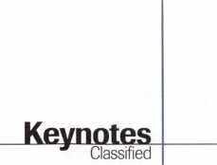

Business For Sale

For Sale: Lock Technology Corp. New Rochelle, NY Lock Mfg. Co., est. 1974. For details, call and ask for Frank. Owner is retiring. Call (914) 632-4373

For Sale

Sunny Southern CA—successful retail and mobile lock and safe business. Estblished in 1962. Sale includes: van, inventory, equipment and commercial property. Many commercial accounts. Owner will stay dur­ing transition.

(909) 638-2777

For Sale

Well established locksmith business in Casa Grande, halfway between Phoenix and Tuscon. Successful family busi­ness for 27 years in downtown location. The only full service locksmith in Pinal County. Excellent business and invest­ment opportunity.

Call Milton Thompson, CML or Florence Thompson:

(320) 836-7662 (daytime)

(320) 836-8810 (evenings)

Locksmith Business For Sale

Excellent growth potential, highly profitable, well estab­lished (over 12 years), Chicago, IL, surburban locksmith compa­ny for sale. 80% commerical long-term accounts base. Sales exceeding 500K for last three years. Turnkey operation, fully equipped service vehicles, ideal location showroom and shop on main street, low rent. Owners can stay on to train. Additional information available to quali­fied buyers. Respond to:

Keynotes Classifieds 3003 Live Oak Street Dallas, TX 73204

Shop For Sale

Southern California locksmith shop in beautiful mountain community. Established over 20 years. Handles 75 percent of surrounding community. Large commercial accounts. Residential, automotive servic­ing. Grosses $110,000 per year. $95,000 with $25,000 down. Seller will carry. Call:

(909) 272-3871

Business For Sale

Locksmith shop in upper mid­west town of 60,000. Business is eight years old and still grow­ing. Avg. gross for ’93, ’94,

’95—$220K. 1996 gross— $260K+. Three person opera­tion, could easily support more. Little competition, 80% com­mercial accounts, two fully equipped service vans (1200’s, Adrian Steel cabinets, 110vt., power, etc.) Good lease on shop w/option to buy. Lots of regular commerical accounts. Buyer must be competent in all aspects of the trade. Owner will stay on as needed to insure smooth transition. $170,000 includes all inventory, equip­ment, vans, accounts and a very good reputation. No CDs. Serious inquiries only.

Respond to:

Keynotes Classifieds 3003 Live Oak St.

Dallas, TX 73203

■Wanted to Buy/Sell

Wanted to Buy

Used Ilco KD 87 old style abloy machine and keying kit. Contact:

Glen Johnson (218) 624-4136

For Sale

A-l Pak-a-Punch, brand new in box, never used. Does not have quick change kits. $195. Arrow six-pin originals precut factory keys $.60 per set Contact:

Ebel’s Lock Service P.O. Box 33973 Las Vegas, NV 89133 (702) 633-7280

For Sale

Silca Club Junior. Like new with assorted keys. Also, cutter for Dom keys—$800. Call:

Dave at (201) 827-3060

For sale

Open Tidel TACC 11 safes with ease. Sometimes they can be opened without drilling. $19-95 shipping and handling for tips and drill points. Send check, credit card or money order to: Lonnie McKinney, CML P.O. Box 3691 Salina, KS 67402-3691



Keynotes

April 1997

Wanted to Buy

Medeco code machine for 10-11 series commercial keys. Contact: Leroy

Donaco Enterprises (303) 326-4106 (phonelfax)

For Sale

Diebold safe and safe deposit locks, cases, time movements, handles, cylinders and related products. Call for fax list. Safemasters at (301) 363-2100

For Sale

Locknetics model 268-10- 24VDC, New, $200.

Acme Lock at (203) 787-6103

For Sale

Safe deposit locks, parts, sec­tions of S.D. boxes and bank equipment parts, etc. For infor­mation, price list, or ordering,

call: (800) 642-8763 (972) 289-8476 (fax)

■Commercial Classified

High Security Auto Keys

Aero Lock provides high securi­ty auto keys by code. Shipped via express mail. Cut and out the same day. $22 delivered. Price good in U.S. territory only.

Aero Lock

3673 New Getwell Rd. #9 Memphis, TN 38118 (800) 627-9433 aerolock@ix. netcom.com

Aero Lock

Did you get a backed-up writ­ten guarantee when you bought your tryout keys? If you bought them from Aero Lock you did! 3673 New Getwell #9 Memphis, TN 38118-6033 (800) 627-9433 (901)362-1197 aerolock @ix. netcom. com http: 11 www. clear star, com! locked!ae ro.htm or http:Il[www.aerolock.com](http://www.aerolock.com)

Aero Lock

Are the tryout keys you are buying cut between service calls on a duplicator in the back of a service van? Aero Lock’s are not! Original cuts each time. It’s our full time business.

3673 New Getwell #9 Memphis, TN 38118-6033

(800) 627-9433 (901) 362-1197(FAX) aerolock @ix. netcom.com wwwlclearstar.com/locked!aero, ht or [www.aerolock.com](http://www.aerolock.com)

Help! Masterkeying.

Let us do your masterkeying. Computer generated custom systems created. We can: formu­late only (key schedule/bitting); formulate and supply system (“soup to nuts”); key your cores sent to our facility; high securi- ty-Medeco, Schlage, Primus, etc.; cut all keys necessary. Commercial Lock, Inc.

Ill Broadway NY, NY 10006 (212) 766-0774

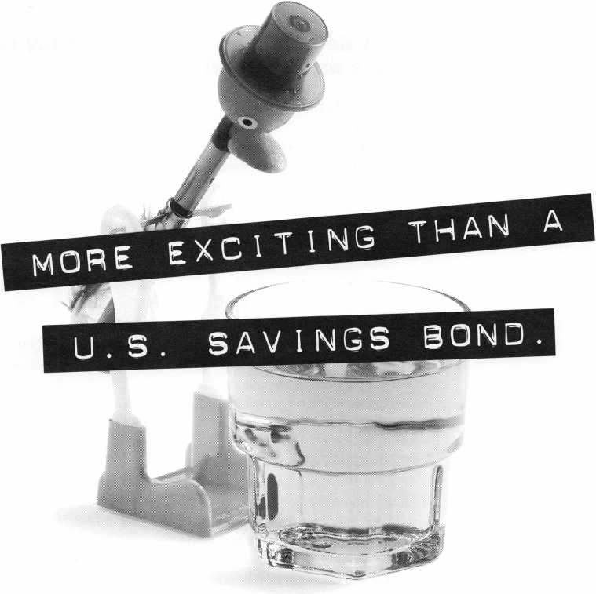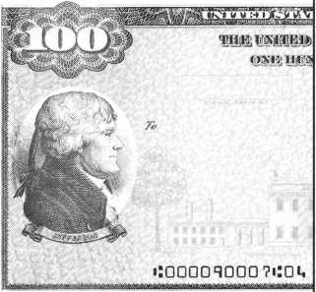

**ALL RIGHT ALREADY,** so a U.S. Savings Bond isn’t the most exciting thing in the  
world. **GOOD FOR YOU!** After all, this is your hard-earned money we’re talking about. Do  
you really want your investments to he thrilling? Breathtaking? **NO WAY.** Wouldn’t you rather

have an investment that’s guaranteed to grow, one that’s backed  
by the full faith and credit of the United States government?

Sure you would. U.S. Savings Bonds.

Yawn all the way to the bank!

is.

Take Stock in America

SAVINGS

BONDS

A public service of this magazine

PRP

Report

I James Watt, CML

Committee Chairman

The public deserves a means of determining the competency of a locksmith so that they can make an informed choice.

**/PRP Dates**

May 10

Eau Claire, Wl Indianhead Chapter John Dorsey, CPL (715) 832-4207

May 10

Louisville, KY SAFETECH ‘97 Jessica Vasquez (214) 827-1701

June 8

Portland, OR Clark Security Products Amy Barrett (206) 467-3000

June 8

Ruidoso, NM New Mexico Chapter Steven Highland, CML (505) 884-0046

June 22

Fargo, ND

North Dakota Chapter Todd Ladwig, CML (701) 232-9440

June 29

Rosemont, IL Clark Securitiy Products Marlene Sealey-Frey (619) 974-5273

July 19

Boston, MA

North Bennet Street School Jack Hobin, CPL (617) 227-0155

July 31

Reno, NV ALOA ‘97 Jessica Vasquez (214) 827-1701

August 1

Reno, NV ALOA ‘97 Jessica Vasquez (214) 827-1701

30 Day Application Period on PRP Classes0

**PRP & Door Hardware**

In this issue of Keynotes, there is an excellent article, “The Complete Door,” by Claire Cohen, CML, that will give you some point­ers on studying for several of the mandato­ry—and a number of the elective—cate­gories of the PRP as they relate to door hardware. Check it out.

**Why the PRP?**

This month, I’d like to give some of our newer members a little background on why ALOA developed the Proficiency Registration Program (PRP). The association does not require members to take the evalua­tion, nor are we promoting it as a means of restricting access to the locksmithing indus­try. ALOA recognizes the need for a means of self evaluation to identify those subjects in which an individual may need further educa­tion. Furthermore, the public deserves a means of determining the competency of a locksmith so that they can make an informed choice.

ALOA is working with manufacturers of security products to inform the public about PRP designations. Often product literature and instructions now include information about how quality service and installation can be obtained from an ALOA certified locksmith.

It is the desire and hope of ALOA that each locksmith who participates in this pro­gram will achieve the professionalism that will enhance their image in the community. Each participant should proudly advertise their PRP designation at every opportunity.

**New CPLs**

David M. Kersch, San Antonio, TX

Kenneth C. Stout, Carrollton, TX

James D. Tate, Tulsa, OK

**PRP Resource Guides**

As a last note, The PRP Resource Guide, although not the last word on the PRP by any means, is an excellent beginning source to use to find the information you need to prepare for your next sitting. The guides are available from either the PRC Chairman or the ALOA office for only $18, which

includes shipping. Call today to get your copy.

**I PRP History Requests**

There have been a lot of requests for PRP history reports recently as the 1997 PRP sea­son gets underway. If you do not know what your PRP history is, please contact the Chairman by phone at 406-721-9797 or by fax at 406-549-7067. Be sure to have your current ALOA membership number and /or old ALOA membership numbers you might have taken the PRP under when you call or write. PRP history reports will be mailed or faxed to you upon your written request.

About the Chairman: James Watt,

CML, CPS, owns and operates Art and Ray’s  
Lock and Safe in Missoula, MT. He has been an  
ALOA member since 1977 and is also serving as  
the Northeast Regional Vice President of ALOA.

Proficiency Registration Program

Available to locksmiths worldwide, ALOA’s  
proficiency registration program (PRP) evalu-  
ates the educational and technical competence  
of dedicated individuals in 36 categories such  
as hardware installation, high security and  
safe/safe vault locks, master keying, alarms and  
access control devices. There are four levels of  
PRP certification:

Registered Locksmith (RL)

Certified Registered Locksmith (CRL) Certified Professional Locksmith (CPL) and Certified Master Locksmith (CML)

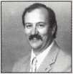

52

Keynotes

April 1997

**ENO-SPARKS CONVENTION CENTER**

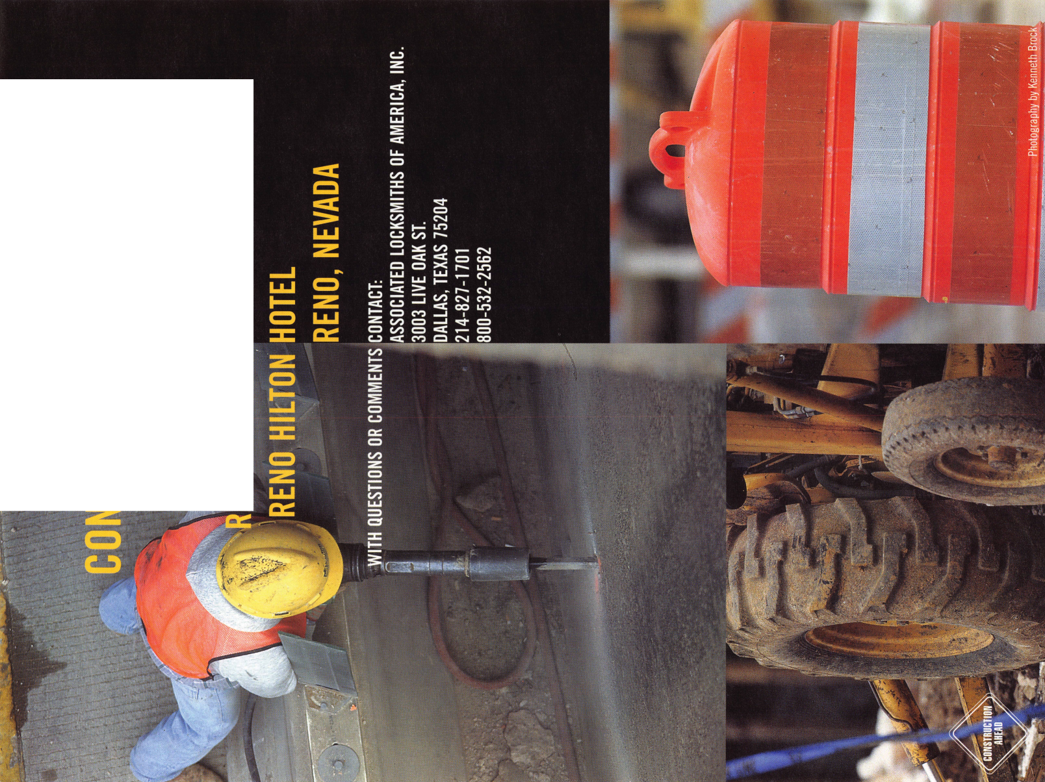

Buyer's

Guide

The Sectorater GM

Removing the ignition lock from a GM auto with VATS to see numbers stamped on the cylinder, and then disassembling the cylinder to decode and generate a key, is a trying task. The Sector gear can be difficult to remove. The Sectorater GM is a GM ignition disassembly tool that saves time and money.

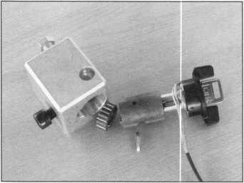

The Sectorater GM holds the locks so the steel wedge can punched out with a 3/32- pin punch, and it presses the lock apart in seconds. A vice is not needed.

The milled space on the side allows a lock casing to be attached to the tool with a 1/4 20 bolt. Simply align the wire past the notch and insert the casing into the steering column bowl. The Sectorater GM is easy to use. For more information, contact Robert Bullard at (520) 790-2290.

Reader Service #19

SPEEDYPIK"

The automatic key ID system. This com­pact unit fits inside your IBM compatible computer in a 51/4 bay the same as a disk drive. The latest addition is a 5,000 key pre-programmed database. Now you can leave the key cutting in the care of an

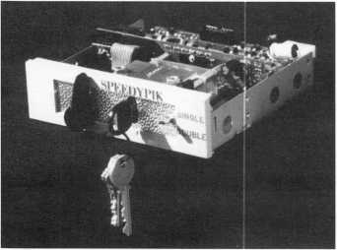

Keynotes April 1997



apprentice without a long training period.  
This will free the locksmith up to do other  
work.

(617) 567-1111; FAX (617) 277-7777;  
e-mail: [SPEEDYPIK@juno.com](mailto:SPEEDYPIK@juno.com)  
Reader Service #20

Allstate Locksmith Insurance Program

As a retail or  
mobile locksmith,  
you understand  
how important it  
is to rely on a  
solid, reputable  
company to help  
you with your  
business insurance  
needs. If you have  
any questions  
about your insur-  
ance needs in gen-  
eral, an Allstate  
Agent can provide  
you with addition-  
al information. To  
be referred to an

Allstate Agent, please call 1-800-669-6711.

Reader Service #21

Cap with Built-In Light

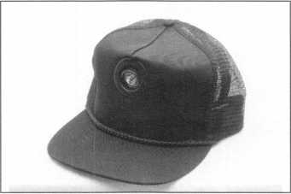

This cap is the perfect solution for hands­free lock and safe work which requires some illumination. The light is build right in and can be adjusted to three different positions. The light turns on when it is pushed down in any of the three angles. Operates on two AAA batteries (included). Made from black cotton mesh, the cap is fully adjustable and very affordable. Contact MBA (mark bates Associates) toll free at (888) 622-5495,

(606) 887-0496, Fax (606) 887-9491 or write: 101 Edgewood Plaza Dr., Nicholasville, KY 40356-1850.

Reader Service #22

h.e.s., Inc 7500 Series Strike Passes UL Fire Door Test

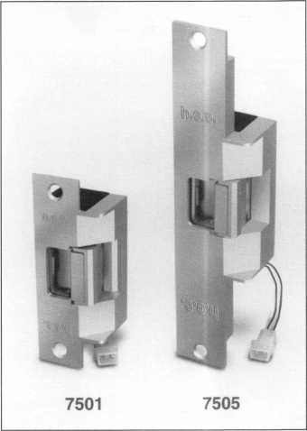

The test was a success. The h.e.s. models 7501 and 7505 are now UL listed for fire doors, category 10B, for use on class “A”— three hour or less doors. This is the highest rating an electric strike can obtain from UL.

The 7501 and 7505 models are available now for immediate shipment, h.e.s is very excited to offer such a superior electric strike to our customers, and we look forward to a successful partnership in 1997.

Hanchett Entry Systems 2040 W. Quail Avenue Phoenix, AX 85027 *Reader Service* #23

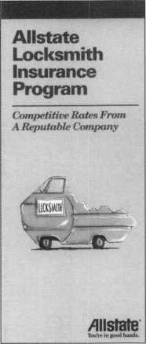

ALOA

Extra

Sign Contest

It’s time again for the ALOA Truck and Storefront Sign Contest. It’s easy to join in the fun—simply follow these contest rules:

* Participants should send in a color 3x5 photograph by July 1, 1997. Be sure your photo is current—last years photos are not acceptable.
* Last year’s winners are not eligible to par­

ticipate and all entries become the exclu­sive property of Keynotes.

* Judging will be done by the Publications

Committee and Keynotes staff.

Entrants will be published in Keynotes and the winners will be announced at the ALOA ’97 Security Expo.

Gussy up your truck and storefront, and send in those snapshots!

Top Secret

If you’re looking for our website password, the search is over! Just remember that this privilege is for ALOA members only so please honor the confidentiality of this infor­mation. First of all, your user name when accessing the restricted portion of the web­site is ALOA

And the password? Pssssst. It’s lockup97

Friends

ALOA has had to say goodbye to several friends who have recently passed away. Keynotes would like to mention these people:

* Travis Gaines, #026254, Austin, TX
* James May, #013394, Sparks, NV
* Jim Kaiser, #002745, Lovington, NM
* Craig Mansfield, #012179, Waterloo, ON
* Joseph Gray, #007153, Dallas, TX

**Keynotes** Reprint Policy

Keynotes magazine, the official international publication of the Associated Locksmiths of America, Inc., currently extends, as a cour­tesy, permission to reprint portions of the publication to ALOA members, ALOA chapters and regional locksmith associa­tions. This policy is based on the assump­tion that the material is being used for informational purposes only and that no



direct profit is to be made by the reprinting party. The Keynotes reprint policy carries the following stipulations:

* The party wishing to reprint a portion of Keynotes will inform ALOA, in writing, of what is to be reprinted, where and for what purpose.
* The reprinted information must appear verbatim—i.e., exactly as published— with a notation that the material appears “courtesy of Keynotes magazine, Associat­ed Locksmiths of America, Inc., [issue date].”

If the party wishing to reprint a pub­lished portion of Keynotes stands to profit directly from re-publishing this material, arrangements must be made with the author/owner of that material. Contact information for authors is available from ALOA. [This is primarily a requirement for any for-profit publications. This does not, for example, apply to an ALOA member who wishes to make photocopies of Keynotes material to educate consumers about profes­sional standards such as the recommended ALOA Positive ID Policy.]

If the party wishing to reprint a pub­lished portion of Keynotes—either on a profit OR nonprofit basis—wishes to use the pho­tography or illustrations from the magazine, arrangements must be made with the artist/owner of that material. Contact infor­mation for artists is available from ALOA. (Note: Art executed by ALOA staff is “work for hire” and does not fall under this provi­sion.)

Positive ID Policy

ALOA would like to remind its members to use the following ID policy for lockouts: Notify Caller. When a call comes in to request lockout services, ask the caller if he/she has identification and authority to open the lock.

Complete Form. Upon arrival at the job site, the locksmith should complete an Authorization Form that asks for the name, address, phone number, identification num­ber and property description from the cus­

tomer. ALOA provides a model form.

Verify I.D. Verify the customer’s photo-iden­tification card and compare it to the infor­mation provided by the customer. If no photo-ID card is available, ask for some other reasonable form of ID.

Verify Authority. The locksmith should inquire as to what authority the customer has to open the lock, and request to see any reasonable and appropriate evidence that could verify the authority. This may be impossible in some cases.

Ask for Signature. Ask the customer to sign the Authorization Form, which should contain a statement that (a) the information given by the customer is correct, (b) the customer has the authority to open the lock, and (c) the customer shall identify and hold harmless the locksmith against liability.

The ALOA model form contains this state­ment.

Optional Last Resort. If you have any sus­picions that the customer is giving false information or does not have authority to open the lock, say that you will be happy to open the lock provided a law enforcement officer is present. If the customer agrees, call the police; if not, leave.

File the Form. Keep the Authorization Form on file for a reasonable period of time (at least three years).

Keynotes Advertisers Index

|  |  |  |
| --- | --- | --- |
| RS#  17 | Advertiser  H.E.S., Inc. | Page  25 |
| 18 | JLM Wholesale, Inc. | 41 |
| 100 | Jet Hardware Mfg. Co. | BC |
| 16 | Locksmith Publishing Corp. | 19 |
| 3 | MIWA Lock USA | 9 |
| 2 | Mas-Hamilton Group | 8 |
| 25 | Medeco Security Locks | Insert |
| 14 | Monday Security Group | 15 |
| 15 | Omaha Wholesale Hardware | 15 |
| 1 | STRATTEC Security Coro. | IFC |
| 24 | Winfield Architectural Hardware _ | |
|  | April 1997 | Keynotes |

Security Through electronic Technology.

**MicroKey**

**Presents**

**A Golden Sales**

**Opportunity**

I ake good care of your  
customers with high  
security technology that  
creates repeat business

for you.

The computerized

MicroKey Series is  
easily installed in new  
or retrofit construction  
applications *without  
electrical wiring.* Easily

expandable, it is adaptable to

small or mid-size projects.

It accommodates mortise or cylindrical door prep conditions.

Winfield's sophisticated engineering has instilled the MicroKey System with these state-of-the-art features:

* Audit trail records date, time, authorized user names, unauthorized attempts (1200 entries)
* Five-level keying capabilities (also construction keying)
* System capable of controlling more than 60,000 users
* Instantaneous re-keying capabilities following installation
* Time zone keying control
* Smart, reusable micro-chip key blanks

Don't miss this golden opportunity for increased sales from one source. Call Winfield today for complete information.

A Division of CSS  
1020 West 17th Street, Dept. C-6  
Costa Mesa, California 92627  
Phone: 800-562-5733 (ask for ext. 407)  
(or) 714-722-5400  
Fax: 714-722-0129

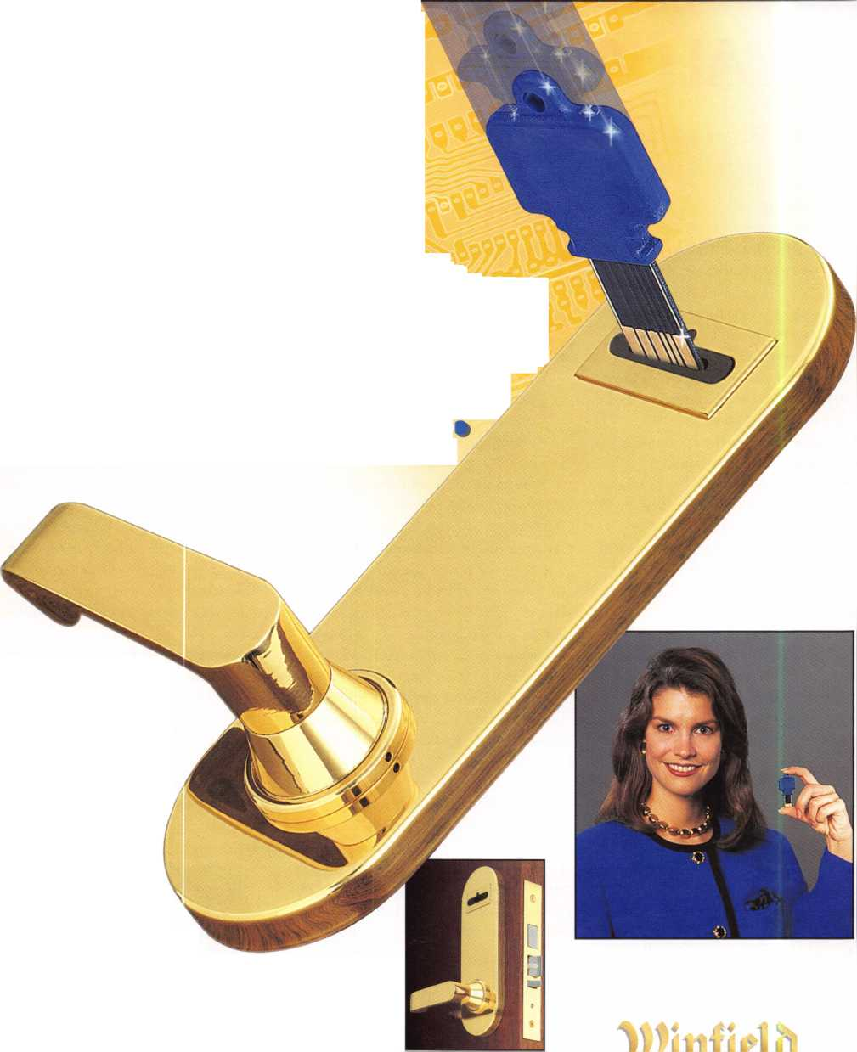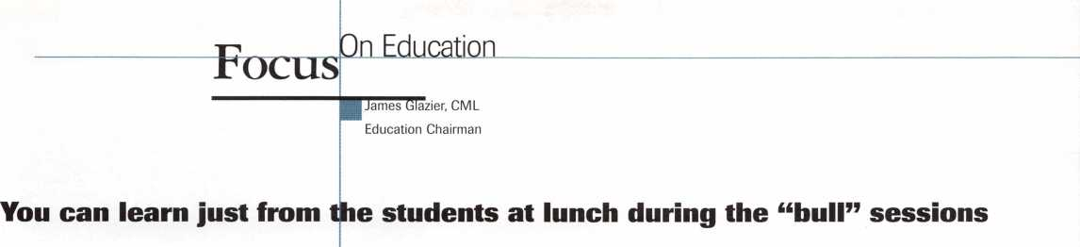

Texas Locksmith Association’s 34th Annual Convention and Trade Show, Feb. 4 to 8, 1997, is now history. There were four days of safe classes by Locksmasters, 10 days of ACE classes and three days of classes by TLA instructors—all of which were just great. It is always amazing to me to see what you can learn just from the students at lunch during the “bull” sessions, the trade shows and sharing with your fellow lock­smiths at such events. We learned some­thing at TLA, and that was that many of those attending were not members of ALOA, TLA or any other association. We had several “institutional” locksmiths, one whole shop (the father and three sons) and a large number of locksmiths who were attending such an event for the first time. Both ALOA and TLA got some new mem-

**Tjpcoming ACE Classes**

Grand Canyon Chapter of ALOA

April 5-6, 1997 Phoenix, AZ Contact: John Ilk [520) 474-8879

Combination Lock Manipulation Instructor: Ken Lee, CPL

Master Locksmith Assoc, of New Jersey

April 17-21, 1997 Somerset, NJ Contact [201) 267-8884 19 full-day classes and two evening seminars

ALOA 97

July 28-Aug. 1, 1997 Reno, NV

Contact: ALOA Meetings Department [214) 827-1701 [800) 532-2562 Approx. 45 full-day classes, 30 half-day classes and six evening seminars More information TBA

Gateway Locksmith Association

September 6-7, 1997 St. Louis, MO

Contact: Steven Meinhardt [314) 638-6440

Master Key Methods & Formats Instructor: Jerome Andrews, CML

J

bers, but more important, these locksmiths  
got some excellent education and will come  
back for more as soon as possible.

This was really a fine event. The Mardi

Gras theme carried into their ban-  
quet and awards breakfast on  
Sunday morning. Yours truly had  
some great seafood and beef, some  
fantastic fellowship with lock-  
smiths in Texas and, as always, I  
learned a lot from many people  
there. It is always a pleasure to get  
to know these Texans a bit better,  
even if I’m not a Cowboys fan!  
Congratulations, TLA on one fine  
event!

If you have always said you

couldn’t afford to attend such events, I have

to tell you that you can’t afford not to attend  
the national and regional conventions, asso-  
ciation classes and any other opportunity you  
can find to keep abreast of our ever-changing  
profession. Times are changing, and you and  
I have to change with them or we could  
become extinct. I do not know how many of  
you are aware that the ALOA scholarship  
committee can offer scholarships to any such  
event. These scholarships are not limited to  
the ALOA convention. You can apply for a  
scholarship to SAFETECH ’97, MLANJ in  
Somerset, NJ, in April or ALOA ’97  
Security Expo in Reno, NV. You can also  
apply for a scholarship for any ACE class  
during the year. Contact ALOA in Dallas for  
a scholarship application, or look through  
past Keynotes. There are applications in there  
about three or four times a year. “Try it—  
you might like it!” as they say.

Master Locksmith’s Association of New Jersey will be your next opportunity to attend some great education and a fine trade show. April 17 to 21, 1997, in Somerset,

NJ, will be a fine time for those who attend. ACE is offering 20 full-day classes, and you can get all the details by calling (201) 267- 2441 and requesting information. Don’t wait—do it right now so you don’t forget.

Then there is SAFETECH ’97 in Louisville, KY, from May 5 to 10, 1997, at the Galt House. Contact SAVTA in Dallas

for full details. There will be some great safe classes during this time, a manipulation contest, prizes and one great trade show held in the heart of safe country. This is the

home of S&G, Lockmasters and many more, so make every effort to be a part of this edu­cational experience.

ACE has some exciting new classes at ALOA ’97 Security Expo in Reno, NV, from July 28 to Aug. 2, 1997. Just a few of the 45 full-day and 30-half day classes: Investigative Locksmithing by D. Shiles; Servicing Aluminum Storefront Doors by D. Thielen, CML; High Security Import Auto by R. D’Adamo; Basic Safe Penetration by C. Stephenson; Basic Computers by B. Neff and many more. You should receive your ALOA ’97 brochure this month, and if you don’t, contact Dallas to be sure you get your copy so you can sign up for some of these great classes.

The list of upcoming classes are shown to the left, and I hope you will take the oppor­tunity to attend one or more of these events. I can promise you it will be the best money you ever spend. Until next month, have a great day and learn something new this week!

El

lmJI— I About the Chairman: James

Glazier, CML, #14240, is a retired police officer and operates Security Plus in Mount Airy, MD. He also serves on the Finance, Convention and Personnel Committees of the ALOA Board.

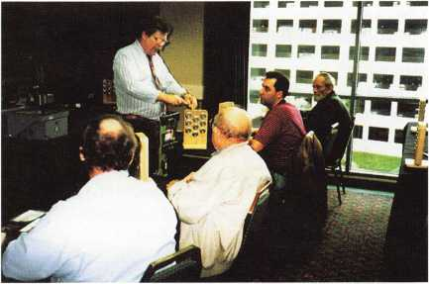

TLA Class

April 1997

Keynotes



Chapter

Roster



Dept

^ **The best way to leam about ALOA’s programs  
and to network with locksmiths in your area is by  
participating in local ALOA chapter activities. This is  
your opportunity to exchange management and tech-  
nical information, build your professional image, and  
share trade tips with your fellow locksmiths.**

**If you want to start a chapter in your area, please call  
ALOA, (214) 827-1701.**

w

Alabama

Alabama Locksmiths Association

411 6th St.

Decatur, AL 35601 (800) 292-5008 *Larry Warnick, CML

Arizona

Grand Canyon Chapter

13016 S. 131st St.

Gilbert, AZ 85233 (602) 786-8182 *Larry Schlemmer, CRL

California

Los Angeles/

Orange Counties Chap­ter

P.O. Box 697

Alhambra, CA 91820-0697 (310) 869-2555 *John H. Cosby, CPL San Diego Chapter

1049 Island Ave.

San Diego, CA 92101-7228

(619) 234-4829

Burt Fieser—Chairman

Colorado

Colorado Front Range

2055 26th St.

Boulder, CO 80302 (303) 443-9740 John I. Shandy, CML— Chairman

*John M. Thomas, CRL— Vice Chairman (303) 666-8980

Connecticut

Nutmeg Chapter

Phil’s Lock Shop 360 E. Main

Meriden, CT 06450-6022 (203) 237-4602 Phillip Hobbs, CPL—Chair­man

Florida

South Florida Chapter

1710 NE Miami Gardens Dr.

Miami, FL 33179 (305) 944-0469 *Jerri Moeller, CRL Secre­tary

Paul Renderer, CML— Chairman

Georgia

Georgia Chapter

P.O. Box 48088 Atlanta, GA 30362-1088 (404) 455-6244 John T. Grist, CML—Chair­man

*M.W. Whitman, Jr.

Hawaii

Hawaii Chapter

4420 Lawehana St.

Unit 4

Honolulu, HI 96818 (808) 623-5914

* Andreas Muenker, CML— Chairman

Indiana

Central Indiana

1237 Wabash Ave.

Terre Haute, IN 47807 (812) 234-6249

^Herbert Dusenberry, CML

Northern Indiana

122 N Orchard St. Kendallville, IN 46755 (219) 347-1754 *Earl Shanfelt

Southern Indiana

P.O. Box 185 Bloomington, IN 47402- 0185

(812)334-3737

* Daniel W. Hill, CML

Kentucky

Kyana Chapter

510 E. Parrish Ave. Owensboro, KY 42303- 3125

(502) 684-5093

*Timothy Morrison, CML—

Secretary

Maryland

Chesapeake Chapter

205 Cleveland Ave. Baltimore, MD 21222 (410) 633-0111

* Bob De Weese, CPL— Chairman

Massachusetts

Massachusetts Chapter

200 Weir Street Taunton, MA 02780 (508) 823-4649 *Stephen Ehrlich, CML— Treasurer

Minnesota

Minnesota Chapter

3M Center

Bldg. 223-BE-04

St. Paul, MN 55144-1000

(612)733-6674

^Douglas Rude, CRL

Montana

Montana Chapter

1000 S. Main Butte, MT 59701 (406) 782-0125 * Aggie Cooney, CPL

Nebraska

Nebraska Chapter

343 W. 2nd St.

Hastings, NE 68901 (402) 463-6661 *Brad Boden

Nevada

Sierra Nevada Chapter

C/O Pamela Vankirk P.O. Box 115 Reno, NV 89504 (702) 328-9285 *Danniel F. Howard,

CML—Chairman

New Jersey

Garden State Chapter

106 Ridgedale Ave. Morristown, NJ 07960 (201) 538-2737 *Steve Frei, Chairman

New Mexico

New Mexico Chapter

917 2nd St. NW Albuquerque, NM 87102 (505) 242-1380 *Evelyn Wersonick, CML Marc McGrannahan, Chair­man

Sunbelt Chapter

South Central Region New Mexico State University

Box 30001 Dept. 3545 Las Cruces, NM 88003-0001 (505) 846-6292 *Don Brazil—Chairman

North Dakota

North Dakota Chapter

Rte. 1 Box 67 Devil’s Lake, ND 58301-

Ohio

Ohio North Coast Chap­ter

#2 Horseshoe Drive Monroeville, OH 44847 (419) 465-4153

* Ronald Betschman,

CML—Chairman

Ohio Valley Chapter

144 Julep

Cincinnati, OH 45218 (513) 825-7528 *James T. Brickler,

Chairman

Pennsylvania

Keystone State Chapter

3 W 4th St.

Bridgeport, PA 19405 (610) 272-9292 *Barry Leas, CRL

South Dakota

South Dakota Chapter

402 S. Minnesota Ave.

Sioux Falls, SD 57102 (605) 331-6026

* Ronald Heidzig—Chair­man

Tennessee

Smokey Mountain Chapter

2557 Middle Creek Rd. Pigeon Forge, TN 37863 (615)453-8344 *Jessie Swan, RL West Tennessee 1643 Bartlett Rd.

Memphis, TN 38134 (901) 372-7464 *Richard Pat Walker,

CML—Chairman

Texas

Sunbelt Chapter

see New Mexico listing

Washington, D.C.

Washington, D.C. Area

4713 Tallahassee Ave. Rockville, MD 20853 (202) 722-0900 *Lester Brodsky—Chairman

Wisconsin

Fox Valley Chapter

1425 N. Richmond St. Appleton, WI 54911 (414) 731-5400

e-mail [sageinc@athenet.net](mailto:sageinc@athenet.net) *John F. Engel, CRL Chairman

Matt Swoboda—Vice Chair­man

Indianhead Chapter

201 N. Barstow St.

Eau Claire, WI 54703-3525 (715) 832-4207 *John Dorsey, CPL Chairman

Wyoming

Wyoming Chapter

5920 E. Pershing Cheyenne, WY 82001 (307) 638-8752 * Betty Crenshaw, CML

International Chapters

Hong Kong Chapter

901 Canton Rd, G/Fl Mong Kok Hong Kong

*Timothy Chow—Chairman

Korea Chapter

#1250-7 Bi San 7 Dong Seo Gu TaeGu Korea

(053) 353-0058 *Myeong-rae Cho

* Denotes contact person for this chapter.

All questions regarding chap­ter activities, meetings and events should he directed to this individual.

3907

(701) 662-5625 *James H. Strong, CRL

Keynotes

April 1997

Chapter

pan^amum, CML Committee Chairman

Don’t just tell me and everyone else the problems—give us logical solutions that work!

In this issue of Keynotes I would like to talk about personal integrity and standing up to those who tear down our association. Recently, I was sent, from a fellow member, a few open letters of complaints concerning ALOA that were left on a bulletin board on the Internet. Almost all of the comments and innuendoes made are totally false. Some of the ones complaining had never been involved in ALOA long enough to learn how many ways ALOA can help them benefit from their profession and each other. I must say, I am fed up with hearing about lock­smiths who think ALOA isn’t doing any­thing for or them or is not giving them their money’s worth. I have just one thing to say to people with those kinds of complaints: Don’t just tell me and everyone else the problems—give us logical solutions that work!

If anyone would care to write me about any solutions, they may do so. If it’s broke, let’s fix it together. ALOA is still the best thing we have for gaining technical knowl­edge, and by learning how to use that knowledge, we make a better living for our­selves and our families. ALOA stands for unity and strength among all locksmiths worldwide.

If the complainers could only realize that ALOA is just what we and they make it to be! ALOA can’t do all that needs to be done without more help. There are so many worthwhile projects that cannot be imple­mented because of a lack of funds. If every­one who calls themselves a locksmith was a member of ALOA, we would be able to offer many more beneficial and educational pro­grams for our members.

ALOA is charged with the responsibility of making the locksmithing trade a better profession for all locksmiths. The officers who have been elected to lead the association take this responsibility seriously and wel­come any suggestions to achieve that goal. If “they” are not getting anything out of ALOA, it’s probably because they are not putting anything into it. Sometimes it takes more than just dues—it takes people to fill positions, leaders to take charge and make

things happen or even an entire group to  
lobby against bad locksmith legislation.  
What it really takes is involvement and  
cooperation from everyone who calls them-  
selves a locksmith. Let’s face it, we all have  
the same vested interest in improving the  
image of our trade.

One of the major goals of ALOA is to  
provide educational opportunities to mem-  
bers, to upgrade the level of professionalism  
and then show that professionalism to the  
general public through better trained techni-

cians.

That’s all for now. Don’t forget  
to make those plans for ALOA ’97  
in Reno, NV. See you there!

San Diego Elections

The ALOA San Diego chapter  
recently elected four new officers:

* Burt Fieser—Chairman
* Bill Grimaud—Assistant
* Mike Howell—Treasurer
* JP & Carol Maloof—Secretary  
  Congratulations to the new crew!

Minnesota Donation

At a recent meeting, the Minnesota chapter  
voted to donate $200 to the ALOA legisla-  
tive effort. Legislative contributions are  
always appreciated and help immensely.

**Other Local Reports**

The new crew is as follows:

Mike Clark—President Ken Shoup—1st Vice President Bert Wallace—2nd Vice President Ken Warden—Secretary Robert Hernandez—Treasurer Gilbert Aguirre—Parliamentarian Wanda Sawyer—Sergeant-at-Arms Sheila Rushing—Editor Congratulations to the new officers.

In addition to nominating officers,TLA members kicked up their heels at their Mardi Gras party.

Be sure to let the Keynotes staff know what’s happening, or recently happened, in your chapter. Send information about meet­ings, elections, banquets, charity events, or any other points of interest to the editor. We welcome your submissions.

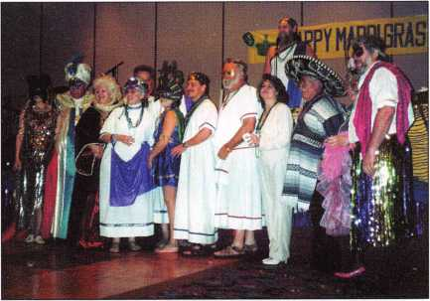

A good time was had by all!

One Person’s Trash Is Another’s Treasure

The Locksmith Security Association has a tip: Before throwing away old or duplicate magazines, locks and parts you don’t need or want, bring them to chapter or association meetings and see if anyone else can find the items useful.

TAOL

The Association of Ontario Locksmiths has recently elected a new president. Congratualations, Don DeKuyper!

New TLA Crew

This year, at their annual convention in Corpus Christi, a new group of officers were chosen for the Texas Locksmith Association.

About the Chairman: Dana

Bamum, CML, #05444, operates South Penn  
Lock & Safe Co. in Media, PA. He also serves on  
the ALOA Education, Membership and Bylaws  
committees, as well as having been on the board of  
directors of the Greater Philadelphia Locksmiths  
Association (GPLA). Dana has also sponsored  
many new ALOA members. Dana can be reached  
at FAX (610) 565-9902 or e-mail him at  
dlbamum@aol. com.

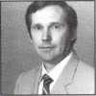

April 1997

Keynotes

Page

Ginsu Knives seemed like a good idea: you could cut an armored tank in half and still slice ripe tomatoes perfectly. You could cut through concrete mortars and still dice a fine cheddar cheese. But where are Ginsu Knives now?

The Studebaker seemed like a good idea: hot new car, revved up engine and sporty good looks. The handling and design were state of the art—for the times. But the Studebaker never came close to being Motor Trend’s car of the year. After all, you have to sell vehicles to start a motor trend.

Following in the footsteps of products in the category, “good idea/no staying- power” comes the tale of a little oddball named Dudley.

Dudley is a keyless lock that was manufactured sometime before 1970 by the Chicago-based Dudley Lock Cor- poration. To get to the other side of the door, the

operator must turn the handle three times, |K

stopping on the correct numbers that make up *lpii

**\* * > / 4**

the right combination.

Click right, click left and click right v . j. •

a*ain\ .

Just imagine the convenience of not hav­ing to worry about finding or losing your 7.

keys. Seems like Dudley would’ve been a ter- Vy

rific asset to latch-key kids and people with busy schedules. But where are the keyless locks

The Dudley Lock Corporation went out of business in 1980, and although there were once over four million combination locks in use, very few, if any, are used today. What seemed like a good idea was traded for the old fashioned stand-by: tra­ditional lock with traditional key. Although the Dudley Lock Corporation issued over 64,000 combinations, perhaps people were afraid someone with a thievish nature would have the patience to turn and turn until they figured out the right series of numbers.

So there, on a crammed shelf full of antique and near-antique locksmith memora­bilia, sits Dudley. Will it ever regain its popularity? Hard to tell. One thing is for sure: If you look close and read the first line on the safety-orange tag, you’ll find an interesting message. “This lock can be operated with gloved hand at night.”

Maybe the ’90s is just a more skeptical decade.

—Laurie Kline

60**1** ***Keynotes***

Photo by Kenneth Broc.k

Louisville, Kentucky May 5-10 The Galt House

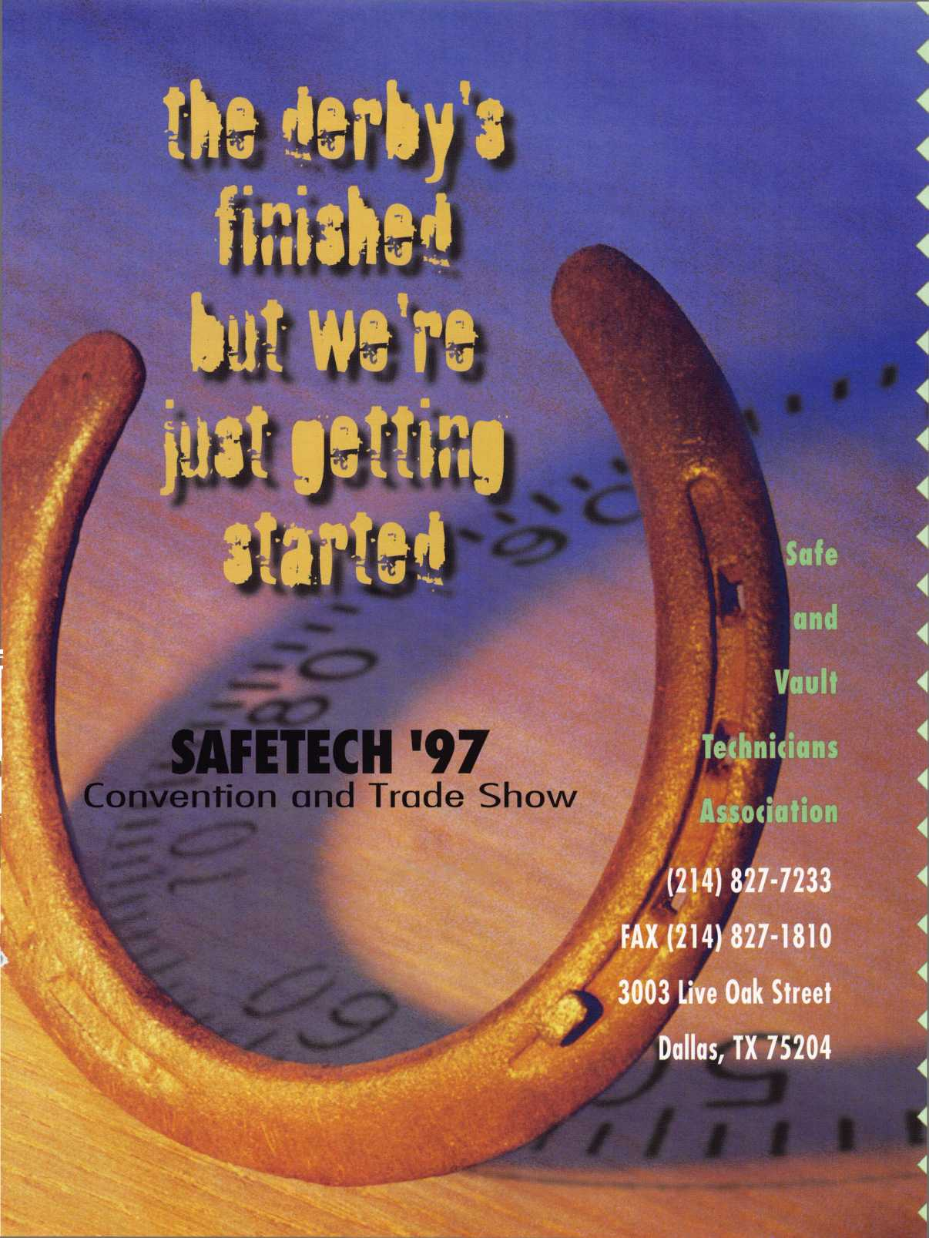

Iliill

Jet Silver Line... Landmark of Precision

PRECISION MANUFACTURED from the finest NICKEL SILVER and Polished  
to a Magnificent Silver Finish! A landmark in key manufacturing.

Over 170 numbers, coined, embossed and designed to create the appearance  
of the originals!

Offering Regular and Sectional keys from...

ARROW BEST CORBIN RUSSWIN

DIEBOLD FALCON HHM

KWIKSET LeFEBURE MEDECO

MOSLER SARGENT SARGENT & GREENLEAF

SCHLAGE YALE YORK

PERFECT for Master Keying and Duplication!

GUARANTEED to be consistently Superior to the Original Manufacturers  
productions! For the JET Silver Distributor near you, circle our number on  
the reader response card.

jet hardware... where

QUALITY is OUR KEY!

*%Po*%^0

JET HARDWARE MANUFACTURING CORP

800 Hinsdale Street, Brooklyn NY 11207

Free Information - Reader Service Card #100j

